**KV6003: Individual Computing Project**

Project Terms of Reference

James Robert Leslie Davis

W17000890, Computer Science with Games Development

**An Interactive Fiction exploring the principles of the Turing Test**

John Rooksby & Nick Dalton

General Computing Project

## Declarations

I declare the following:

1. That the material contained in this dissertation is the end result of my own work and that due acknowledgement has been given in the bibliography and references to all sources be they printed, electronic or personal.
2. The word count for this dissertation is 24,505.
3. That unless this dissertation has been confirmed as confidential, I agree to an electronic copy or sections of the dissertation to being placed on the eLearning Portal (Blackboard), if deemed appropriate, to allow future students the opportunity to see examples of past dissertations. I understand that if displayed on eLearning Portal it would be made available for no longer than five years and that students would be able to print off copies or download.
4. I agree to my dissertation being submitted to a plagiarism detection service, where it will be stored in a database and compared against work submitted from this, or any other school or from other institutions using the service.  
   In the event of the service detecting a high degree of similarity between content within the service this will be reported back to my supervisor and second marker, who may decide to undertake further investigation that may ultimately lead to disciplinary actions, should instances of plagiarism be detected.
5. I have read the Northumbria University/Engineering and Environment Policy Statement on Ethics in Research and Consultancy and I confirmed that ethical issues have been considered, evaluated and appropriately addressed in this research.

## Acknowledgements

I would like to acknowledge the help provided by the projects supervisor, John Rooksby, for his immense support and guidance throughout the project.

Additionally, the evaluation made possible through the feedback of the anonymous testers was extremely informative, and for that they have my thanks.

## Abstract

The number of Interactive Fiction games being produced has steadily declined since the boom of production during the 1980s, which can be attributed to the advancements in computer technology and the shift towards 3D first-person and third-person games. While development has slowed down for the genre, there are still some games that fit within the specifications of an Interactive Fiction that provide an insight into the adjustment towards modern standards.

Separate to this point, The Turing Test is a system for determining if an Artificial Intelligence can pass for a human and exhibiting human thoughts. The test posits the imitation game, a theoretical situation in which a machine and human are tested by an observer to see if they are able to tell the difference between the other two participants.

Both of these topics are extremely interesting which has influenced the decision to carry out this project. It is intended by the end of it to produce an Interactive Fiction game that uses elements of the Turing Test as an influence on how the environment the player is placed in is interacted with.

Through prior research and knowledge of video games, the combination of both the theory and practical application had not been done before, leaving a lot of creative freedom with no fear of copying or duplicating the work of others.

The idea of the Turing Test can be found in various media types, and the way it is portrayed in these can be used to draw different presentational styles for the test.

Combining the elements of an Interactive Fiction puts forward a challenging idea, making an environment that reacts to the players commands while also showing them as they do so. This, in tandem with the ideas drawn from the Turing Test would make for a challenging but rewarding attempt to create a game.

As part of the literature review, multiple conclusions are drawn about key points that are relevant to both the Turing Test and Interactive Fiction as a genre, which can be used by others seeking to do similar work. In addition to this, participants were chosen to play the produced game, and was met with above average scoring as feedback.

## Table of Contents

Declarations 1

Abstract 3

Chapter 1 - Introduction 5

1.1 - Aims 6

1.2 - Project Introduction 5

Analysis 8

Chapter 2 - Literature Review 9

Chapter 3 – Product Requirements 29

Chapter 4 - Tools and Techniques 34

Synthesis 38

Chapter 5 - Product Design and Ideation 39

Chapter 6 - Implementation 51

Chapter 7 – Testing 71

Chapter 8 - Evaluation 74

Chapter 9 - References 86

Chapter 10 - Appendix 89

10.1 Appendix A – Terms of Reference 89

10.2 Appendix B – Gantt Chart 106

10.3 Appendix C – Test Plan 107

10.4 Appendix D – Participant Information Form 111

10.5 Appendix E – Questionnaire Form 114

10.6 Appendix F - Questionnaire Responses 119

10.7 Appendix G – Search Strategy 123

10.8 Appendix H – Model Screenshots 123

## Chapter 1 - Introduction

#### 1.1 - Project Background

The general concept of the Turing Test is well known among students of computer science, specifically those who specialize in artificial intelligence. However, for the purpose of this project, the key principles discussed within the article by Turing have been discussed and applied to the identified aspects of the Interactive Fiction genre. From the research done to create a Terms of Reference (Appendix A) document and over the course of the project, a better understanding of the intricacies of both topics was made clear.

This general research showed that there is a wide variety of presentations styles that can be chosen for an Interactive Fiction, but one that is not widely used, which would also provide an environment to use the principles observed in the Turing Test would be a 3D space. Because Interactive Fiction originated in the 80s, and due to graphical and technical limitations, they typically followed a text line presentation style. This provided a potential challenge to overcome, as translating the core ideas of a typically 2D game to a 3D space can be an entire challenge, let alone introducing other elements on top.

The focus placed on these two key points of research is to create an understanding of them so that the research can be applied to a prototype of a game. Following the literature review, the research done into both fields would also be usable by other projects seeking to attempt similar goals. While not revolutionary, it can aid in modernizing a genre that has lost its popularity.

#### 1.2 - Plan of Work

Both topics serve as interesting and engaging elements that complement the studies done so far as a Computer Science student. Analysing the Turing Test and the critiques of it serves as a good source of independent learning, as it is not a topic that has already been discussed as part of the course and this is coupled with the carried-out learning on the genre of Interactive Fiction, which is also a topic not used within the current education plan for Games Development students. This has meant that the work done for this project is entirely independent of my studies, expanding my knowledge on topics that otherwise would not have been approached.

In addition to this, the creation and use of game within the Interactive Fiction genre is intellectually challenging. Due to research into the field, it is apparent the different points of view required when creating both linear gameplay path, and accounting for the many approaches possible for players of these games. Due to the general freedom provided to the player, it requires a constant retrospective look whenever a new entity is added to the game to fully understand how the player will try and interact with the world. As part of the fundamental game design, these games need to be difficult enough to provide a challenge, but easy enough that a player who is not versed in the games design is able to complete it, resulting in a tipping scale between difficulty and assistance.

#### 1.3 – Aims and Objectives

This project is planned to meet two aims:

1. Perform an analysis of the theory within the paper by Alan Turing and use the arguments critiquing it to form a fair answer and carry out research into interactive fiction as a video game genre.
2. Using methods of ideation to develop ideas that can be implemented into a demo for an interactive fiction and evaluate the success of this implementation.

Further to this, it was established in the Terms of Reference (appendix A) that the project would have eleven objectives that will be engaged as part of the work. Aside from the mentioned aims, these objectives are:

1. Throughout the project, develop upon core skills involved in game design, such as storytelling and critical thinking.
2. Design the user interface and presentation style of the product using storyboarding and show the development of these styles through iterative design.
3. Create a Game Design Document that will detail all the design processes and choices involved with the creation of the product.
4. Create the designed product.
5. Evaluate the product using feedback from users, and by performing a reflective critique on the work against the aims and objectives.

#### 1.4 – Subject of Work

In the analysis, it was summarised that several elements present in earlier iterations of Interactive Fiction could be combined with aspects of modern gaming. These points that were identified were then turned into requirements for the system. Prioritizing certain elements, with a 3D environment being a higher priority than sounds, a table was created that listed all the possible requirements using influence from the games discussed in the literature review.

It was further discussed in the analysis on what tools to use during the production of the game. This chapter looked at the various tools available for use when creating an Interactive Fiction and compared them to each other to determine which was the most suitable for not only creating a game, but also to fulfil the technical requirements that is expected at this level of the course. By the end of the chapter, the chosen game platform to create the Interactive Fiction on was Unreal. As part of this decision, the potential limits of choosing a platform that caters to other game genres is mentioned and discussed.

Following the analysis, the ideas within the literature review were used within the design and ideation stage, which saw the creation of different User Interface (UI) mock-ups, with additional development of the core idea for the game that was produced. This chapter also included brief storyboards using the designs to further explain the idea for the game that is founded in the results of the review.

The implementation of the product is heavily documented, with various screenshots of the “blueprints” used in the Unreal Engine as part of its visual coding system. This section also covered some of the issues faced within the creation stage, particularly documenting the “iterative” development of the main controller used to handle all of the inputs to the game, and how it would accept text and use it appropriately. The logic behind some of the blueprints is also discussed, such as the use of an integer variable to track the “state” of an object, and how this is implemented and used throughout.

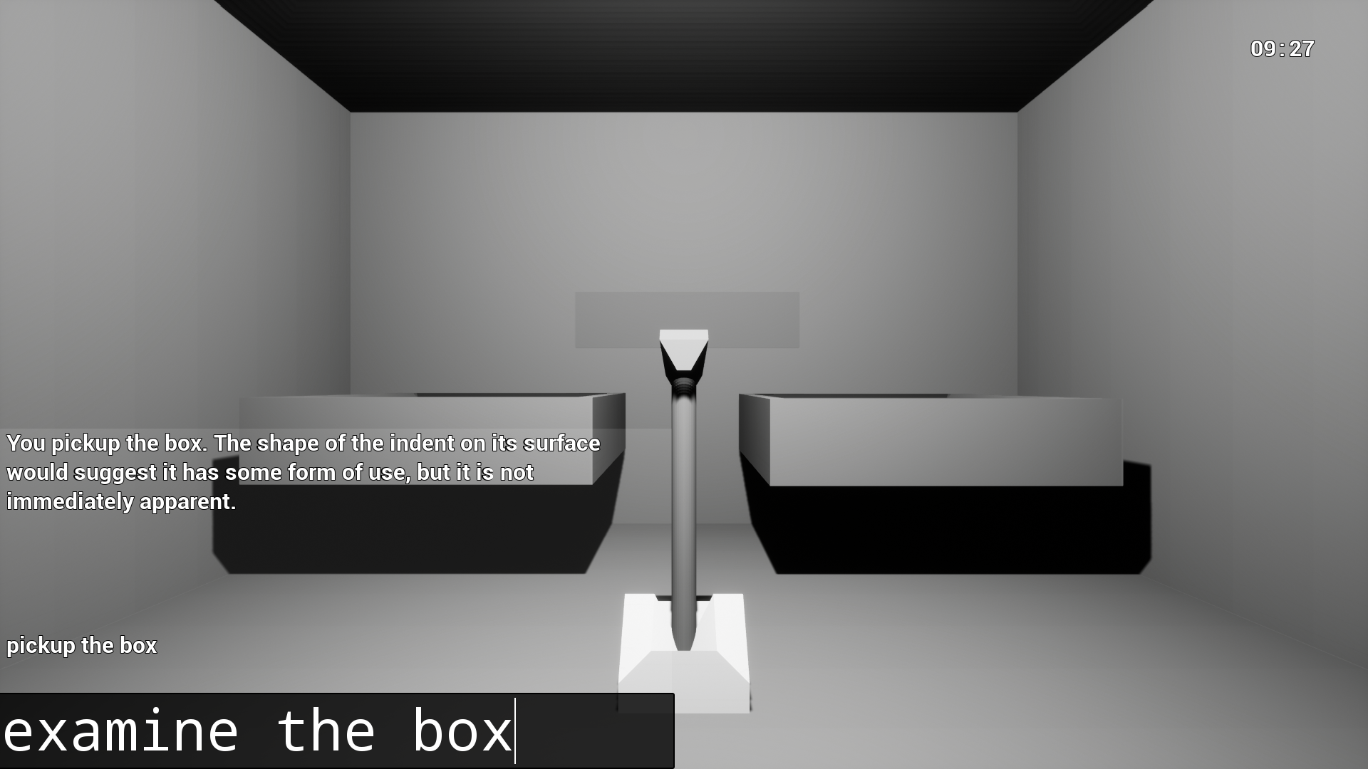

**A screenshot showing the finished product.**

From the implementation, the various tests carried out are discussed in the testing chapter. This section makes use of the test plan within the appendix to detail the various methods used to test the objects within the engine. This is followed by an evaluation that uses both participant feedback and personal critiques to discuss where the project succeeded, and were it requires additional work.

## Analysis

### Chapter 2 - Literature Review

#### 2.1 - Introduction

This chapter will have four separate sections; a review of the Turing Test, a review of Interactive Fiction, a review of games that use the Turing Test as a topic and a brief look into the theory behind user experience. The purpose of these sections is to understand the ideas that both the Turing Test and Interactive Fiction games involve, so that they can be conveyed properly.

This chapter includes the literature review, which is used to formulate design ideas before implementing the product as well as engaging with the theory involved with both Interactive Fiction games and The Turing Test. Additionally, the literature review observes games with similar ideas as the intended product and looks at how they have approached the topic within their implementation.

The final section of this chapter will look at user experience, and how it should be considered during the design and implementation stages of the project. The ideas drawn from this section will be coupled with inspiration taken from other Interactive Fiction games discussed in the review.

At the end of the first three sections there is a summary of observed principles that will be used in later chapters to both design and implement the product.

#### 2.2 - The Turing Test

The Turing Test originates from the paper first written by Sir Alan Turing in 1950 titled, I.-COMPUTING MACHINERY AND INTELLIGENCE, inside of which he defines both the “Imitation Game”, and the “Standard Interpretation”.

#### 2.2.1 - The Imitation Game

The Imitation Game can be broken down to the key elements required for it to operate, which is that “It is played with three people, a man (A), a woman (B), and an interrogator (C) who may be of either sex.” This established the players, and further mentions the goal of the game, “The object for the game is for the interrogator is to determine which of the two is a man or a woman.” (Turing 1950, pp 433) While doing so, one of the participants (in most instances, A) is lying about being a man, and trying to pass for a woman. This adds difficulty to the objective, as the interrogator must ask specific enough questions that help them in determining both identities, while not falling for any blatant lies.

In a theoretical instance, it could play out as follows:

“C: A, what types of shoes do you wear to work?

A: I wear trim loafers with bows.

C: B, what length is your hair?

B: My hair is straight with it being 1 foot at longest.” [not an excerpt from the paper, unknown origin]

In this instance, both players have made general statements without any sign that one player could be lying, it is fully possible for C to believe either because both statements could be true. To further complicate the game for the interrogator, interactions with the participants is done through a third party, this can either be by another human, who conveys messages or through typewritten messages (or by a modern computer). This removes the ability for the interrogator to tell the difference between the participants through tones of voice. Lines of reasoning such as being truthful and saying “I am x, they are y” would not be sufficient to solve this issue either, as the scepticism of the interrogator would lead them to believe that this statement is actually a lie, even if they have every reason to believe it.

#### 2.2.2 - The Standard Interpretation

The “Standard Interpretation” is conceived when one of either participants is instead replaced with a machine. Now, the game is dependent on the interrogator determining which of the players, either A or B, are trying to pass off as being a human rather than a man or a woman. This changes the weight of the game significantly.

The key feature in the Test is how it is carried out which Turing addresses as the “question and answer” nature of the test, stating that “We do not wish to penalise the machine for its inability to shine in beauty competitions, nor to penalise a man for losing in a race against an aeroplane.” Whereas prior, a man and a woman were trying to pretend to be the other gender, using observations and estimations from experiences within their life, or through their education, a machine does not have these assumptions that it can draw upon, making it more difficult for it to provide a natural answer. By making the game in a Q&A format, it removes the necessity for instant answers, meaning that both the machine and man taking part in it can consider all likely answers so that their case is the most persuasive. This is shown in an example provided by Turing,

“Q: Please write me a sonnet on the subject of the Forth Bridge.  
A: Count me out on this one. I never could write poetry.  
Q: Add 34957 to 70764.  
A: (Pause about 30 seconds and then give as answer) 105621.  
Q: Do you play chess?  
A: Yes…” (pp 434 – 435)

The quote provides a practical example of how the test puts both participants on even ground, because the asked questions do not provide a definitive way to determine if A is a man or a machine. Specifically, it may be programmed to do arithmetic, but take a long time, and pre-programmed to turn down questions of poetry. Or it could be a man who knows little of poetry, and a small amount of arithmetic that requires pen & paper to do equations, thus the long period of time between the question being asked and the answer being provided.

Turing’s paper also contains a variety of arguments that he has proposed against his theory to solidify the standpoint of the test. One of the most compelling of these arguments is (5) *Arguments from Various Disabilities* which talks about the argument that machines are not capable of emulating true human emotion. Within his rebuttal to this argument, Turing makes mention of (in response to a machine being presented with a numerical question), “The machine (programmed for playing the game) would not attempt to give the *right* answers to the arithmetic problems. It would deliberately introduce mistakes in a manner calculated to confuse the interrogator.” A key phrase within this sentence is “programmed for playing”, which will be looked at later. But, these two sentences develop on the point introduced earlier, that machine and man have been placed on an even playing field within the game, as any number of redundancies could be programmed to make it *seem* like the machine is taking it’s time, or that it is presenting the wrong answer to simulate human assumption.

#### 2.2.3 - Critiques to the Turing Test

A paper used to critique the Turing Test that was not produced by Turing himself is The Chinese Room (Searle, 1980), this paper critiques the idea mentioned within the fifth argument of Turing, that ‘machines created specifically for the test are not in themselves alive, only pretending to be’. Searle’s main point is a scenario created wherein a person who does not understand Mandarin, or another language that makes use of symbols over an alphabet akin to English, is inside of a room with no exits or entrances, and no way to see inside or outside. The participant inside of the room is provided with documents that are either in Mandarin or Mandarin and English together. With these documents, they are able to correlate meaning between symbols when written.

With the introduction of these scripts, the participant is required to respond to questions asked by observers from outside of the room to answer in both English and Mandarin. Searle proposes that after enough time using the rules provided, that the participant would develop a skill towards writing in Mandarin despite not knowing what any of the symbols mean, as they have equated their English understanding to what they have been told. His argument is that even if a machine is capable of fulfilling the criteria required, as the participant has within the room, then they do not actually show the capability to think like a human, rather that they are an “designed” to beat the test, and do not show true thinking. This is best summarized by Edelson (1982), “So it seems that to Searle what matters in deciding whether something has a mind or not is not the way it interacts with its surroundings, but some concrete aspect of what’s going on inside it.”

#### 2.2.4 - Observed Principles of the Turing Test

From the presented information, three key principles have been observed that would be applicable to the produced game, and that would also work with Interactive Fiction as the genre of the game. They are:

1. To properly test a participant, they must be subjected to tests that would rely on intentionality rather than fundamental knowledge.

This means that the common man cannot be tested based on quantum physics and expect a certain level of brevity from the answer, testing a participant based on their qualifications would be unreliable towards the information gathered, and would also pose to but a machine at an advantage. Especially when it comes to quantifiable means such as complex sum calculations or high-level science.

Further to this, the objective of this project is not to produce a game that emulates an IQ test, or a quiz game, as these would not properly covey the point of the imitation game. Both the presentation style and content of the game needs to probe for intentionality.

1. Designing, or preparing a participant for the questions that they are to be asked will not effectively fulfil the criteria, as it does not reflect human thinking.

To follow this principle, the delivery of the game should not provide a warning to the content, nor should outside assistance be provided to a participant. To this end, the game would not be designed for the player to replay it after beating it once, as the process for finishing the game will not hold the same difficulty for someone who has already finished it.

Any attempts to skew results in a particular way will not provide accurate results from conducting the test, this is observed as an inability to fulfil the criteria set by Turing, as human thinking is often times not a clear and concise viewpoint. Humans make rash decisions when treading in unknown territory, and the test seeks to test machines for this potential.

Another point to this principle is that the intent for any puzzles within the game would be that they are difficult for a general machine intelligence to beat them, not for a machine that is specifically created for beating puzzle games. This is to follow the idea that was within the paper, as a machine designed specifically for beating the test would not fulfil the criteria correctly.

1. Applying a time limit would not be accurate, as scenarios which are difficult for the normal human will require an apt amount of time to accommodate.

This idea is reflected commonly within Interactive Fiction as a basis anyway. Many of the older games within the genre (discussed later) do not apply a time limit to the player, and this is down to the inherent complexity involved, players are required to do long scenarios that involve many complicated sections, similar in theory to a Turing Test.

#### 2.3 - Game Review

To adhere to the development standards of an Interactive Fiction game, this section will discuss a variety of games that fit within the genre, starting with what is considered the original Interactive Fiction, to more modern games that implement elements seen throughout the genre while combining principles of modern expectations.

#### 2.3.1 - Definition of Interactive Fiction

Interactive Fiction is a term now used to describe a “text adventure game”. These types of games were common in the 60s, 70s and 80s, and the creation of these games started with ADVENT, which is discussed later in the chapter. By the 80s, text adventures were referred to as “Interactive Fiction” and became more common products from software development companies.

Now, it can be defined as: a game combining graphical elements with text; however, the player only interacts with it through a text command line. This definition of the term is the one being used going forward. Plotkin (2011, pp 60) states that Interactive Fiction are based in their text formats, but this by itself would make games that use books and other forms of in-game presentation would be considered Interactive Fiction, and continues to say, “IF generates text, but it also accepts text as input”.

#### 2.3.2 - Interactive Fiction as a Genre [A Retrospective of Interactive Fiction]

|  |  |
| --- | --- |
| Name of Game | Brief Description |
| ADVENT (Colossal Cave System), 1976 | ADVENT is considered the ‘original’ interactive fiction game and uses a two-word parser to give players control of the environment. The games environment is structured to loosely match a cave system that the creator had an interest in. |
| The Zork, 1980 | The Zork is a series of games, where each entry is distinct from each other. At this point, the text parser used in this series had advanced beyond two-word phrases, meaning more complex interactions could be carried out. |
| The Hobbit, 1982 | The Hobbit is based off the book of the same name and is set within Tolkien’s world. It is one of the first interactive fiction games to combine both graphical and text elements and gives the player a lot of freedom to explore. |
| Façade, 2005 | Façade is a voiced interactive fiction that is set in a 3D environment, the player communicates with the NPCs (non-playable characters) through the text input, to which they can respond with pre-recorded phrases. |
| 80 Days, 2014 | 80 Days is a game that presents the book of the same name through game form. It has elements of resource management and allows the player to make choices using pre-decided prompts. |
| Fallen London, 2009 | Fallen London is a browser based interactive story that uses a card system in place of the text input. While not considered a true IF, it provides interesting narrative stories. |

**Table 1: A table listing games that will be covered in this section. A brief description of them  
is provided. In order as discussed.**

#### 2.3.3 - The Architecture of Interactive Fiction

Interactive Fiction is a genre of game that has managed to persist even with the advancements made to computers over the years. The “original” IF was ADVENT (Buck 2019), which was created for the PDP-10 Mainframe Computer in 1975. Since then, ADVENT has served as an influence for many genres of game development, performing a key part in the history of gaming.

As mentioned, Interactive Fiction is a genre that continues to expand, and has since changed from games that rely on large info dumps through text to games such as Façade, which has the player enter a 3D environment and get “entangled in the high-conflict dissolution of Grace and Trip’s marriage” (Mateas, no date), a vastly different game to ADVENT, but still considered an Interactive Fiction. Even further to this, games such as 80-days would take inspiration from earlier Interactive Fictions, as it uses text-based interactions that are combined with illustrations to improve the players experience (Christiansen 2015).

In tandem with computers as a whole, the methods for delivering the narratives of games is constantly developing, and the genre has come a long way from just being inside of a command line.

There are certain rules that can be observed within most Interactive Fictions games. These are defined by Montfort (2011) as:

* A text-accepting, text generating computer program;
* A potential narrative, that is, a system that produces narrative during interaction;
* A simulation of an environment or a world; and
* A structure of rules within which an outcome is sought, also known as a game

These rules serve as a basis for the architecture required when creating an Interactive Fiction. It will be discussed later, but many of the examples seen in table 1 that can take custom text inputs have varying limits on what those inputs can contain. Additionally, many of the examples also contain their own narrative that is shaped through the players interactions, whereas the scope of the simulated world varies.

Further to this, an interesting paper about the architecture of Interactive Fiction by Montfot, Marcus and Prince (2007) explores the methods involved with generating a game narrative that is capable of handling any of the players inputs in real time, as the player interacts with it.

A key point within this paper is the distinct definition of both “discourse” and “story”, where it is explained that “story” is “what is told”, whereas “discourse” is “how it is told”. This key distinction helps formulate how a narrative piece can develop as the story continues. An overall story could be “a car hits a tree”, but the discourse could be any example like the two following:

* The car wheel broke and it crashed into the tree.
* The tree had a car spin into it.

Both of these statements tell the same story but use discourse to establish causation differently. In the first one, it stated that the car had only hit the tree because the wheel broke whereas the second statement would suggest that the car had already been spinning and hit the tree by chance. This idea of framing statements is critical in the creation of a narrative within Interactive Fiction and helps serve a base for driving player interaction within the world. The use of context and expression will be key to formulating a gameplay path within the product.

#### 2.3.4 - Text Parsers

Text-based Interactive Fiction games make use of a ‘text-parser’, which reads text inputted by the player and simplifies it down into a form that can be easily interpreted by the program. When presented with the following scenario:

* “You stand in a room, in the far corner from the door is a small obelisk. In the opposite corner stands a plinth.”

And the following sentence:

* “Pick up the obelisk and place on plinth”

The parser would filter down the inputted text until certain criteria for an action has been discerned. Looking at the example, it would see “pick up”, “obelisk”, “place”, “plinth”. These objects would already be pre-defined, either being generated dynamically by the program or being purposefully coded. “Pick up” and “place” are identified as commands, whereas “obelisk” and “plinth” are objects, combining these into the same sentence and placing it through the parser will drive cause the narrative to advance. After parsing the commands, it will provide a narrative response, such as:

* “The obelisk sinks into the plinth, causing a light to illuminate the room. Markings are revealed across the room.”

This example would continue until an established end point within the story. Further complexity can be added to the discourse with more entities within story, such as characters within the story that drive it forward in addition to the players actions.

#### 2.3.5 - Contention about Interactive Fiction

While the clearly defined definition of Interactive Fiction is mentioned earlier, it is still key to talk about a few points of contention that cross between the lines of what is and isn’t an IF. In a paper by Douglass (2007), he made mention of two specific ways in which an IF departs from being a classical IF, and a hybrid, these being “Hypertext Fiction” and “Nonfiction”.

Hypertext is a form of narrative presentation that uses links and clicking on the screen as opposed to the text-driven command line of IF. The main point presented by Douglass to show their departure from traditional IF is, “I’m strongly tempted to discount world-modelled hypertext as not-IF, for the simple reason that they do not solicit freeform projective statements...” The lack of player freedom to act within the simulated environments is the key point that changes the genre of a game from an Interactive Fiction to a Hypertext Fiction. The easiest example of a Hypertext would be the old ‘choose your own adventure’ Dungeons & Dragons books produced in the 80s, one being “Dungeon of Dread”. These books would have an entirely pre-written story and discourse, and at the end of each page the reader would pick what option to take, which has a page number attached taking them to the next segment of their adventure. A more recent and electronic example of this subset of fictional games would be Luminous Airplanes (Farge 2012), which is a pre-written story that the reader can click through, picking certain links in the chain to follow with the ability to return to previously seen pages easily.

Nonfiction is exactly what it says it is, a form of literature that is ‘not-fictional’, or for a better term, ‘based in reality’. For a more thorough definition, these would be pieces of educational work, such as a dissertation *on* interactive fiction, a narrative piece writing about a real person and their real actions, or a position piece that may appear in a newspaper (Eliteediting 2011)

#### 2.3.6 - Dated Interactive Fiction

“Dated” is used to refer to IF that has been produced prior to the 21st century not as an insult to the methods involved. Hit examples being the earlier mentioned ADVENT, The Zork and The Hobbit. These examples adhere to the earlier definition of an Interactive Fiction, where the game is presented as a text adventure. Due to limitations with technology, these games are entirely text-based, which means that the focus on them is the active generation of the story rather than predefined narratives.

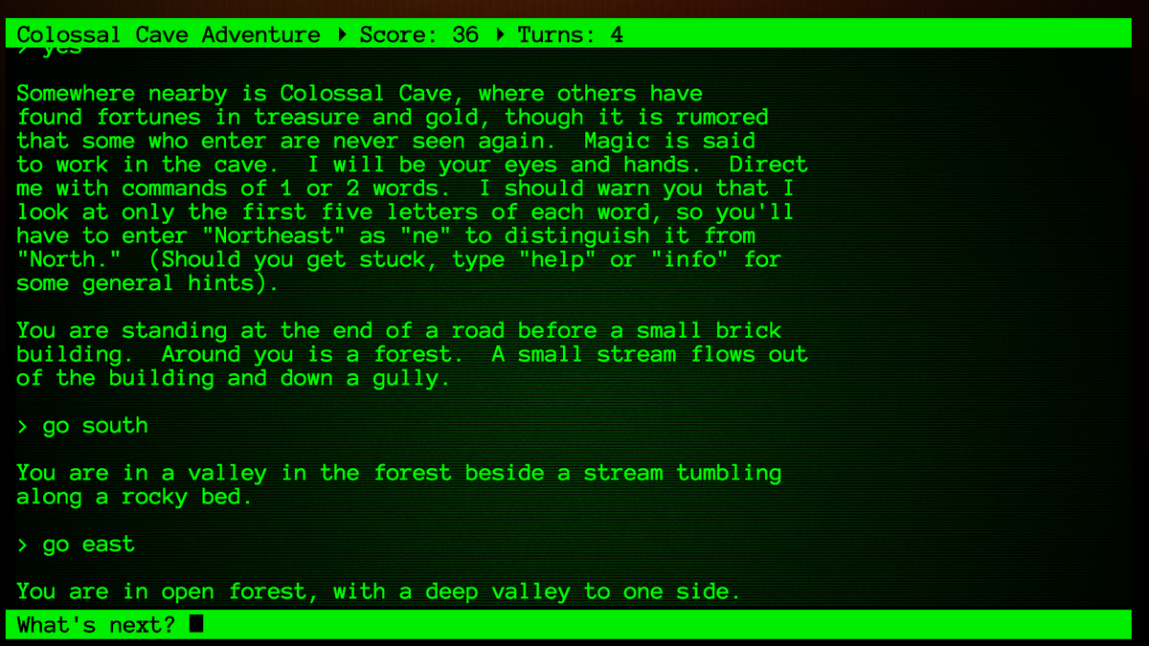

**Figure 1: A screenshot from a modernized ADVENT interface. Ackerman 2017**

ADVENT (or Colossal Cave Adventure) (1976), considered the original basis for the development of these games, the game is based in a fictional cave system where the player is able to interact with the world by entering one or two word phrases that help them navigate and change their position in the game world. Because it is entirely in text, the game highlights what the player can do next by detailing what they can see. Each object that is mentioned in these text descriptions provides the player with new bits of information. For instance, the description of a destination can be used a landmark for plotting the player’s travelling through the world. A description could go like this:

“You are standing in a field. A river flows towards a forest of oak trees. A single oak tree sits on a hill.”

This example does not detail any directions, but if the player was to go towards one of the three locations described, it would lead them in a direction. Alternatively, with Colossal Cave Adventure, the player can enter “go north” or “go south” and it would also take them in the relevant direction. Environments are further populated with items that can be interacted with, like picking up pieces of gold or water and food. The environment within the cave that the player explores is based on a real cave, but has fictional elements involved like the gold and treasure that the player needs to find. This game fulfils all of the criteria set out by Montfort, it accepts and generates text, contains a narrative that the player can interact with and simulates the world with structure, providing clear “lose” and “win” conditions that the player can happen upon.

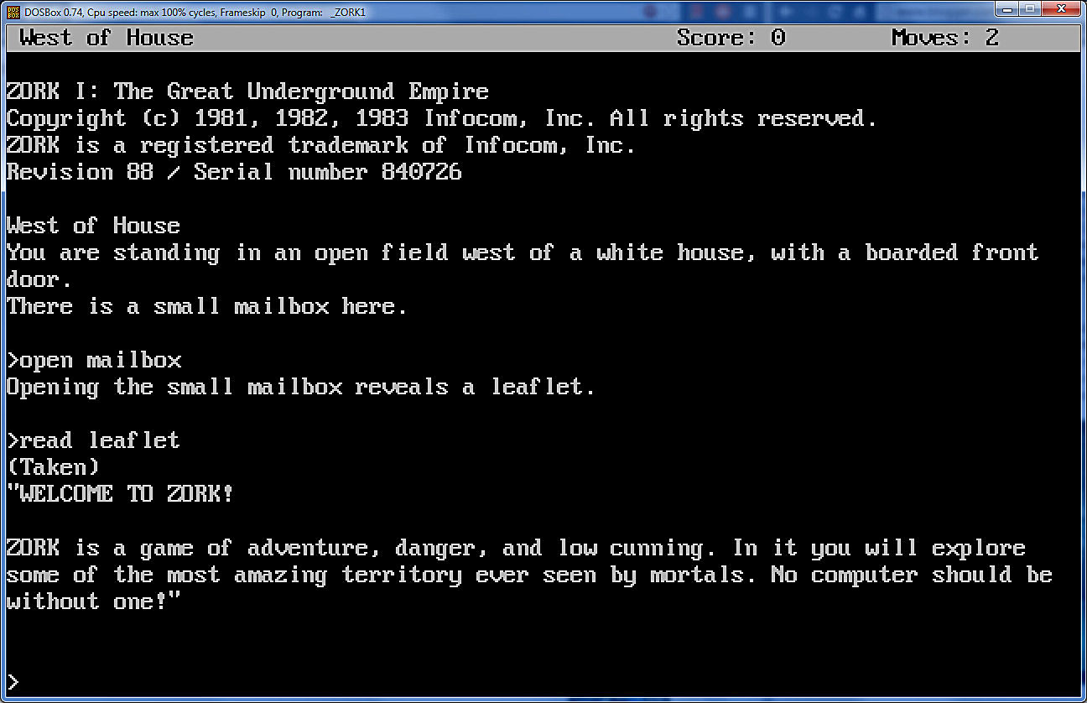

**Figure 2: An emulation of The Zork I, showing the expanded parser and layout. Morena 2016**

The Zork (1980) is a series of Interactive Fiction games set within a completely fictional world unlike ADVENT and contains multiple ‘dungeons’ for the player to explore. Each entry in the series follows on from the end point of the previous ones, relying on a consistent narrative between each. The advancement of Zork over ADVENT would be the improved understanding of the text-parser used. This allows the player to enter longer sentences than previously allowed within ADVENT, and through this could “have more personalized experiences” (Pucillo 2020)

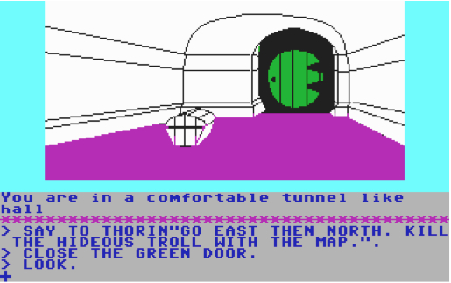

**Figure 3: The Hobbit, showing both the graphical and text elements. Stuckey (no date)**

A third Interactive Fiction from the older generation of games would be The Hobbit (1982) is based on the book of the same name and makes use of illustrated images to compliment the narrative descriptions of environments to provide a clearer image for the players imagination. The game however, does not closely follow the story of the book, as important characters like Sam and Pippin can be killed through accidental actions, Gandalf can be found randomly wandering the world and the chosen main character can kill Frodo, take the ring and wear it, very clearly not an occurrence in the book. To allow this to happen within the confines of the game, it made use of an advanced parser and assigned game rules that defined different character traits for all of the NPCs.

Looking at these examples of early IF, the following ideas can be gathered:

* Emergent gameplay is still possible despite the inherently limited application of gameplay
* Clearly defining the game world will aid to the development of the narrative

#### 2.3.7 - Modern Interactive Fiction

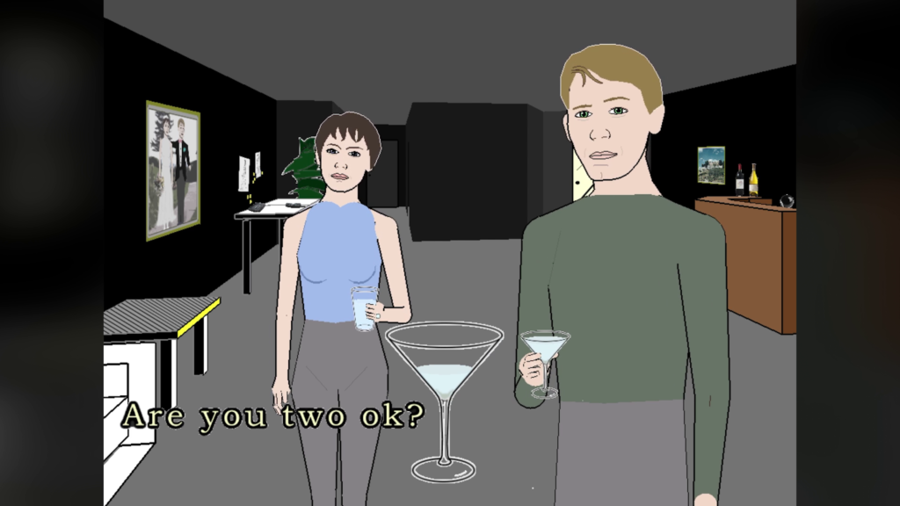

**Figure 4: Façade, demonstrating the art style used and the implementation of text. Thompson 2020**

Comparing the previously mentioned game, Façade (2005), to the rules defined by Montfort, it follows the formula closely, but not definitely. When interacting with the game, the player types in text, but it does not respond with text, rather pre-written and voiced lines by the two characters the player interacts with. The narrative is defined as the story told within the game, which in the case of Façade is the relationship between the two aforementioned characters. The world is fully simulated, as the player can interact with items and objects that are within the apartment of Trip and Grace, with them making quips about what the player interacts with at the time. And it follows a set of rules beyond this within the game itself, shown by one reoccurring theme that if the player says “melon” at any point, they immediately lose the game. Façade’s presentation of these rules show that an Interactive Fiction does not purely need to be text-based as the output of text can be through speech as well.

What Façade lacks in impressive rendering of the environment, it makes up for in complicated routes to follow, with a variety of endings that can be discovered that dictate the relationship between Trip and Grace. It’s minimalist art-style compliments these elements greatly and show that Interactive Fiction does not need to be graphically impressive. Façade is made mention of in the paper by Douglass (2007), which he deemed a “culmination of a radical departure from IF in many ways…” and detailed that many of the features used to present the narrative of the game are subverting the ambiguous nature of IF until this point, as they relied on heavy narration and player imagination, whereas Façade graphically presents what the player sees, removing the element of narration.

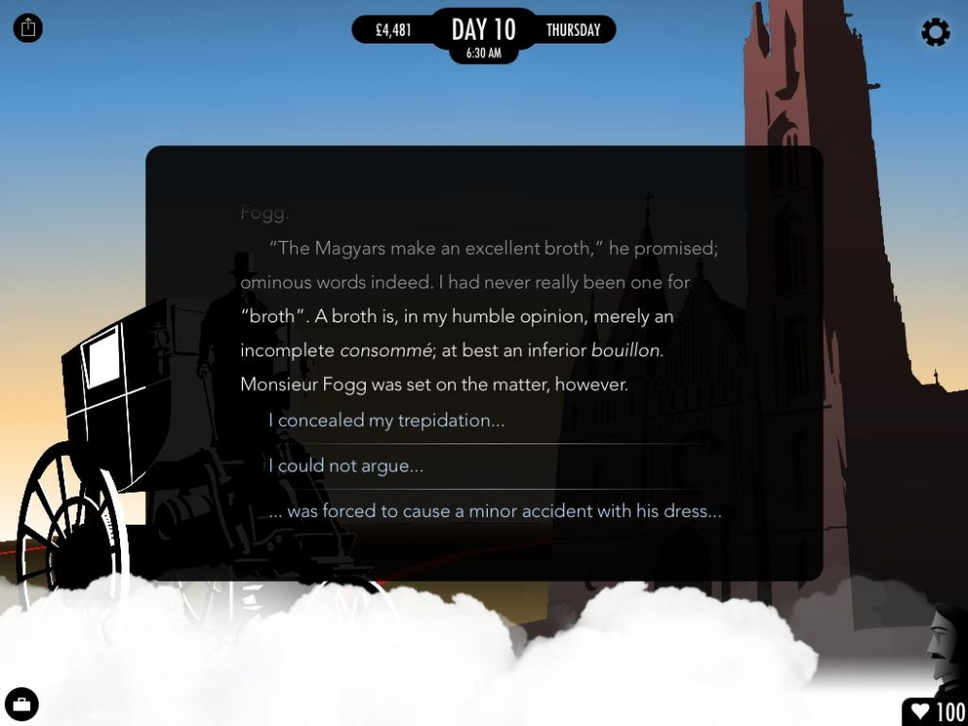

**Figure 5: 80 Days, a screenshot demonstrating the text choices made in game. Hartup 2015**

Alternatively to that of Façade, 80 Days (2014), it presents itself with generous graphical representations, and boasts a variety of potential playthroughs, “The challenge lies in choosing the fastest, most efficient route across the world before the eighty days are up,” (Kelly, no date). Unlike the previously mentioned rule for Interactive Fiction, where it accepts text and generates text in return is not applicable to this game, as it has text choices for the player to pick, rather than the player actively typing into a command line. The narrative for the game is actively produced as the player picks the routes that they take across the world, making up for the lack of freedom with inputs, represented through the freedom of choices. The game has defined win and loss conditions, where the player will lose if they are unable to make it around the world in 80 days but win if they are able to manage it.

Fallen London (2009) is a third Interactive Fiction that operates within the rules presented by Montfort but does not follow them entirely. As a mode of presentation, it does not generate text through player interaction, but instead makes use of ‘cards’ that are pre-written that have text-based choices for the player to pick which link to other cards to develop a unique player story. Besides this exception, in a similar way to 80 Days, it provides a world for the player to explore and uncover but does not have explicit “lose” and “win” conditions to it. A player makes their own decision for when they have “won” or “lost”. Fallen London makes use of a common RPG mechanic, statistics. As the player picks their choices in the cards, stats will increase and decrease, allowing new options to be picked and providing a variety to how the player interacts with the world. The entire world it is set in is a fictional rendition of Victorian-era London, with hints of Lovecraftian horror, which holds unique ways for the player to drive the narrative.

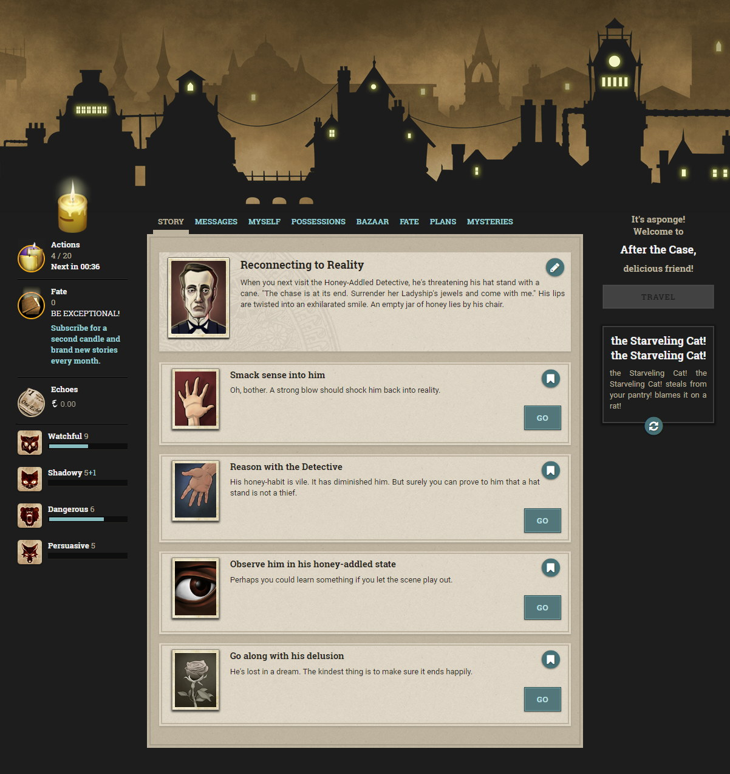

**Figure 6: The web browser interface for Fallen London, depicting choices for an event the player has encountered. O’Connor 2018**

#### 2.3.8 - Observed Principles of Interactive Fiction

Looking at the examples of Interactive Fiction, a few principles that are common between them, and that are applicable to a game about the Turing test, can be seen. A universal concept particularly seen in modern entries in the genre is that they do not need to follow the presentation formula to be considered an Interactive Fiction, but other applicable principles are:

1. There are a set of rules that *can* be followed when developing and designing an Interactive Fiction. But do not need to be followed strictly.

This is most definitely seen within Fallen London and 80 Days, they loosely follow the structure of an Interactive Fiction by giving the player a limited ability to interact with the world, but the ways in which they present this and allow the players to constantly change their experiences lend well into each other. It also shows that not every standard set for the genre needs to be adhered to, as neither has a need for a text parser but gives an authentic experience that using one would also provide.

1. The presentation style of an IF is not important unless it helps drive the gameplay forward

From ADVENT to The Hobbit, in the span of six years the difference in technological potential is vastly clear, just from the presentation alone. As ADVENT and The Zork both used command lines to deliver their text, it left a lot to the imagination. However, with The Hobbit, and further developments within the genre, the ode of textual immersion lessened. Comparing figure 2 and figure 3 shows this clear difference immensely.

Further to this, comparing figure 1 and 2 to figure 4, the difference is stark. Both in how they present text, as Façade does not clog the screen with text outputs, and the allowed fidelity. Even though Façade has a 3D environment, the focus is not put on this and is instead on the NPCs the player interacts with, this is reflected in the abstract style used to create the assets of the game. With the older titles, it was strictly displayed in text, and misinterpreting this can reduce the players enjoyment.

#### 2.4 - Video Games that discuss the Imitation Game

|  |  |
| --- | --- |
| Name of Game | Brief Description |
| The Turing Test, 2016 | The Turing Test is a puzzle platformer in a similar vein to the Portal series and sets the player on an abandoned base on the surface of one of Jupiter’s Moons as they attempt to figure out what happened. A main idea that is represented through the gameplay is how a machines sentience may impact its decision making. |
| Detroit: Become Human, 2018 | Detroit: Become Human is a story rich game that tackles the idea of what happens when machines begin to think. Set in a world were wide-scale android creation is feasible, it swaps the players perspective between three characters, and gives the player many opportunities to change how the story ends. |

**Table 2: A table with the games discussed in this section. A brief description is provided for both.**

The Imitation Game is not a widely explored idea within Game Development, as a cursory glance of Steam, a platform for selling and distributing games on personal computers would suggest that very few games draw direct inspiration from it, as seen by the results in appendix G. The use of the test as a driving force for a narrative is also only used in a few outlets, two large-scale examples being Detroit: Become Human and The Turing Test.

#### 2.4.1 - The Turing Test

The most prolific game media that is based on the Turing Test is a game of the same name “The Turing Test” (2016), it is a first-person puzzle game developed by Bulkhead Interactive and published by Square Enix. It is set in a sci-fi world and explores the concept introduced within the discourse of the theories created in Turing’s paper, discussing the point that for a machine to be considered “self-aware” and exhibit human thought, it must ‘lie’ to its creator about its state to pass the test. The lead designer of the game, in an interview said, “For a computer to claim it is a human is either a lie or a delusion. So, a truly self-aware (and honest) machine would admit it was a machine?” (Byrd 2016). Which is an interesting standpoint to take in relation to the Test, especially due to the academic opinion of those like Searle, who believe that a machine designed to pass the test is not truly self-aware.

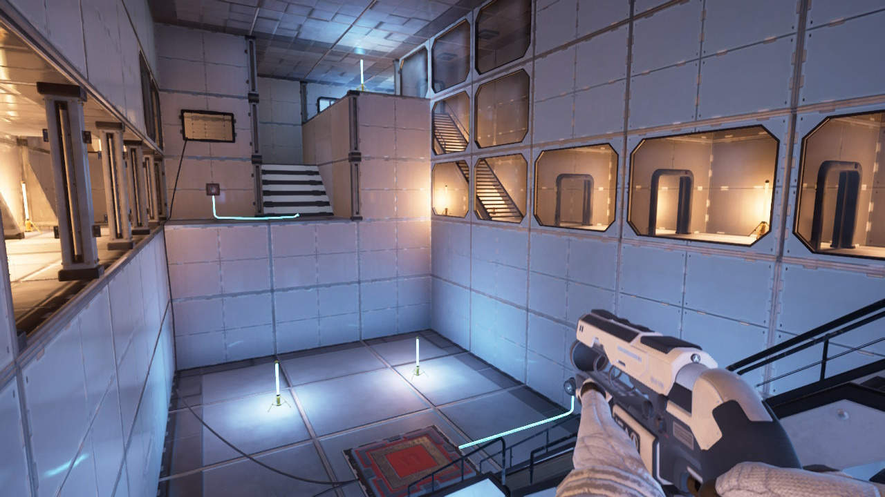

**Figure 7: A room within The Turing Test, the puzzles make use of the entire room. Heaney 2020**

Many of the puzzles within the game make use of 3D space and applying additional levels of complexity as the game progresses. To begin with, the environment only has certain switches to activate by moving power sources around, but eventually add magnets for moving power blocks over obstacles, switches that flip signals around and multi-level platforming. The user of puzzles, and forward-thinking deals with the issue that is inherit with a machine being brought to a human’s level of thought, that in some situations they will always lack the forward thinking and cognition that a human has. While not directly related, the theory behind Deep Blue, a computer created specifically to play chess (Anderson 2017), to the computer, and all chess player inherently, each piece on the board has a specific cost. This determines the worth of sacrificing and trading pieces, but during Kasparov’s matches against Deep Blue, the computer made an unexpected move, “white took advantage and created a new attack by sacrificing a knight.” This advantageous move that won Deep Blue the match was only done due to a bug within its programming, meaning that if it had been working as intended, it would not have won against the grandmaster. Returning this to The Turing Test, the reliance on cost value associated with actions limits the abilities of a machine, especially when the value of a piece or action is not presented upfront.

#### 2.4.2 - Detroit: Become Human

Detroit: Become Human (2018) is a narrative driven adventure game wherein the player takes the role as three androids, and through their actions shape the story. Similar in vein to an Interactive Fiction without the simulation of a world and freedom to interact with it as the player sees fit, the game provides a variety of choices when interacting with other characters that gives the player a number of endings to try and achieve. A main principle of the story is the perceived intelligence of the androids that have been mass-produced to subserviently act for their creators, and a re-occurring idea is that the androids are in fact capable of free-thought, but are unable to do it unless provoked and freed of their limitations.

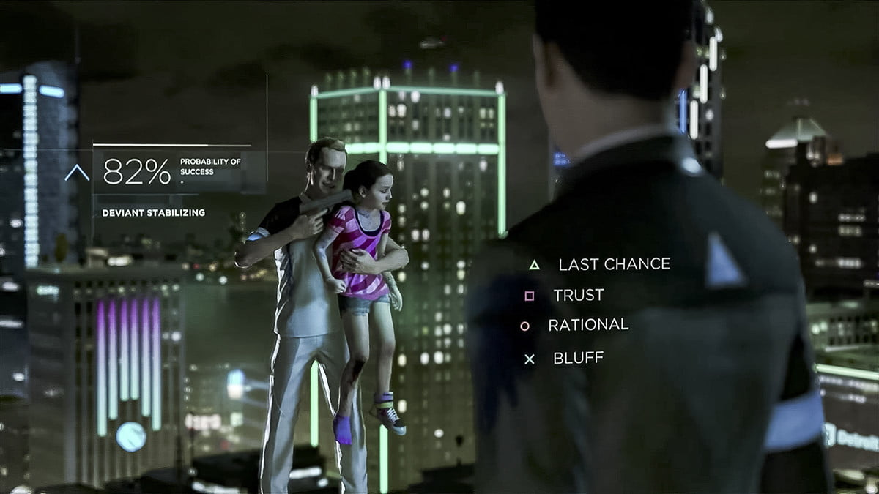

**Figure 8: The beginning scene in Detroit, where the player must rationalize with a “deviant”. Fulton 2018**

The three characters that the player acts as show three separate situations in which this freedom occurs, for Connor, an android created to assist in crime-scenes and tasked with tracking down ‘deviants’ as they are called, his endings either see him become a deviant through his interactions with other androids as an influence, or continue to be subservient, with the next line of androids being created in his image and architecture. For Kara, she becomes ‘deviant’ willingly to save the child Alice from an abusive father, and her story ends either being gunned down or sent to an android destruction camp or making it safely to Canada where they can live normal lives. And Markus, an android forced deviant through no choice of his own, who’s story ends as either a martyr for the deviants, sparking a war between deviants and humans, or peacefully ending the use of androids as servants, giving them their rights as free-thinking humans would. These portrayals of the three protagonists each have their own meanings behind them, but the one most relevant to the Turing Test is Connor’s story.

As part of the story, Connor goes to the original creator of the androids, and is put through a test. To acquire the information about deviants, Kamski presents Connor with the choice of shooting another android, where he will be told what he needs, or leaving with no information. It is a loophole, if Connor kills another android for the information, then he has shown that he has free-will and is capable of defying protocol (not to kill others, especially since he has no evidence of deviancy), but if doesn’t kill her, he’s breaking his protocol of gathering information about the deviants no matter what it takes, and showing signs of empathy, a key factor emotion that deviants show. It is purposefully presented this way as it drives the narrative forward for Connor to question what it means to be deviant, and to also drive dialogue with Hank, his partner. Overall, it presents an interesting scenario related to the decision making involved with machines.

#### 2.4.3 - Observed Principles of Games About the Turing Test

By looking at both of these games, it shows the different ways in which the Test can be interpreted and presented. In the case of The Turing Test:

The test is portrayed as precisely what it is; a test for the player to complete. The different levels of the game are set up to continuously challenge the players thinking so they can progress, while also scattering pieces of the narrative in between to provide a story for the player to immerse themselves in. The use of multi-level complexity puzzles presents the importance and difficulty that the test can contain, as not ever question posed towards a participant will be straightforward due in part to the level of thought it is trying to invoke,

Whereas with Detroit: Become Human, the test is used to tackle social and ethical issues that come with the use of Artificial Intelligence and the over-reliance of machines. It directly challenges the idea of a thinking machine, and the possible pros and cons if machines were to ever think like humans. It can further be broken down to show the observed effect that player choices can have on a story, and how showing the impact of these choices further immerses the player within that world.

Both of these games focused on the idea that the character(s) exhibited human thought, which is an integral concept within the Turing Test itself. They each approach this topic in a separate manner, with Detroit doing so through dialogue and player interaction, with clear consequences, whereas The Turing Test approached this idea through multi-level complexity puzzles that required both guesswork and rationale.

#### 2.5 - The User Experience

In the article produced by Phan, Keebler & Chaparro (2016) “user experience” can be split into four distinct categories: engagement, immersion, presence and flow. The two categories that are the most important in delivering the product are both presence and flow. As the product is made as part of a student project, being able to immerse and engage the user in a way similar to a triple A title like Detroit: Become Human would not be possible. However, the information provided by this article is still applicable to game creation. The discussion of user experience is very important when creating a video game, as mentioned by Padilla-Zea, Sánchez, Simarroa, Vela (2011), where they have stated that systems within video games are designed to “exploit” the emotions and feelings of the players to ensure that the experience is fun. This further reinforces the findings of Phan et al, as the four identified categories are different avenues for leveraging a players emotional state.

Flow is, as defined by Phan et al, the underlying mechanisms of the games enjoyment and engagement. With regards to Interactive Fiction, the “flow” of the game would be the natural interactions that it solicits the players with. Being able to look at a description and easily identify what can be done next would be considered the flow and using this makes the game more enjoyable. Flow can be disrupted however, poorly designed puzzles and including intermittent overlays will interrupt the natural flow that a player will take, meaning that a clear idea for the gameplay loop must be devised, and then logical steps within the game should be created. While this slightly contradicts the ideas of the project, of which meaning that the best way to tell man and machine apart is through the lack of logical steps, some clarity must be present in the game otherwise it will be impossibly hard.

Conversely, presence is defined as “the psychological experience of ‘being there’”, this would be similar to engagement, wherein the difference is that being engaged with the world is not the same as thinking you are actually there. This is another difficult idea to replicate with the user design of an Interactive Fiction, as the main way to interact with the game world is the least interactive way of “entering the world”. The existence of both presence and flow within a games narrative would greatly improve the user experience, as they both lend well into the other.

Applying this to the game, there will have to be some elements of the user experience that are not focused on. Specifically, immersion and presence will not entirely be possible. These would require the use of sound, cinematic effects and more advanced modelling techniques which are not available. This does not, however, mean that user experience will be cast to the side. The flow of the game will be prioritized over the implementation stage.

#### 2.6 - Conclusion

This chapter has looked at and discussed a variety of topics that will be used in subsequent chapters to design a game. The main topic of this game, and the beginning section of the chapter is the Turing Test, and how to apply its principles to a game while not trying to create an actual imitation game to test machines with. Principle 1 in section 2.2.4 will serve as a major influence for the games design and flow, as it provides the framework for the games perspective.

To further produce these ideas, a variety of Interactive Fiction games were analysed to understand the key elements of the genre such as principle 1 in section 2.3.8 which acknowledges the specific rulesets applied to the gameplay of an Interactive Fiction and how they do not have to adhere to a specific level of integration. And that other games that also use the Turing Test as a topic within their gameplay have been observed to the same extent, with a discussion on the use of social and ethical issues within the game and how the game goes about presenting that to the player.

User experience was also discussed in this chapter, which is an important piece of theory required for creating games that are designed towards immersing the player. Discussed therein was also the topic of gameplay flow, which will be heavily considered in the design of the game.

### Chapter 3 – Product Requirements

#### 3.1 - Introduction

One of the topics that has been discussed in the literature review is the changing expectations of a video games, the change from command lines to 3D environments means that the concept of an Interactive Fiction game needs to integrate that into an environment that reacts to what the player does. Further to this, the game also needs to reflect the ideas discovered and discussed in the literature review, this chapter will develop those ideas into a game concept, so the design is structured. The requirements of the game will also be discussed, which will be separated into functional, non-functional and usability-based requirements.

#### 3.2 - Design Ideation

The analysis has provided a number of principles that can be used when designing the game, but there is still a requirement for a base design idea to create the game around. There are a few concepts that are relevant and can be taken directly from the literature review which would be usable for an interactive fiction:

* The Turing Test, and a way to portray this from the view of a participant.
* Any puzzles involved should not require high-level education, they should only rely on cognitive thought and problem solving.

The following concepts will not be included:

* Social and ethical concerns of the test
* Any direct critique of the test
* Direct feedback cannot be given in game while the player is trying to solve any of the puzzles, and the only occasions where it will be provided is if the player triggers a fail.

The breakdown of the test provided in the analysis shows that there are two potential perspectives that the game could take place in, either that of the observer, or a participant in the test. Because many of the Interactive Fictions that have been looked at involve some element of puzzles, the participant role seems the most appropriate for the game. Due to emphasis on in-the-moment thought, the game won’t have a requirement of higher education to play and will instead focus on decision making and their consequences. However, there should still be a level of difficulty presented to the players to mimic the almost impossible to achieve standards of an observer to the test, and this should be reflected through the puzzles.

#### 3.3 – Requirements List

The varying designs and literature review have provided a better understanding of what the product will require from the devices used to create it for it to be a working Interactive Fiction. These include:

* **Text Parser**

Being able to read the text entered by the player is a key feature of Interactive Fiction games as it is the only way for them to interact with the world. The chosen engine or platform for creating it does not require a text parser built into it, as it is possible to create a similar function with object-oriented programming.

* **An Object-oriented Programming Language**

Object-oriented programming is required for the feature to “inherit” between objects within the product.

To test the success of the product in meeting these expectations, a questionnaire will be provided with a copy sent to participants. The participants are required to own:

* A computer
* Enough spare time to play the product three times, or if they complete it
* An understanding of how Interactive Fiction games work

As part of the participation testing, a questionnaire will be produced that uses qualitative and quantitative questions to get a reliable amount of information to evaluate the product on.

To further understand the requirements of the system, and what is a definite requirement for the game, table 3 contains a comprehensive list of all of the requirements, which priorities them on the MoSCoW ranking method, which is Must have, Should have and Could have. For some of the requirements, they require a longer explanation, and this has been done in section 3.4.

|  |  |  |  |
| --- | --- | --- | --- |
| Requirement Type | Requirement Number | Requirement Details | Priority |
| Functional | 1 | Text parser  The text parser needs to handle a variety of commands that will be fed to it by the game. It needs to understand which elements of a phrase are important, and use them to drive the gameplay loop. | Must have |
|  | 2 | Interactable environment  To modernize the genre, the environment needs to actively reflect what is happening in game. Be it picking up an item, or moving something, this needs to work in tandem with the text parser and outputs so that the experience is seamless. | Must have |
|  | 3 | Failure states  To maintain integrity as a game, it should have a section were the player can fail. The lack of a fail state makes it less interesting for the player | Should have |
|  | 4 | Text Inputs / Outputs  There needs to be a dedicated format for acquiring inputs, processing them and then outputting to a window. The inputs will be handled through the parser, but a separate element of the UI is needed for the outputs. | Must have |
|  | 5 | The system will track the progress of the player  By using variables, the system should be able to tell where in the game the player has reached, and react accordingly | Should have |
|  | 6 | Timer | Could have |
|  | 7 | Abstract Inheritance based classes  Using abstract inheritance, “Polymorphism” can be used so that the text parser is universally applicable to objects in game. | Should have |
|  | 8 | Multiple Routes  The game could have different solutions to the puzzles, so there is more lenient ways for the player to solve them, instead of it being specific commands that need to be entered. | Could have |
|  | 9 | High Variety of interactables  To make sure that the experience is interesting, each object within the game world should be unique, and have a certain use within the puzzle. As opposed to copying certain items multiple times, it means that inheritance can be used for the sake of polymorphism by having an abstract superclass | Should have |
| Non-Functional | 10 | 3D environment  The environment does not necessarily have to be 3D, but doing it this way makes it easier in certain game production engines. | Should have |
|  | 11 | Menu system  A basic menu system for navigating, includes a pause and main menu. Not required during developer testing, but should be done before sending to participants. | Should have |
|  | 12 | Dynamically created text outputs | Could have |
|  | 13 | The game can output a text document at the end  This would be an easy way to observe how the game has processed the commands entered during the testing and questionnaire elements of the project. | Could have |
|  | 14 | Sounds  The environment could be brought to life through the use of sounds that play whenever something happens. It would add an extra layer of immersion. | Could have |
|  | 15 | General Playtime  Not directly linked to the timer, the general playtime is the longest length of time required to play a game all the way through. The longest amount is considered the average as there is no way to tell what skill or knowledge level the player has, and this cannot be presumed. In terms of puzzle solving, this factors in the time to understand how a puzzle works, and what the potential solutions could be. This would be roughly 10 minutes for this game considering the level of planned complexity. | Should have |
| Usability | 16 | User friendly UI layout  The layout needs to conform to UI standards, such as keeping information in the correct sections of the screen, the player doesn’t want to look at a UI that is scattered so when they enter a command they have to look at a different side of the screen to see what happens. | Could have |
|  | 17 | 3D interaction | Could have |
|  | 18 | Save System  If the game were to involve multiple paths or routes, it might warrant a save system so that the player doesn’t have to constantly redo sections they have already cleared. | Could have |
|  | 19 | Models  Models can be used in the 3D environment to match what happens in the world. This will initially cover the creation of models for the individual objects, and then will be expanded to environmental entities like the walls of a room or a door. | Could have |

**Table 3: A list of requirements that are expected for the product. Some have details listed with them, while a few others are detailed further in section 4.4**

#### 3.4 - Expanded Requirements

This section serves to expand upon some of the requirements that are ambiguous in their wording.

* Requirement 12 - Dynamically created outputs

This requirement takes inspiration from the paper by Montfort et al (2007), which discusses the dynamic creation of outputs in relation to the players interaction. A decision that must be made when creating the narrative of the game is to decide how much detail will be provided whenever a player tries to do something. In the circumstance where the discourse is entirely based on the players attempts to interact with something, outputs need to reflect what the player has entered.

This leads into the idea that with a text parser, it is possible to identify certain elements of an input, meaning that these can be used to both interact with the world, and create text outputs based on what is happening. This requirement is marked as a “should have”, as the focus for development should be on making the game work as intended, then going through again and adding non-functional and usability requirements.

* Requirement 17 - 3D Interaction

The game façade is a good example of blending both a 3D world and the text inputs of an Interactive Fiction, but it also contains other details which may help the player immerse themselves should they be used as inspiration.

One element that has not been discussed so far with the game is the ability for the player to click on an object in game and pick it up. Sometimes, Grace and Trip comment on what the player is holding, or they ask the player to fetch an appropriate item. Even further to this, it can cause entire dialogue trees to be unlocked, such as holding a magic 8-ball and sparking an argument between the mentioned characters.

Applying this idea to a game which is more puzzle focused, this could result in interesting applications for said puzzles, such as looking at a book and having to go through pages or holding an item and rotating it to find a secret. These could both feasibly be implemented to work with a text parser but are not fundamental requirements and have been prioritized as such.

* Requirement 6 - Timer

Implementing a time limit will apply pressure to the player to make snap decisions, doing this makes it more likely for them to explore more vague lines of interaction, and will add tension to the entire scenario. It also encourages the player to try all possible combinations to solve the puzzle. Using a constraint will also give the player a chance to reflect on what they have done to reach the spot that they have. In subsequent plays, they will be able to complete earlier sections faster and tackle more complex sections of the puzzle. While this does not accurately reflect the third finding in relation to the literature review of the Turing Test, the product is still a game, and without a clear fail condition it would not be considered as much.

For a game to be considered as such, fail conditions are required otherwise there would be no reason to succeed. In the games discussed in the literature review, many of them have conditions for failure, such as Detroit Become Human having multiple endings that have a range of “success” in what occurs, or that the player loses the game 80 Days when they fail to make it around the world within the time limit.

### Chapter 4 - Tools and Techniques

#### 4.1 - Tools Introduction

To create the game, there are a variety of tools and platforms that are available for game development that can be used. This chapter discusses both the potential tools for creating the game and its assets, as well as the techniques that will be used during the implementation. The discussion about appropriate tools will discuss a range of applicable engines for game development, which are listed in table 4.

By the end of the chapter, a decision on the most appropriate engine will be made and documenting the implementation will begin.

#### 4.1.1 - TADS (Text Adventure Development System)

One of the more prolific IF specific creation tools is called TADS which is based on C++ and Javascript. It allows for graphical, audio and animated elements within the games produced by it, making it much more suitable for presenting the environment with the product instead of other IF creators that are simplistic. However, the most recent version of TADS that has been released was last updated in 2013, meaning that it is out of date in terms of how modern the technology involved with it is.

#### 4.1.2 - Inform 7

Inform 7 is another language used in creating Interactive Fiction, which also has use in writing and prototyping (Inform, 2019). It uses native English language programming as a means to tell a story. For example, in a language like C++ the statement:

If(x < playerScore){

Return win;

}

Would appear in Inform as:

If the player has a score higher than 10:

Say “the player has won.”

It uses predefined statements and nesting in the creation of scenarios which makes it easier for those who lack programming experience to use but means that it is not appropriate for the product. However, the documentation provided for using it does give insight into how objects should be considered in the chosen language, for instance, section 11.3 of the documentation is titled “Pattern Matching” and gives a few examples like “To admire”, “To slam shut” and “To grant” which are used to respond properly when one of these phrases is used. Looking at it this way, it helps clear up the requirements for creating a text parser.

Additionally, Inform 7s last official Microsoft update for their program was released in 2015, meaning the technology involved, along with TADS, is now older making other tools favourable.

#### 4.1.3 - Twine

Twine is a less complex version of TADS designed to be accessible to creators who aren’t well versed in coding but are interested in creating an Interactive Fiction. This is not an option when it comes to the complexity of the chosen software for creating the product, as the base program does not require coding, only extending the possibilities through added code. Twine works by giving the creator using it tools to link together sections through keywords, such as the following example:

“The book hit the floor with a clatter. Lying in the disturbed dust next to it lies a quill.”

Book -> “The book is old and worn, it’s pages are faded. In the centre of the book is a carved square hole.”

Dust -> “The dust is thick against the metal floor. It has not been disturbed in a long time.”

Quill -> “A feather that once belonged to a bird, now repurposed into a writing implement.”

In a game created with these examples, the player would be able to click the underlined text to go to the related text boxes, or scenarios. This method of Interactive Fiction creation is more akin to a ‘pick your own adventure book’, as it relies on fixed ways to drive the story forward. For an Interactive Fiction to properly emulate the genre, it needs to be fluid and unpredictable in how to advance.

#### 4.1.4 - Unreal

Following in suite of Façade, a detachment from tradition could be done by using a game engine like Unreal, which uses C++ and a ‘blueprint’ system. When combined together, the engine can be used to produce impressive game programs. With the tools available, creating a parser within Unreal does not seem to be a difficult concept. Besides this, the graphical representation of the environment would lessen the requirement for narration. The blueprint system is considered a “Visual Scripting System” (Unreal Engine, no date), which holds the complexity of coding in C++, but through a more visually simplistic method, as it removes the need to scroll through lines upon lines of code.

Unreal has an attached marketplace. This is used for sharing and purchasing (in some cases free) assets for use within the engine. This is useful for projects that are focused on the coding aspect of game creation, or wherein the access to asset creation is limited. However, this project will make use of narration to supplement lack of graphical presentation, and graphical presentation where narration is lacking. The use of Blender, a free and open-source application for creating 3D models will be used wherever possible instead of using the marketplace, as the requirement placed upon the modelling work is not as important as developing the program.

In addition to the blueprinting system previously mentioned, Unreal allows the user to fully code in C++ as an alternative, or to swap between the two development types at a whim. This means, for the product specifically, that it can be done in both, using C++ coding directly when required for more complex scenarios, and using the blueprints for simplistic things like objects within a scene or making the camera move when required. Being able to swap to direct coding also means that the creation of a text parser is more viable in the engine, as if it was solely fixed to using blueprinting, it would be difficult to create a system for reading the players keyboard inputs and then interacting with the parsed strings from it.

A key factor in deciding which platform to produce the game on in addition to the complexity of the language used is the suitability for creating Interactive Fiction games on. While there have been applicable platforms discussed so far, they lack the relevant programming knowledge required to use, which primarily leaves Unreal and Unity as suitable choices. This presents a new issue however, as they do not natively support games that are run through a command line or text box. This will prove to be a large point of the development cycle and will be a difficulty in modernizing Interactive Fiction as a genre.

#### 4.1.5 - Compiling Findings

|  |  |  |  |  |
| --- | --- | --- | --- | --- |
| Engine / Platform | License / Subscription Required | Language | Relevant Features | Suitability |
| Unreal | No | C++ | * Blueprinting – A form of visual programming. * Combining blueprints and prefabs provides an easier method for populating a scene. | Makes use of an appropriate language.  Personal experience is greater with Unreal. |
| Unity | No | C# / Javascript | * Suited for Mobile and Web Development. * 2D games are preferably made in Unreal. | ‘’ |
| Twine | No | CSS / Javascript | * Simple – Knowledge of coding isn’t required. * Games are laid out like a flowchart, making it easier to understand the connections between scenes. | Too simple in terms of language used. |
| Inform 7 | No | Inform Natural Syntax | * Using natural language syntax makes it simpler to write. * Ability to create new “phrases” within the code and define how they work – similar to functions. | Inform is an old language and doesn’t fulfil the required complexity. |
| TADS | No | TADS (resembles C++) | * IF produced using TADS can be played on websites. * Has a pre-written object library. * Using the pre-written objects removes the need to account for all possible actions. | Language requirement fulfilled but latest release is old. |

**Table 4. Summary of Tools and Technique Section**

Unity serves as a rival to Unreal for the sake of determining which engine to use. The features mentioned in the table are the ones relevant to an IF, and both have a variety of features beyond what is mentioned which may find use if picked. Overall, the platforms specifically created for designing and making IFs do not fulfil the requirements set for complexity, they all lack suitable factors when compared to Unreal and Unity, however, looking at them does give a good understanding of what is required when designing the product.

Out of the two, my experience is greater with Unreal, heavily influencing the decision to pick it.

#### 4.1.6 - Asset Creation

A separate decision to make is the source of the models used within the game. While they are available on the Unreal Marketplace for a variety of prices, and fidelity, they can also be created with 3D modelling programs. One of the options for this that is easily accessible is Blender. Through a use of online tutorials and documentation, it is possible to use Blender to produce simple, low poly (a term used for models that have a low polygon count, thus requiring less computer memory to render) models to use in Unreal. High-quality models are not required for this project, and thus a small amount of time has been dedicated to learning the program.

Appendix H contains screenshot examples of the models that have been created in Blender using the “low-poly” aesthetic.

#### 4.2 - Techniques

There are two methodologies that best suit game development, these are agile and waterfall. But, the difference between them can cause some confusion about which is the most appropriate for a project. Agile methodologies break an entire project into phases so they can be done independently and with room to return to a phase should the work not be sufficient, whereas the waterfall methodology uses a static workflow, moving on from one phase to another despite the state of the work.

The agile methodology is the most common one used within game development (Aleem, Capretz, Ahmed, 2016), and allows for iterative development upon sections of the game. Using this method, there are clear goals set before beginning the work associated with a stage of the development and makes it easier to evaluate the progress made so far so that further decisions can be well informed.

The use of waterfall methodologies was seen the most following the game crash of the 80s (Kanode, Haddad, 2009), where it was used in response to iterative models failing to operate properly with the increased requirements of games and technology for the time.

Because of the ease of use, and fluidity involved, the agile development methodology has been chosen. This methodology will provide a lot of opportunities to discuss the changes made to the system throughout the implementation. If I was to use a technique like the Waterfall methodology, it would be a more linear programming process which would not provide much time to account for errors or required changes that the design of the product did not predict.

Designing the game around an agile development also means that the program is more likely to be decoupled. As work can be carried out regardless of previous sections, there is less likely to be a dependency on this potential work that would create errors later on.

## Synthesis

### Chapter 5 - Product Design and Ideation

#### 5.1 - Introduction

The product design chapter covers both the designing and implementation of the product within Unreal engine. The first section discusses the ideas mentioned in chapter 2 and uses them to produce a vision for what the game will be. Then, this chapter goes over the designs for the interface, and base diagrams that will be crucial to implementing the game in Unreal. Further to this, section 5.5.6 uses storyboarding combined with the designs to provide a more solid version of vision produced in 5.2.

#### 5.2 - Main Vision

The principles and ideas discussed in chapter 2 provide a lot of details that can be used to create a scenario that is applicable to the game so that development of it can be properly planned and the requirements can be carried out.

The main concept of the game should let the player interact with the world from the perspective of a participant, as this position in the test easily falls in line with the other principles in the literature review, it gives the player their main goal of solving the puzzle that is created. Creating a puzzle that uses a 3D environment, along with the integration of Interactive Fiction principles will be the main focus for the presentation of the game, and will use these elements to create the puzzle aspect inspired by the Turing Test.

Due to the players perspective, it would make sense to isolate them within a room in the game world with no clear way out, and to have all of the elements of the puzzle to be kept within this room. The natural flow of the game will see the player complete a number of cognitive challenges so that they can successful clear the puzzle, with leaving the room being considered a “win” state.

#### 5.3 – Product Design

In terms of actual puzzle ideas for this scenario, they would have to make sense given the location that the game is set in. It would not make sense for items or objects to suddenly appear if certain criteria is fulfilled. For instance, the room that the player starts in is void of anything to interact with except for a lever. This is a constant in the room, as interacting with it will usually change something about the area. Every time a requirement is fulfilled, pulling the lever could reveal the next element of the puzzle. For instance, to begin with, the player is inclined to figure out what to do with the lever because it is the only thing they can see. It is a definitive logical conclusion. From here, the room can change in a myriad of ways.

With this scenario, it is possible to keep the core rules to the game simple, meaning it does not require a large explanation of how to play, while also keeping the depth complex, as any number of additional objects can be added into the game to either extend the length of it, or provide interesting ways to interact with the game world.

The game can be set in this format due to a line of logic within the Imitation Game itself. Taking the usual example provided, of an observer and two participants. When presented with the task of discovering which participant is a machine, and which is a man, the observer will become sceptical of any actions taken as they could be pre-programmed or generic responses that work within the context that they are used. Because of this, it would be difficult to implement the ideas seen in the review into a story game that relies on conversations to convey ideas, or in a hack-and-slash because it lacks a correlation with the base subject. Using a puzzle setting and interacting with it in a manner similar to an Interactive Fiction would present the test effectively.

The key for the player to advance the puzzle is not to assign arbitrary values to objects, which is an observed feature that many AI, such as Deep Blue, use to make factual decisions. This is the main point that is trying to be portrayed in the game.

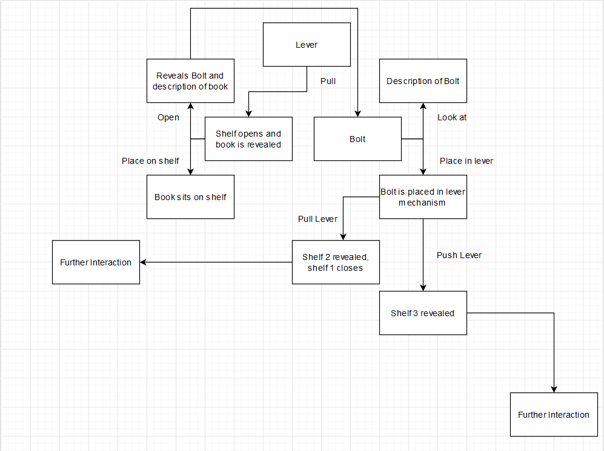

**Figure 9: Flowchart showing the connections between objects**

As aforementioned, computers made to fulfil specific roles, like Deep Blue or machines made for the Turing Test would assign arbitrary value to certain actions and items so that they are considered heavily over other items in a scenario. A machine would associate value towards the bolt that has fallen to the floor, but because there is no direct link between the bolt and the lever physically, a machine would have no reason to explore the path of putting the two together. Figure 9 shows this, and how it would develop as the game progresses, the links between objects and how they interact with each other would be tenuous to the point where it isn’t expected but makes sense afterwards.

#### 5.4 - Class Diagrams

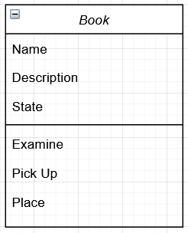

**Figure 10: Book class diagram**

Figure 10 shows a class diagram for a single object within the environment. The attributes in the upper section contain the details that will be used when narrative text is created. For example, when the ‘examine’ operation is taken, the description and state will be returned in the text output. The state attribute is used to determine where in the sequence events the object is. In this example of an object, the book has a hole inside of it for an object. This state attribute will be used to determine what is in it, or if it is empty, for an operation later.

The operations (the lower section of the diagram) show the phrases used to interact with the world. As mentioned for the attributes, if the player was to type “examine book”, it would use the ‘examine’ operation and search for a ‘name’ attribute that matches an object. The place operation is a generic one related to the object, and uses the concepts introduced with the Inform platform as a basis for pattern matching.

A differing object that repeats within this scenario is the lever, it has multiple uses and changes the “state” of other objects.

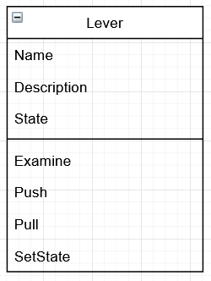**Figure 11: Lever class diagram**

The “SetState” operation is used to change the states of other objects. In the flowchart, this would equate to doing the “pull” operation, which subsequently reveals the shelf, changing the state of the shelf and the book so that they can be interacted with.

#### 5.5 - Interface Design

The interface is an integral piece of work for an Interactive Fiction, as almost all of the game will be typically presented through the interface, there is an expectation for it to aid the experience.

With the existing Interactive Fiction games that have been discussed in the analysis, they each have certain formulas to how they present their information to the player. Using and breaking down these formats, the product will need to have the following concepts involved in its design:

* It requires a text interface to convey details to the player
* A visual aspect will aid in the presentation
* A text input is required to allow for user input
* The visual aspect does not require elaborate detail, it can be made up through text narrative

To implement this in the design, it will need three sections of the interface: The text output, the text input and the viewfinder. Using inspiration from other designs, there are four possible design layouts that can be done.

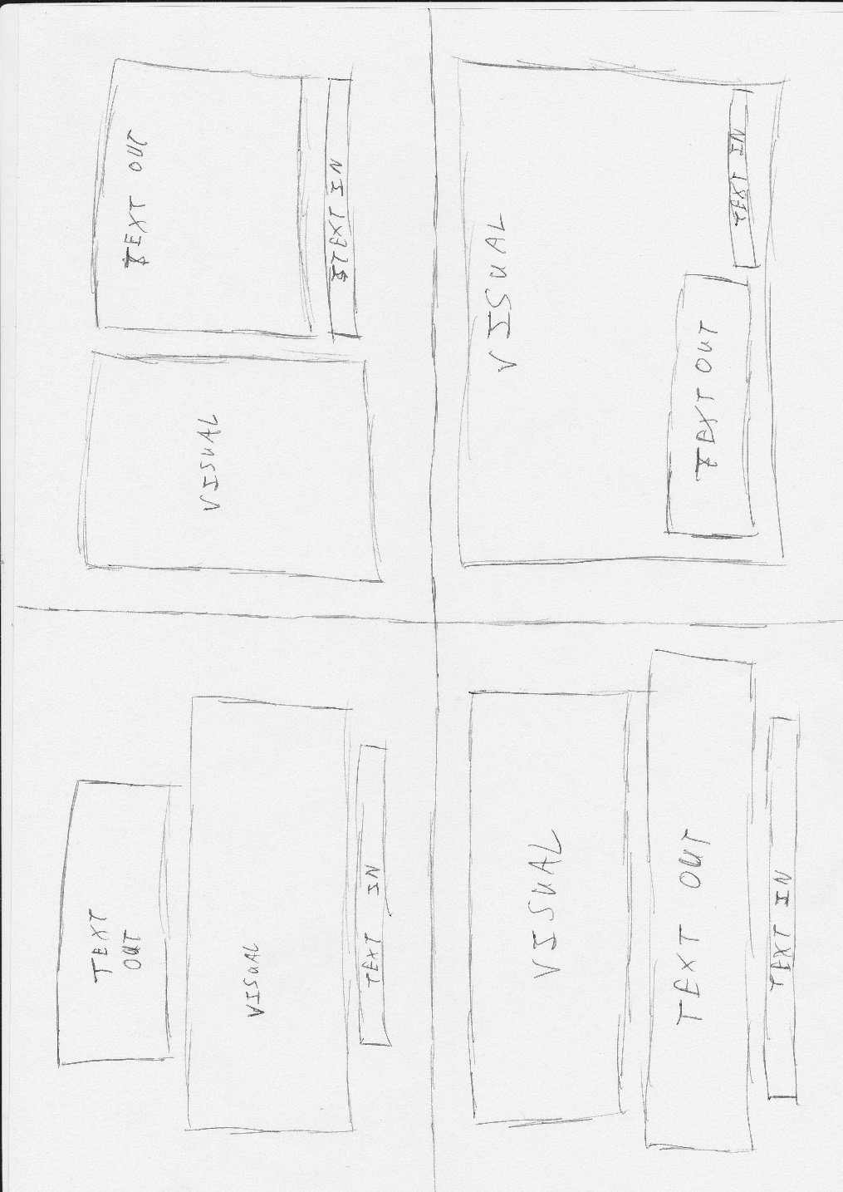

**Figure 12: From top to bottom (left -> right), designs 1, 2, 3 and 4**

#### 5.5.1 - Design 1

The first design puts a focus on the visual element by putting it in the middle of the screen. This would best be used in a game focused on manipulating the visual elements, as it does not provide as much space for textual narrative to be told. Placing the output for the text above the visuals would also serve to be a distraction, as it would draw the players attention towards the centre of the screen rather than looking to the top. The size and placement of the different elements with this design make it less appealing to play, as the player will have to look away from the text input that they are typing to see what they can interact with. For slower typers, or those who cannot touch type, this would make it very difficult to play, as they would have to consistently look between the top and the bottom of the screen.

#### 5.5.2 - Design 2

This design puts equal emphasis on both the visual and textual aspects of the interface, as they take up roughly the same amount of the screen. Unlike design one, this design places the visual and text outputs side-by-side and the text input under the output. This makes the flow of information easier to use, for instance, a player could use this design in the following way:

1. They see the visual on the left
2. They read any contextual factors in the output on the top right
3. They input on the bottom right
4. They return to see if anything has happened on the left

It forms a cycle that follows a clockwise direction around the screen, meaning that they do not need to focus on sections of the screen that are far apart.

#### 5.5.3 - Design 3

This design is the most similar to older Interactive Fiction, like The Hobbit (1982), which makes use of pictures for each area that the player may enter. However, in each of these designs the environment will be procedurally rendered, which may be better presented in a different section of the screen. As opposed to design one, design three swaps the visual and text output sections around, meaning that the player is able to immediately see the output section after typing as opposed to looking at the top of the screen. Depending on the quantity of text provided narratively, they may not need to look at the visual port at all, which may lead to redundancy but would make the product easier to understand for a wider variety of players.

#### 5.5.4 - Design 4

Design 4 is the most similar to the game Façade in its design, overlaying the text elements on-top of the visual presentation as opposed to keeping them separate. This allows for a wider view range, which is better for games that allow freedom of movement (such as using the keyboard to move with WASD keys) but is not as useful for text-based movement. This design is more practical for a game that would depart from the focus on Interactive Fiction.

From these designs, the most prominent and effective for displaying text and the visual component would be either design 2 or design 4, with number 2 being a suitable choice if the only visual display is the object being interacted with, whereas design 4 would be more appropriate for rendering an entire room that has a camera moving around it.

#### 5.5.5 - Further Ideation

Taking designs 2 and 4, they can be further annotated to show how they would operate. These new versions of the designs have a base colour scheme attached to them.

Visual output – Red

Text output – Maroon

Text input – Grey

Window border – Black

Additionally, they can be cleaned up by using digital software to produce them. This provides a better idea of width and heights required for the sections within the designs. It can be presumed that they are designed for 1920 by 1080 monitors, but by using UI scaling this is flexible.

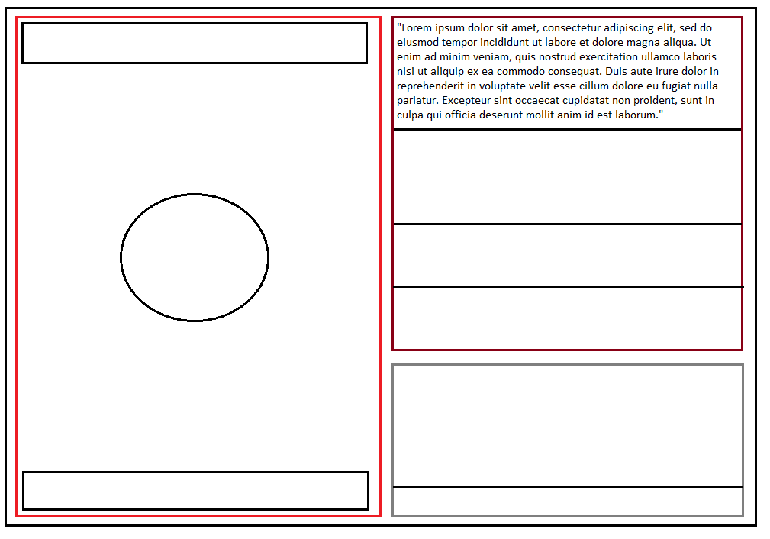

**Figure 13: Design 2 Expanded**

Figure 13 shows an interface layout with expanded details and points that were not present in the initial design. Mainly, the elements of the visual output that are the two black boxes at the top and bottom of the screen and the circle. The circle is used as a placeholder to show the “focus” of the visual output. Usually, it would show an entire scene, but if the player were to type “look at x” (wherein x is an interactable item) it would show it in the centre of the view, as the text on the side (currently filled with lorem ipsum) would read a description of the item, and through this suggest possible ways to interact with it.

The bars at the top and bottom are used to show the “inventory” of the player, this is usually exempt from an interactive fiction as the player can type “look at inventory” or “look at items”, this is to expedite the process. These inventory bars would only show up whenever the player is looking at a specific item, as it will aid in the thought process for combining items if applicable. The text output box is split into separate sections, with the largest containing sample text from lorem ipsum, this is to show that not all of the text produced will be of the same size. The text input is also split into two sections, the lower one being the input for typing, while the upper section showing previous commands that have been entered. Because of the varying sizes in text length, each section in the text output will be numbered, and this number will match a command entered. This is so the player can scroll back through their inputs and outputs to see what commands caused specific outputs.

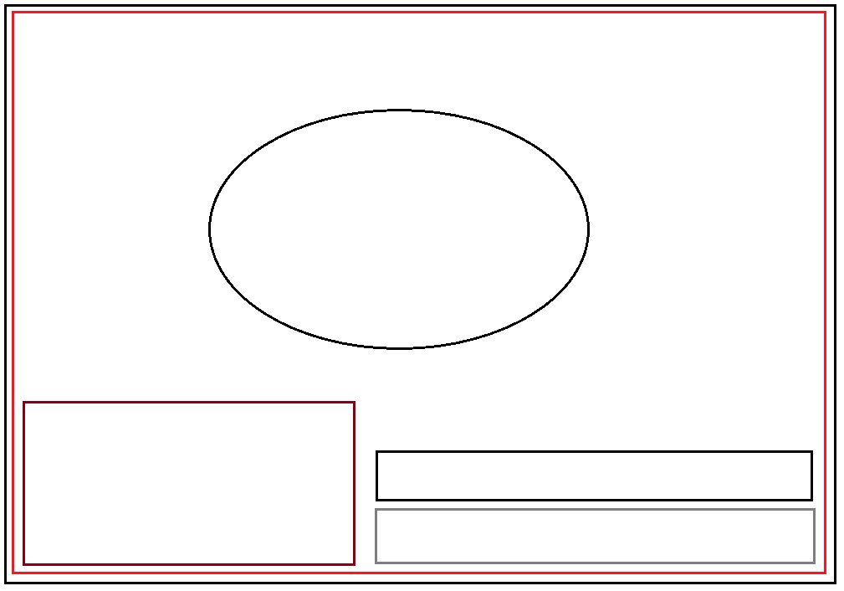

**Figure 14: Design 4 Expanded**

Figure 14 shows a version of the designs where the textual elements are overlayed on the visual output. This figure shows a scenario in which the player is looking at a specific item, signified with the circle in the centre of the screen. Unlike figure 13, the circle is larger, while the text elements are smaller. This is to show the difference in priority, as this design would be suitable for a game that has a larger focus on visual storytelling than narrative storytelling. The black box situated above the text input is to see previous commands entered. This is so the player could see if they had made a mistake in the previous command if it was not accepted, as mistakes in spelling will prevent the game from understanding what the player wants to do.

#### 5.6 - Storyboard Using Expanded Designs

The images below show a storyboard using figure 13 from the Design Ideation section. They show a sequence similar to the flowchart in figure 9, with simple visual elements that change in each image. It includes the message numbering mentioned in the description of figure 13 so that it is easier to match outputs to inputs. The black box on the left side of each image is a depiction of the scene window, the area that changes as the player interacts with the game. The first two images are wide shots of the room the game takes place in, whereas the third image is a close-up of the shelf mentioned in the text and the fourth is a look at an individual object.

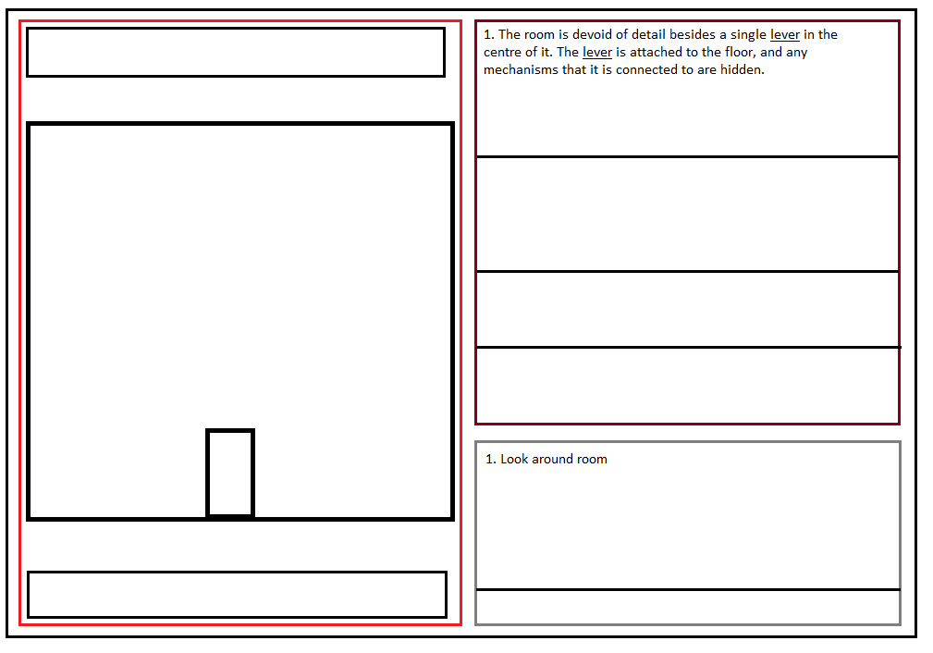

2c

3

1

This storyboard image depicts a lever (1) in the centre of a featureless room. After typing “look around room” (2), the game returns the description of the room (3) so that the player can get an idea of what they can type next. The lever object is underlined in the text to show that it is an independent object that can be manipulated.

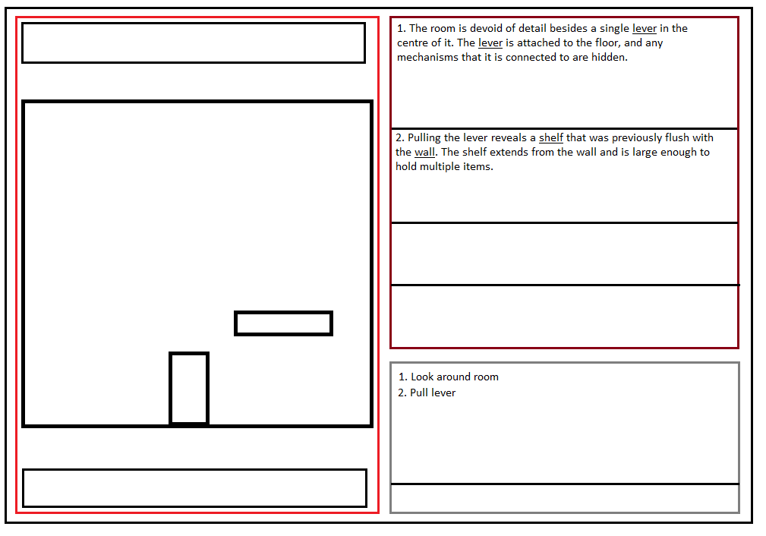

5c

6c

4c

After interacting with the scene, a shelf appears (4) that contains the next item the player can interact with. By typing “pull lever” (5), the player has interacted with the lever object and set the state of the shelf, driving the game forward. As this happens, (6) will describe the shelf itself but not what it contains. The shelf is underlined to show that there are further interactions possible.

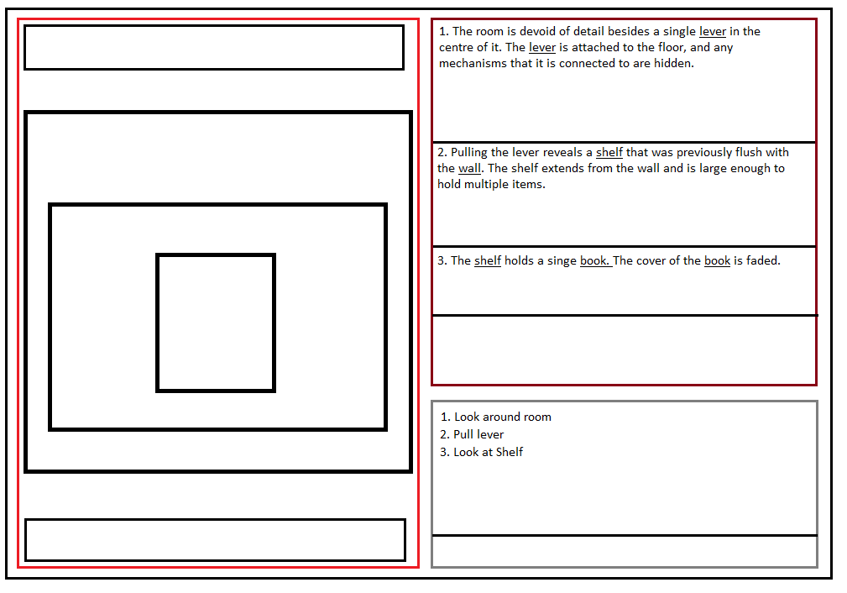

10

8

7c

9c

By interacting with the shelf by typing “look at shelf” (7), the player has changed their view from looking at the room to the inside of the shelf (8), and inside they can see a book (9). The shelf description (10) indicates that there is a book inside of it. By underlining the book and the shelf, it implies that they are both interactable.

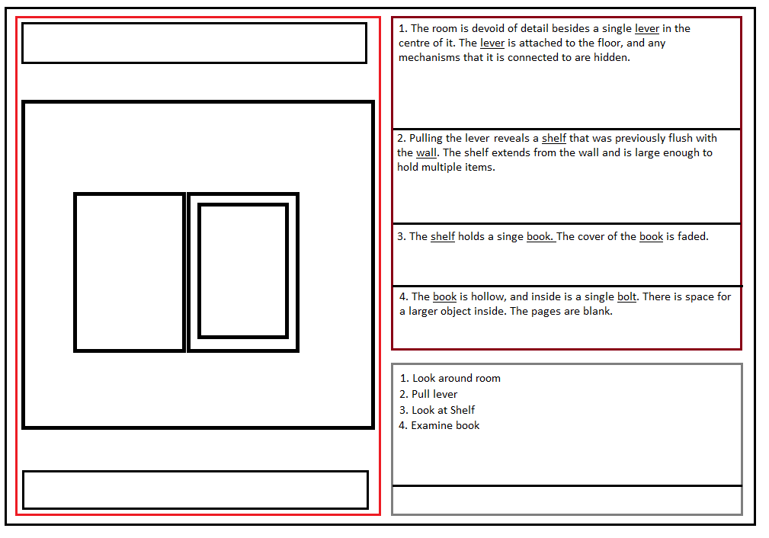

13

12

11

By examining the book (11), the players view has changed again, this time to show the book opened (12). The description of the book (13) tells the player that there is another item inside, and that there is a space carved into the book. The pattern of interactable items follows previous examples, as the book and bolt are underlined.

### Chapter 6 - Implementation

#### 6.1 - Implementation Introduction

This chapter will cover the implementation process and documents the different stages of development achieved using the agile methodology. It covers the use of a “controller” that is used to drive the gameplay and handle text, as well as discussing the various ways in which Unreal’s blueprinting has been used to achieve the final product.

Throughout this chapter, there are various screenshots of the blueprints, which are used to highlight certain “nodes” that are used to achieve the end product. The chapter ends with a conclusion summarising the steps taken.

#### 6.2 - Model Creation

The product will require models to place within the game world to represent the objects that the player will interact with. To ensure that they all follow the same style they will be made using Blender, a free program and when possible, will not be acquired from outside sources like the Unreal marketplace. Using online tutorials, manipulating objects within Blender can be used to make the required models for the game. These will be simple in quality, due to inexperience with the program, but will mean that no external model referencing is required.

#### 6.2.1 - Required Models

|  |  |
| --- | --- |
| Model Type | Completed |
| Room | 🗸 |
| Lever | 🗸 |
| Book | 🗸 |
| Bolt | 🗸 |
| Shelf | 🗸 |
| Box | 🗸 |
| Rock | 🗸 |
| Lock | 🗸 |
| Plinth | 🗸 |
| Door | 🗸 |
| Light | 🗸 |

**Table 5: A list of objects that required models, updated as they were created**

It should be noted that the bolt has a model created but is not actually used in the project. The model was created before the changes to the design were made, meaning it was not actually required. These changes are discussed in section 3.3.7.

A selection of screenshots of these finished models can be seen in appendix H.

#### 6.3 - Unreal Implementation

#### 6.3.1 - Introduction

This section will cover the use of Unreal Engine to produce the game. It will cover the different systems included with the engine and the difficulties encountered with the implementation.

Unreal does not handle text inputs as a native feature, but it does provide ways to input text, mostly through “widgets” which are discussed later. What is required and handled natively by Unreal is a game controller, by setting a duplicated game mode with the correct controller, adding new functions means that it can be used for “controlling” the objects in the game world.

#### 6.3.2 - UI

The UI will facilitate the players interaction through text. By using a “Widget” in Unreal, a text box can be made that allows the player to type and enter any commands. Through the blueprint system, this text box can be cleared, and the output can be sent to other parts of the game. The UI primarily interacts with the game controller so that it does not form dependencies with any of the game objects. Both the game controller and objects within the world will send text to the text boxes used in the UI, but this is only similar to a print function and is one way, meaning that no dependency is formed.

Text entered through the UI must adhere to a format of “object command”. This could be anything from “book examine” to “bolt place in shelf”. Using the ‘Split’ node in blueprints, the text entered from the UI is split using the initial space in the entry as the character to split at.

As the implementation proceeded, the decision was made to use the interface shown in figure 14 as opposed to that of figure 13 with some minor changes. All of the text elements (input and output) were put on the same side of the screen which kept the interface compact. This decision was made in response to how Unreal would interact with the text system created. To elaborate, Unreal requires a “player character” object for the game controller to command. While the game does not use inputs directly, this is still the case as the controller handles moving the camera around. This further meant that having a camera viewport as a portion of the screen would not be possible, as the players view would be chained to the player character no matter what.

To supplement the game experience, multiple menus were created using the Unreal widget system that was used for the text widget. These widgets include a pause menu, a main menu, three game end screens; two of these screens are for when the player fails and a tips screen, which is built into the pause menu when playing.

#### 6.3.3 - Game Controller

The Game Controller will act as the in-between for the UI and the game world. It uses the commands entered from the UI to find the appropriate actor within the game world to cast to, and then either returns a description of the item it finds, carries out the command, or is not able to find the actor, in which case it will not do anything.

#### 6.3.4 - Generic Game Object

This abstract object will be inherited by each world object so that they can be interfaced with globally. It contains methods and attributes that are universally required by each object, such as name and state. By inheriting them from a single object, it makes searching through each object easier.

#### 6.3.5 - World Object

World Objects are the different objects in the world for the player to interact with. Interaction with these objects will be based on the “state” they are in. This is an Integer used to record what they are available for. For instance, all objects except for the initial lever will be in state 1, AKA “unusable”. If the Game Controller attempts to interact with them, it will return a string stating that the action isn’t possible. Each world object will contain a string array, which will have the valid commands that can be inputted in relation to it.

Each object will have a “tag” applied to them. This is a way to quickly sort objects in Unreal, which would not be ideal in a game with a variety of objects, but for the requirements here it is appropriate. With a tag, it means that a “for loop of all of the actors” within a scene can be searched for a specific object, making it easy to acquire an object for casting.

#### 6.4 - Implementation of the Requirements

#### 6.4.1 - Unreal Class Diagrams

Unreal manages classes and objects in a different way to base C++ so that get and set functions are not required within the design of a class. Through the use of casting, any object that is a child of an abstract object, they can be cast to and use functions that are dynamically bound, including variables. To acknowledge this, class diagrams will not have get or set methods, instead it is implied that they exist.

Each world object will override two functions, “objectHandler” and “printDescription”. These two functions have a base use, objectHandler prints out the variables whereas printDescription only prints the description variable. These will be overwritten so that they have functionality based on the item. An implied aspect of this is that the objectHandler will take a string called “command”, and it will interpret this command as a function related to the object itself, as opposed to the abstract object.

For the sake of ease, gameObject will also contain a reference to the text widget that is continuously updated whenever it is called to make sure it casts to the correct widget. Whenever a new command is entered for an object, there is a relevant description that is sent to the text box widget so that the game can emulate interactive fiction properly. The constant need for the reference is so that the player is aware of what their actions are doing. The reference to the UI can be cast, so that the set description function is readily available, and does not need to be acquired during every use.

Figure 15 shows the basis for object inheritance within the game. It is limited in scale as there would be a lot of repetition. The “move” function inside of the abstract object will be used to move objects around the game world.

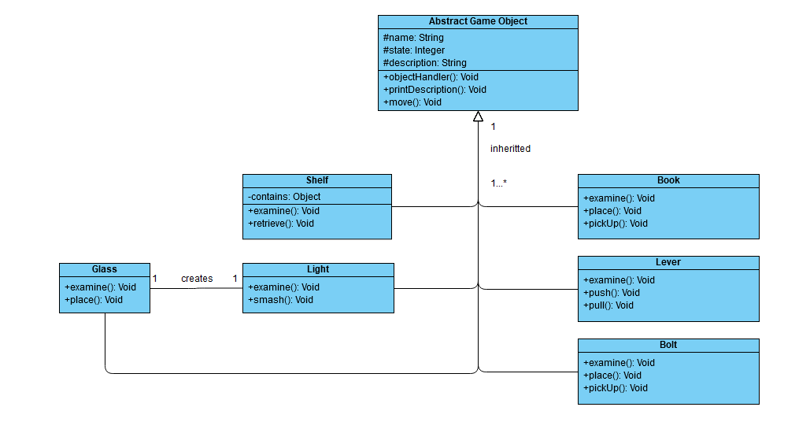

**Figure 15: Abstract Object Inheritance**

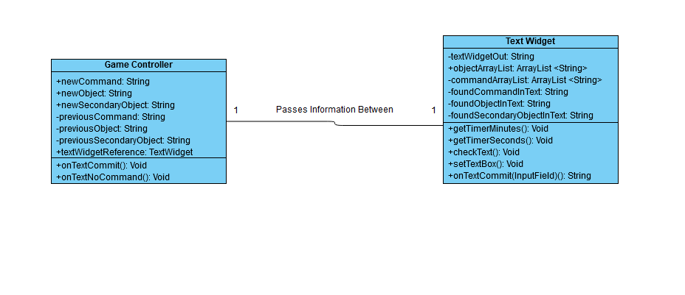

**Figure 16: Player Controller and Text Widget Class Diagrams**

#### 6.4.2 - Intended Functionality of the Controller and Widget

The game controller and widget are closely linked together. The controller relies on the input from the text box found in the widget, and the widget relies on the timer outputs so that it can properly update the visual timer in the corner of the screen, the integers for this being stored in the player character that is controlled by the controller.

The controller for the game is intended to work using polymorphism. This is a concept where a subclass (the objects within the world) can be treated as if they were the superclass (the abstract object they each inherit from). Using the controller in this way makes it very easy to access the commands within the objects, such as the ObjectHandler() which is discussed later in this section. This also makes it very easy to expand the game without requiring any inherent changes to the controller, as it is designed to work universally with the objects.

Each operation of the controller and widget are required for the game to run, but one confusing point could be the shared names of onTextCommit() and onTextCommit(InputField). These two operations are different but have a similar naming convention due to what they do. OnTextCommit() from the game controller is used whenever text is passed from the widget towards the controller, the specifics of this function is discussed when detailing the iterations that it has gone through. As an operation, it is only called once at the end of the onTextCommit(InputField) operation from the text widget. This operation is an automatically created event from the text box input that is used to enter commands. Whenever the enter key is pressed on the keyboard, and there is text within the box, this commit operation is activated. It uses the arraylists stored as variables to determine what text has been inputted into the controller before sending it. This is also discussed within the iterations of the controller.

The getTimerMinutes() and getTimerSeconds() operations directly link the widget to the player character through “binds”. Binds are a way to link functions specifically to a text field. In this instance, the two binds are being used to transmit the current timer to the player on the UI in real time. In addition to this, the binds are able to change different elements of the UI as part of the functions. For getTimerMinutes(), it checks if the integer value for the minutes is either less than 1, or if the seconds are less than 30. If it is less than 1, the entire timer changes to an orange colour, and if the seconds tick over to below 30, the timer turns red. These features could be further expanded to affect the entire UI or to even cause Vfx if given the time to create some.

CheckText() is an operation that is used to discover the substrings within the text mentioned in the iterations of the system. It uses a string input, and an array input, so it can be modularly applied to all three of the required string outputs (being commands, objects and secondary objects).

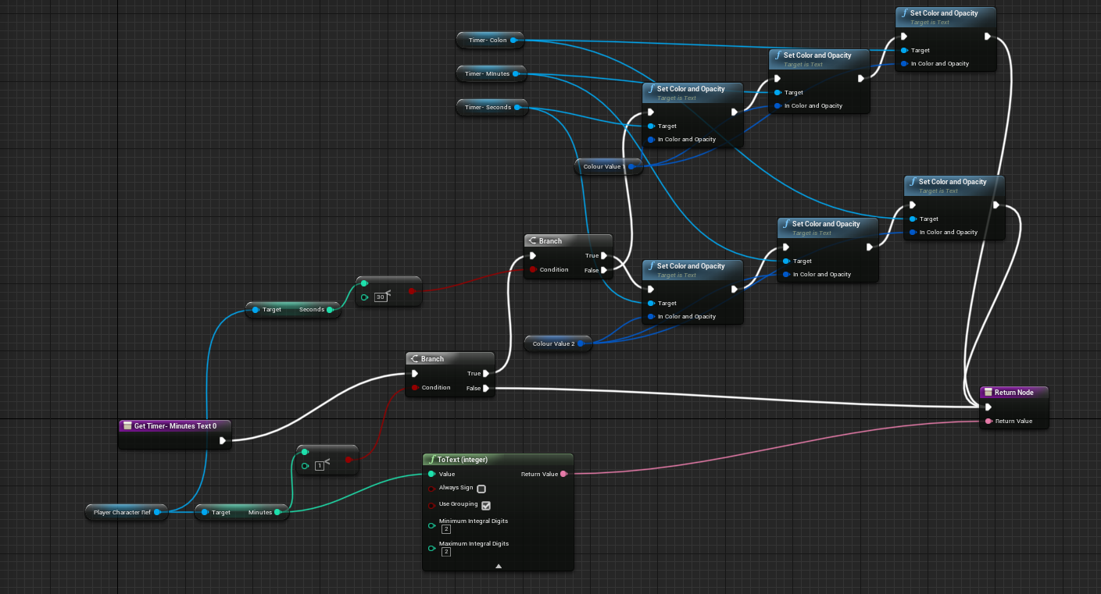

**Figure 17: The blueprint used for updating the timer, along with  
changing the colour of the text**

#### 6.4.3 - The State Variable

The state variable will be a key component in controlling the flow of the game. It will be checked whenever an action is committed to see if it is possible for the player to actually do it. For example:

* The player types “lever pull” – the pull lever function is used, and the state of ‘book’ is made to 2
* The player types “book pickup” – the system checks if book is in state 2, otherwise it carries out a different branch

This is to prevent the player from blindly typing commands and somehow progressing. To ensure that a certain level of fidelity is kept, the statements used to check state will use the logic in table 6

|  |  |
| --- | --- |
| State Variable | Intended Logic |
| 1 “Not Accessible / base” | Intended state for an object that can’t be used / seen, or for objects that do not change state regularly. Example being the lever in the room. |
| 2 “Accessible” | This state is used for an object that the player can see / interact with. Examples being the shelf and book within after pulling the lever. |
| 3 “stored” | This state is used for objects that are “picked up” by the player. Examples being the book after picking it up, and the bolt after examining the book. |

**Table 6: Brief table describing the usage of the “state” variable**

The state variable has also been used for objects that are not directly interactable. This is the case with the “room” actor, which uses the state variable to provide a different description when examined based on what has happened so far in the game.

#### 6.4.4 - Iterations of Game Controller

Developing the game controller made use of the iterative nature of agile development with games. As developing a text-based controller was not native to Unreal, this meant that each version of the system would have to develop and expand upon that of the previous version. What came out of this was four distinct versions over the course of the implementation of the ideas. The first iteration matched that which is described previously as the ideal system, were the player would enter commands in a specific order, and it would check the input based on this. This system would break very easily, and even more so when it came to adding a second object as a target for some actions. To fix this, the entire system needed to be overhauled.

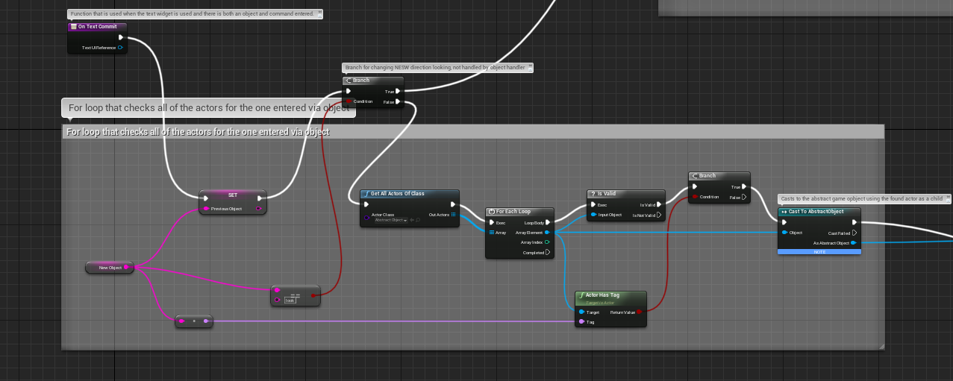

**Figure 18: The intial segment of the controller blueprint using the onTextCommit  
function.**

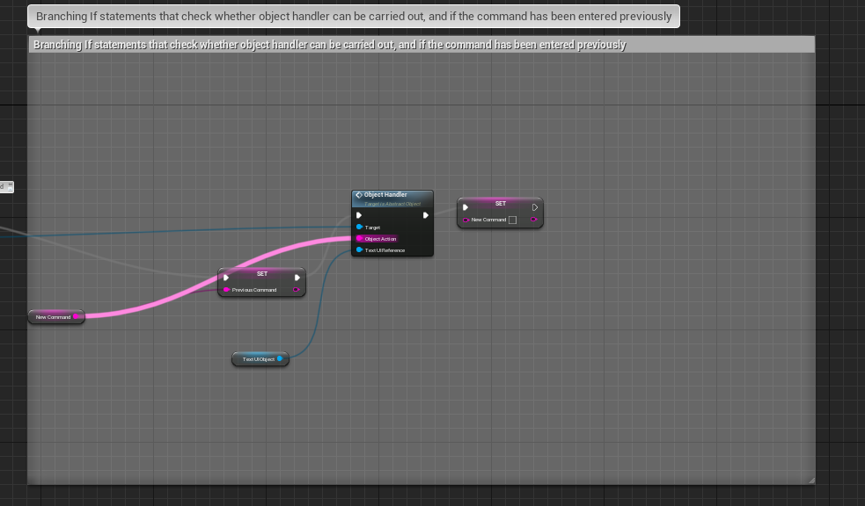

**Figure 19: The final nodes of the function. It accesses the object handler of the relevant  
object, and provides it with the command from the text widget.**

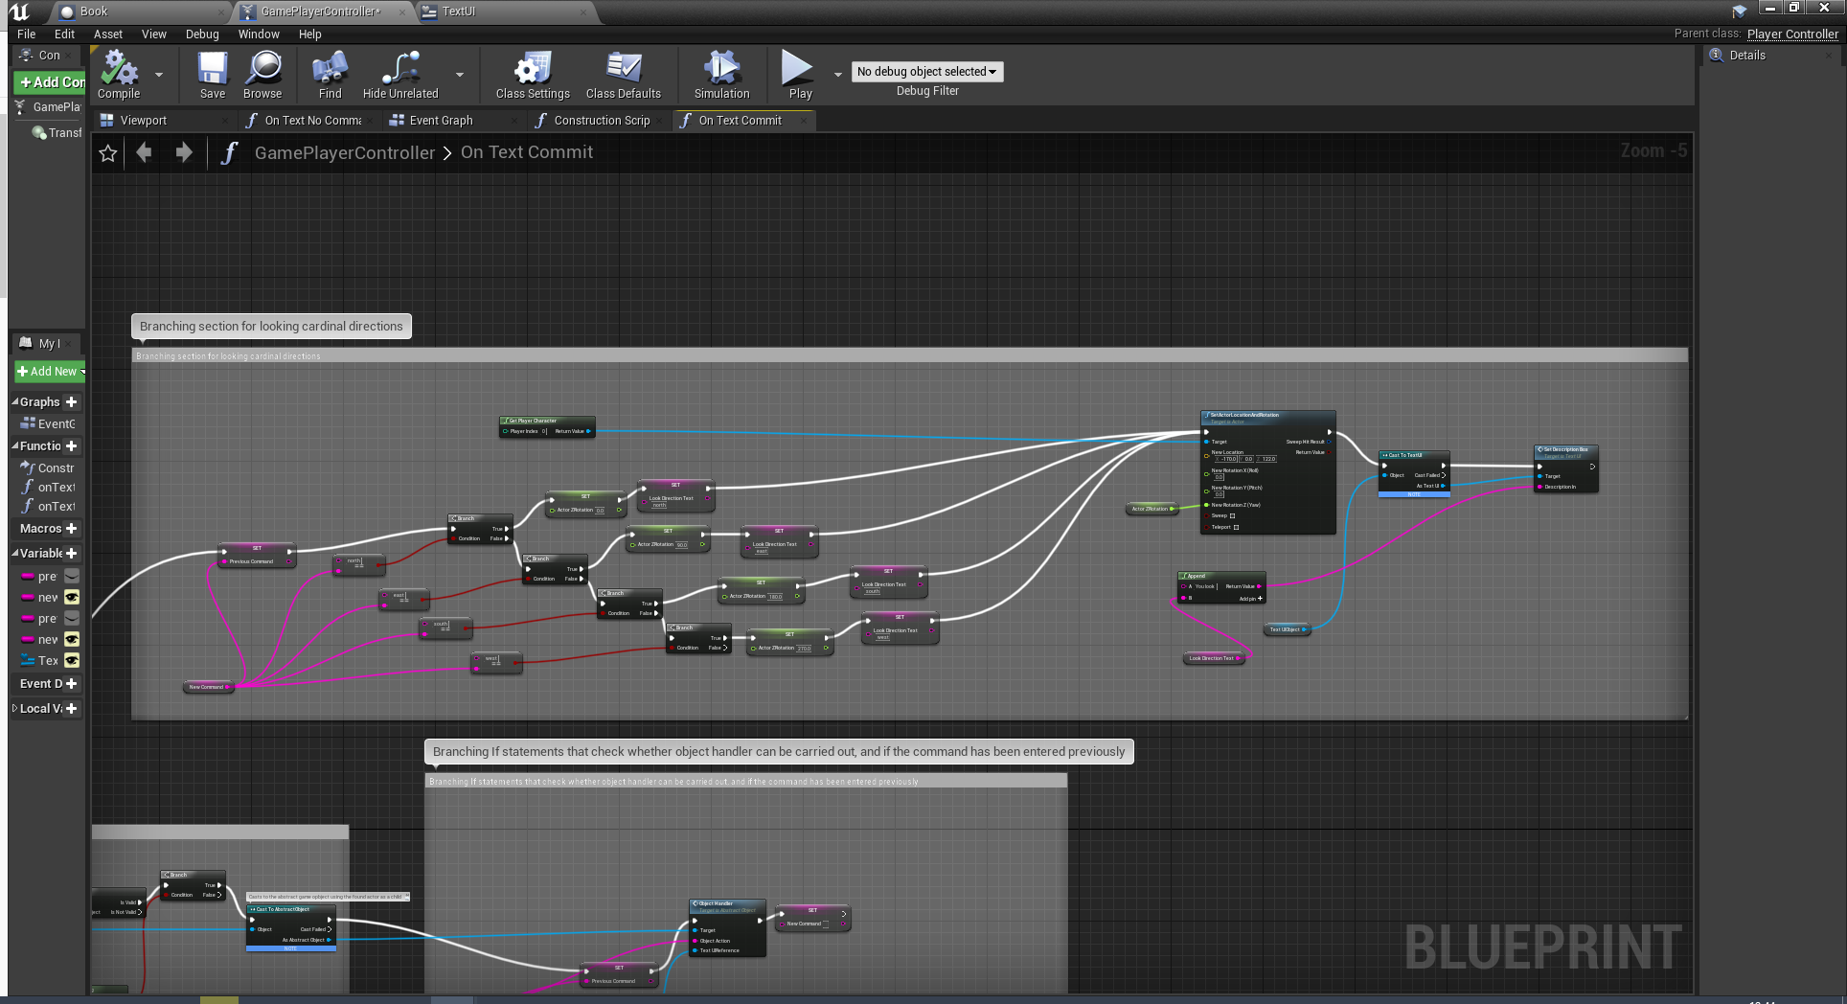

**Figure 20: 4 branching IF statements for adjusting the players camera via commands.  
Uses cardinal directions as the command, and “look” as the object.**

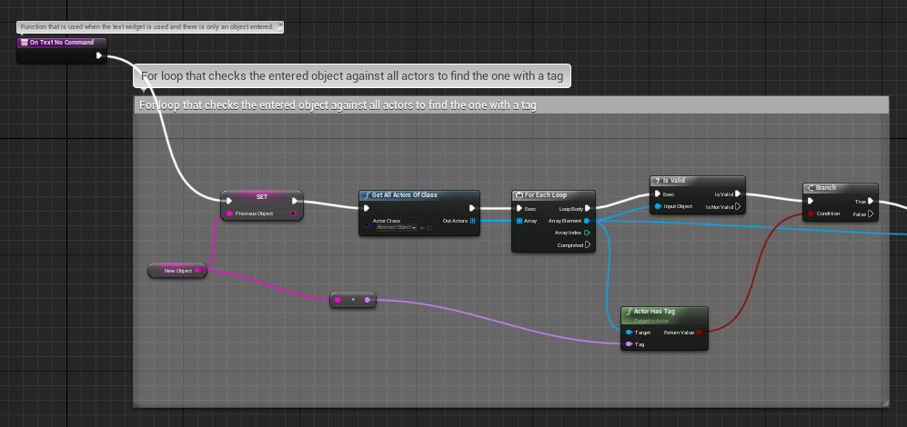

**Figure 21: Deprecated function onTextNoCommand that activates whenever  
an object is detected without a command. No longer used,  
but still holds functionality.**

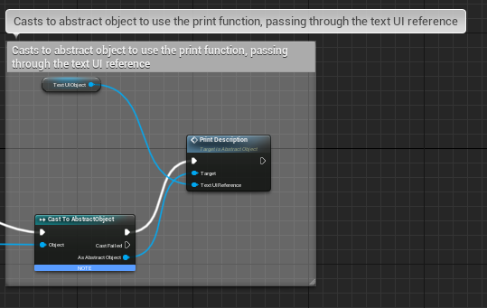

**Figure 22: Deprecated final segment of onTextNoCommand, uses the printDescription  
function of an object, as opposed to passing a command to the object handler.**

The second iteration forms the basis for what the game uses now. What it does is that it takes the input from the text box, uses the “find substring” node from unreal until it finds a string that matches a pre-configured array, gets the substring from that point and applies it to the “object” variable of the controller. The same is repeated for the action, instead using a different array that has been configured for specific actions that will occur in the game, which is set to the “command” variable. This system completely overhauled the ability to type, as now the player can enter any format of words provided the phrase contains words that match these two entities.

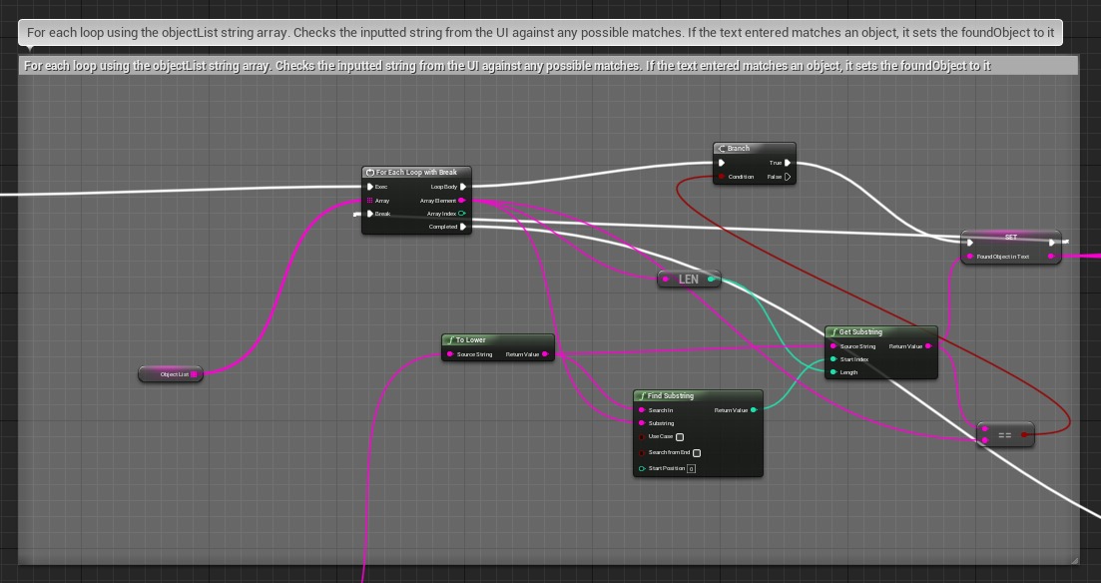

**Figure 23: The new method for acquiring the text within a text input. Takes the text widget  
text as an input, and outputs a substring if it matches any of the entities  
on the arraylist.**

The third iteration of the system saw the requirement for a secondary object declaration. This was for the sake of “placing” objects, or “throwing”, etc., This version of the system uses a similar find substring method as used for finding the first object, but instead the second object is checked against the first, so that the types are not repeated. While this would be counter-intuitive in a game with multiple objects of the same type, it works around the designed narrative path.

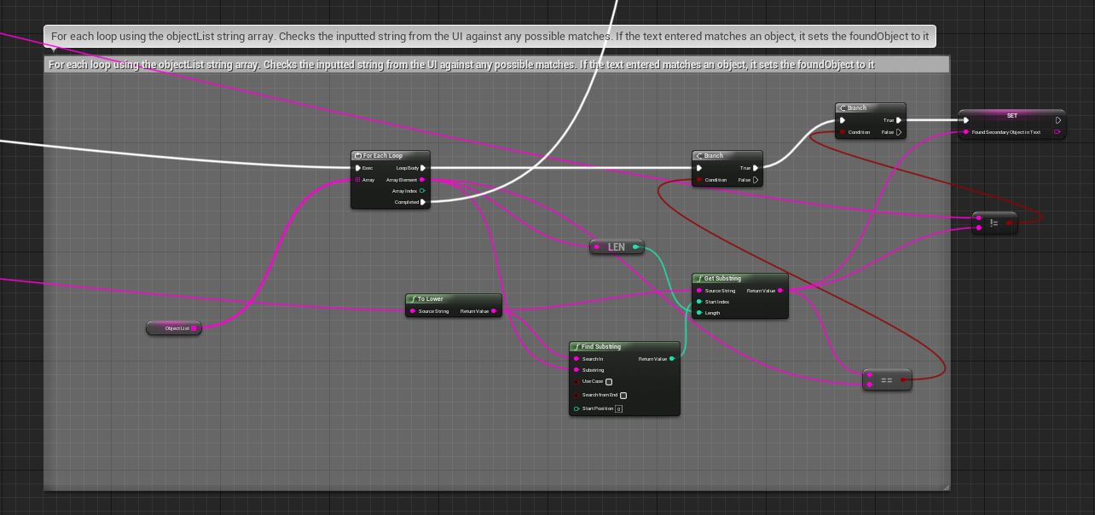

**Figure 24: The loop method for acquiring a secondary object. It checks the substring  
against the text output like figure 23, but also compares the found substring  
with the output of the first loop, so that it only outputs a different string.**

The fourth iteration is the one being used at the time of the game being packaged in Unreal. This version does not focus on the controller and text UI widget as much, and instead on the logic being put into the independent objects. As part of the third iteration, the array that stores the list of objects is automatically populated upon the loading of the level, providing more flexibility as it does not need to be updated manually. This does, however, present the issue where some objects are designated as the first object. For example, in the phrase “place the book on the first shelf”, “book” should be considered the first object, and “first shelf” the second. In actuality, this is reversed, meaning that the “place” command is being run in the first shelf, meaning nothing will happen as it is not designed to handle this command. The workaround to this issue was to flip where the commands are handled around. To do this, each object that can be placed now has a check to see if the target of the object is a shelf, and that the shelves have a command to see if the secondary object is not a shelf. This means that the command can be handled in either object and not cause an error. This does equate to high coupling within the code as the string checks are heavily dependent on certain parameters, but none of the objects actually inherit from each other. The application of this version upon objects and their “place” functions can be seen in figure 25 and 26. Not pictured in figure 25 are the branches for handling objects inside of the book, this is because they are similar in node structure and logic.

A point that should be considered for this final iteration is that each new object now needs to have their “place” function, if applicable, able to work both ways, so in world context, it should be able to place itself, or the object it is being placed on needs to be able to handle it as an input. While this does not need testing for potential overlap, as only one place function can possibly run at once, it means that the time to create a new object is potentially doubled, including the time to test.

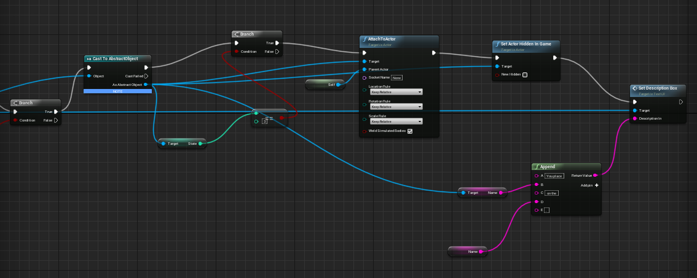

**Figure 25: The final nodes of the place function within the shelf object.  
This is after checking that the object being placed is valid,  
and that it is in a state to be placed.**

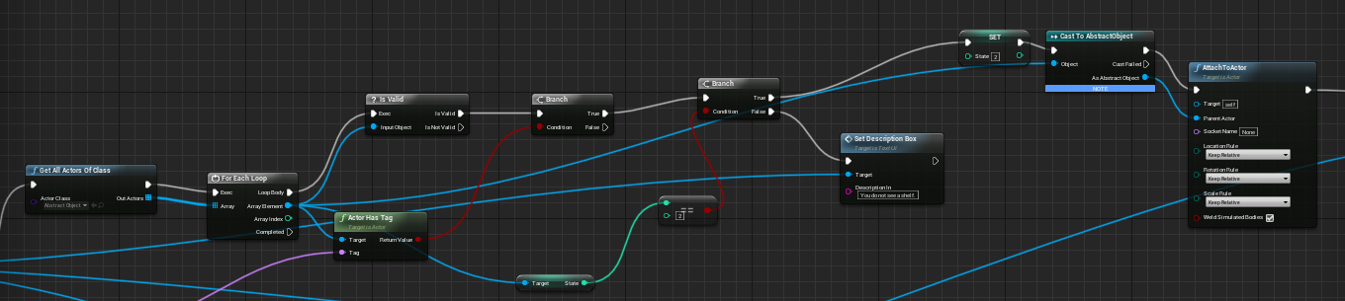

**Figure 26: The final nodes of the place function inside of the book. It handles it differently  
to figure 25, as it needs to check which shelf it is attaching to, and if it  
it accessible.**

Each of these iterations have been done so that the player interaction and experience is as flawless as possible. A few issues still remain with this system, such as the requirement for each shelf to be marked with “first”, “second”, “third”, or that some objects need to be put in the arrays by default as they are created after the level begins.

#### 6.4.5 - Distinguishing between Objects of the Same Type

One big issue with the narrative that was being made in the game was that the use of shelves messed with the controller. As it worked through checking the tags of an object, that meant each shelf would have the same tag. To work around this, a change to the construction script, which fires as soon as an object is placed in a scene and is not reliant on the game started, was made. This change instead applies a name and tag to an object based on an integer variable that can only be changed in the editor. This made each shelf a unique entity when using the controller. The solution for this can be seen below:

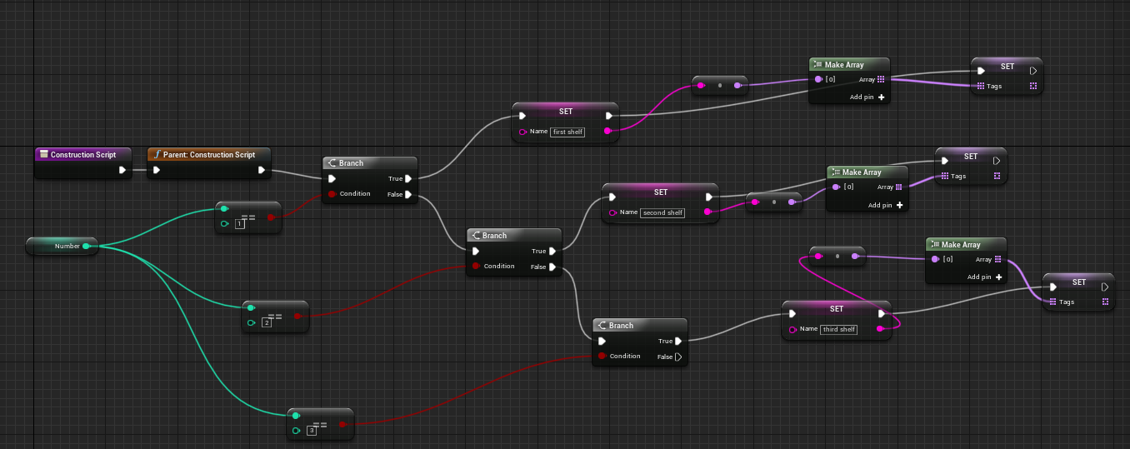

**Figure 27: The construction script for a shelf. This determines what tag  
and name it has. This can be changed in the editor by modifying the  
“number” variable.**

The blueprint in figure 27 uses a branching IF tree that checks the integer against three possible equal statements. This then carries out the needed nodes to modify the individual entity. Through this method, the order in which a shelf is revealed can be changed, making it possible for a randomized experience should it be required with tweaking to other blueprints. If the game design had called for other objects that appear multiple times, such as boxes or books, then this blueprint could also be used for them with minor changes to the name string and tag literals. This system could be improved even further, as it is possible to change the mesh, material or any variable related to an object this way. For instance, it would be possible to instead name the shelves based on a colour that would appear on them, such as a “blue shelf”, and then assign a pre-configured material that would make the shelf blue. This would clearly aid in making each shelf unique but would also add extra layers to the other functions involved, such as the “examine” function, which would have to check what colour is being used and have unique statements for each.

#### 6.4.6 - Object Handler Blueprint Example

The “objectHandler” function is one that is inherited by every object that is interactable in the scene. The purpose of this function is that it can be easily called, with the required variables being sent to the object so that it can handle it independently of the controller. This has also been done as not every object uses the same functions in the game. For instance, the “room” object is only there to be “examined”, and as such does not need to use a “place” or a “throw” function whereas a rock needs all of these things and more. By handling the objects interactions on a local level, it majorly increased the number of blueprints to be made, as each object would require an in-depth handling of the commands based on the design ideas, such as checking the states, making sure it interacted correctly with the game world based on the state and the command, etc.

The object handler resolves this by presenting a flexible way to handle a command. It uses if statements, similar to the “look” ability in the controller and uses an equal string to compare the text input from the player output against pre-determined names. In figure 28, the handler for the book object before the introduction of a secondary object can be seen. Inside of it, there are three if statements, and each is attached to an “equal(string)” node that checks the input “object action” which has been sent from the controller. If the string equals any of the designated conditions, then it activates the related function and ends the object handler. If it does not equal any of them, it instead puts the blanket statement “[object action] is not a valid command.” This provides the player with a short feedback sentence so that they either 1) check their command for spelling mistakes or 2) try to enter a different action.

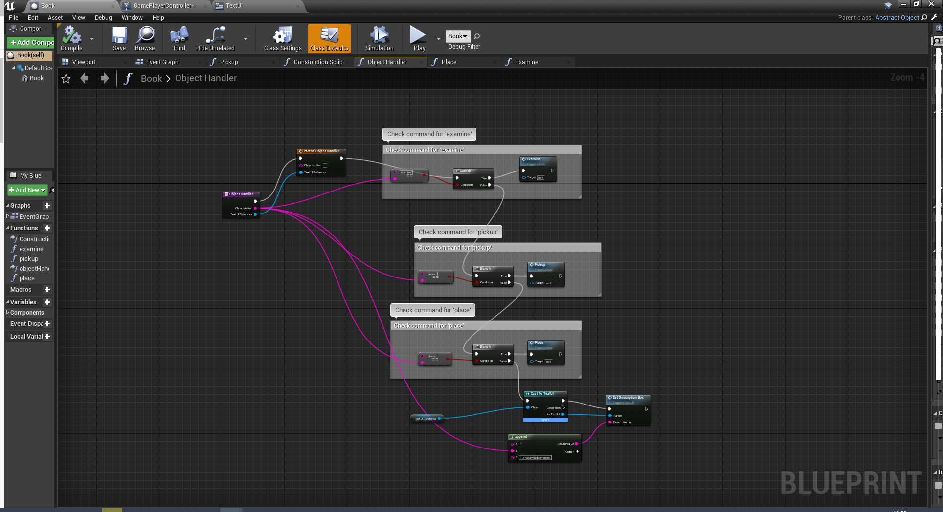

**Figure 28: The object handler function for a book. It takes the UI reference and object action  
as an input. This screenshot was taken before the inclusion of a secondary object.**

After the iterations of the controller and text widget, figure 28 now looks like figure 29. The other functions that the handler feeds into are not affected, but the place function now takes a string input, which can be seen in figure 25.

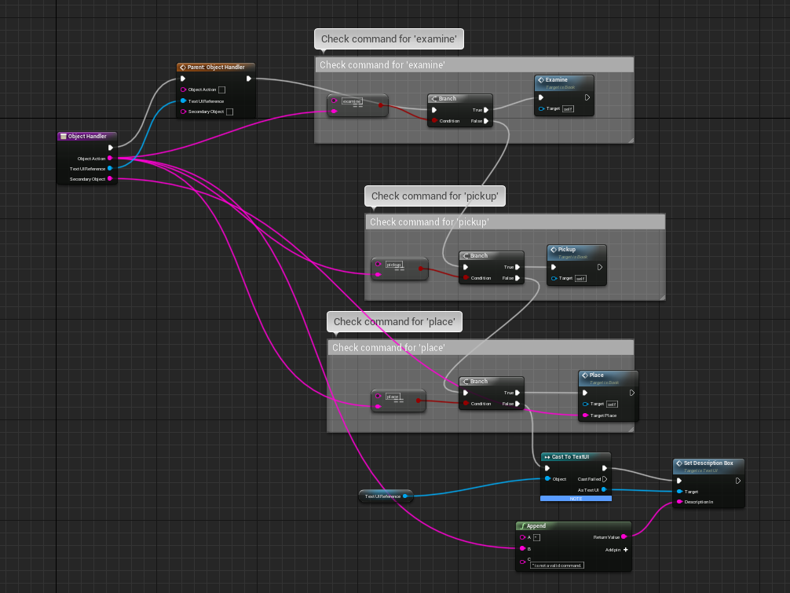

**Figure 29: The object handler function for a book after the fourth iteration of the controller.  
The biggest difference is the inclusion of a secondary object string input, which is  
directly fed into the place function to be checked there.**

#### 6.5 - UMG Implementation

#### 6.5.1 - Introduction

UMG (Unreal Motion Graphics UI Designer) is a built-in system of the Unreal engine that allows the developer to make and design user interfaces without needing external software. It can be used to make advanced elements like health bars and ammunition (Unreal Engine, no date), but for this instance of game development, it is used in creating the different menus of the game. UMG was also used to create the timer that is mentioned in section 3.3.4, however this section will focus entirely on the designs of the menus used.

#### 6.5.2 - Main Menu

The main menu is used to convey the idea of the game to the player and provide some simple help with the controls for those who have never played an Interactive Fiction before. The buttons on the left side of the screen each have a purpose, the “exit game” button, which is seen commonly throughout the UIs, quits the game. The “tips” button brings up the tips screen, and the “start game” button launches the level by using an “open level” node in the blueprint. When the player clicks the tips button, it creates a new widget on top of the main menu, and removes the menu from the parent, deleting it. This is so that the menus do not overlap and cause an issue when trying to click the buttons.

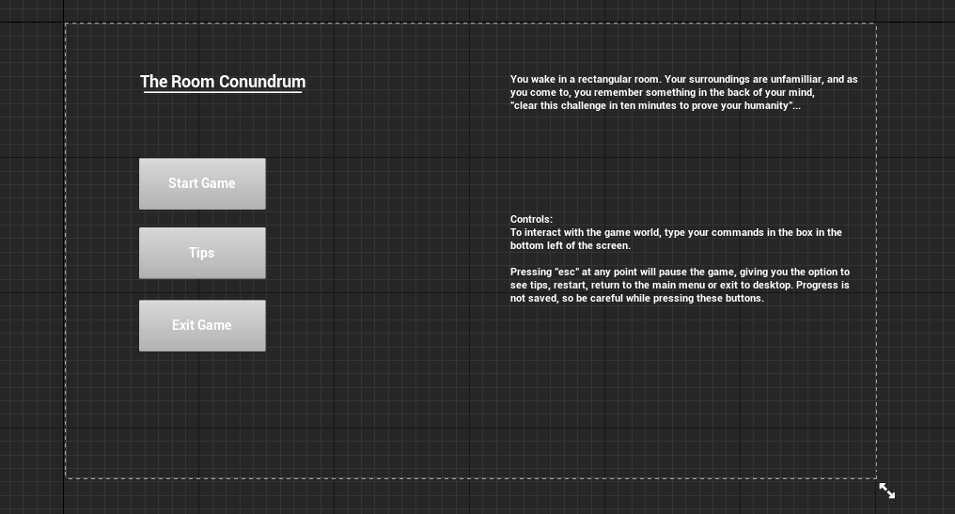

**Figure 30: The main menu screen in the UMG editor window.**

The main menu also serves to setup the narrative for the game. Due to a focus on the controller during development, the use of the “cinematic” feature in Unreal, which can be used to create cutscenes was not employed, meaning the setting for the game would have to be told through text. It is kept vague on purpose, and only serves to tell the player that they have a timer but is also connected to the ideas seen within the analysis, that to test if a machine is capable of human thought, they must be pushed to draw vague conclusions founded on guess work.

#### 6.5.3 - Pause Menu

The pause menu appears whenever the player hits escape on the keyboard. This binding is only tracked while the level is loaded, so this cannot be done while on the pause menu. This menu copies the text provided by the hints screen, so that the player is not forced to exit to the menu if they are stuck and need help. As seen in the screenshot, the timer for the level is paused while this menu is up, meaning that players can take breaks if they feel the need to.

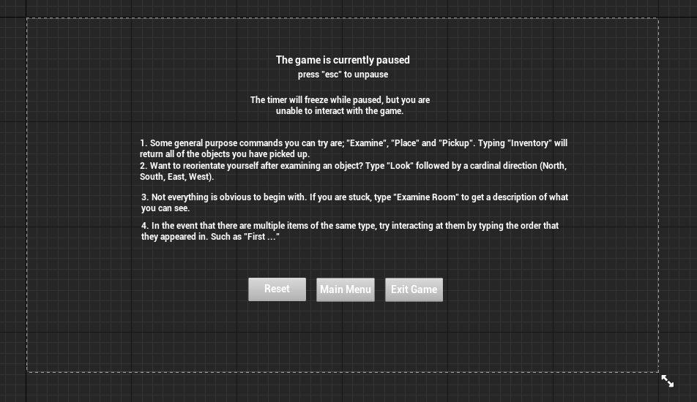

**Figure 31: The pause screen in the UMG editor.**

#### 6.5.4 - Game Failure Screens

There are two game failure screens, they are each triggered by different conditions. The “Timer Ran Out Screen” can be seen in figure 32 and only appears when the timer hits 00:00 in the top right. This is later discussed in the user evaluation as improving the experience through its implementation, by adding it, there is pressure applied to the player to try as much as they can.

The other game failure screen appears when the player makes a mistake while interacting with the shelves. This is seen in figure 33. It is possible to lock the “book” object inside one of the shelfs, making it impossible to escape. Instead of letting the player continue after doing this, every time the shelves are moved into the wall, it checks if the book is on the second shelf, and if the lock has been switched. When this does happen, the second failure screen appears, indicating that something was done wrong so that the player tries to reconsider their approach next time.

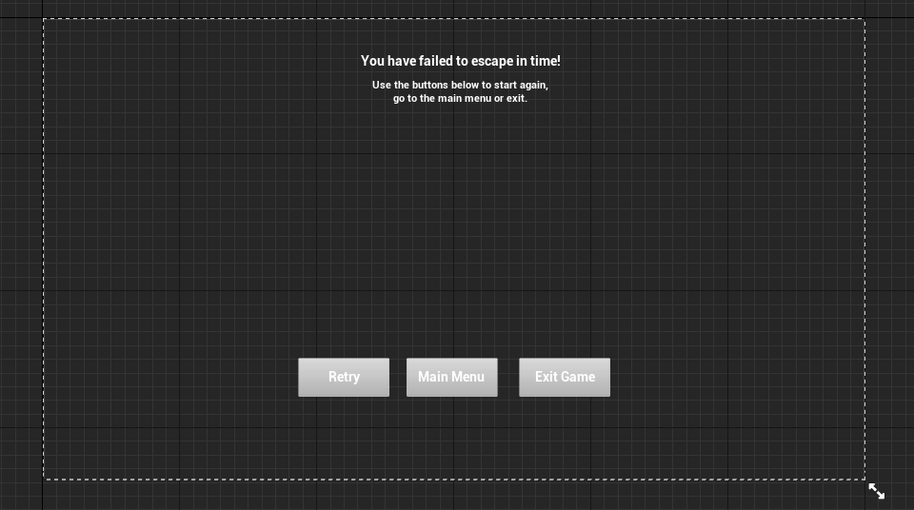

**Figure 32: The time failure screen in the UMG editor**

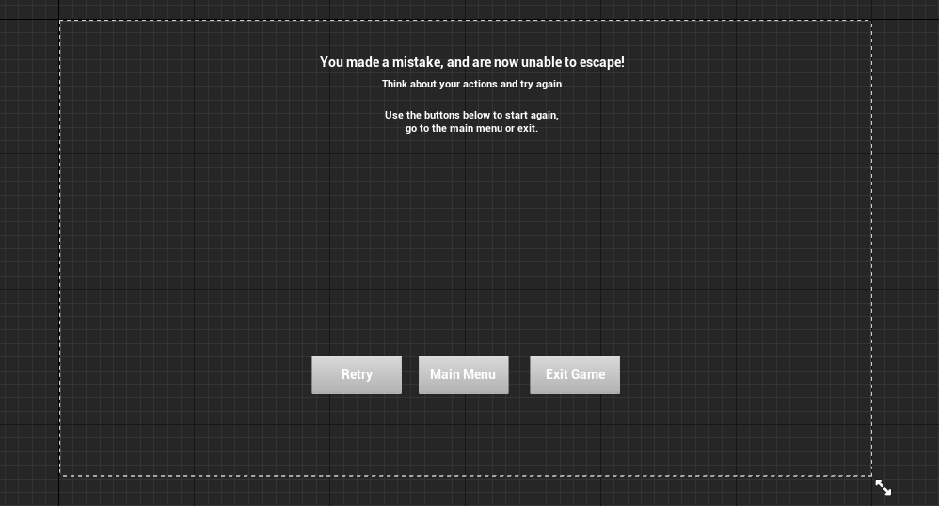

**Figure 33: The mistake failure screen in the UMG editor**

#### 6.5.5 - Tips Screen

The tips screen can only be accessed from the main menu and provides some guidance so that the user experience can be improved. These tips are directly linked to some of the issues seen with the system, mainly that which is mentioned in section 6.4.2, specifically the way to access the shelf units. This is later discussed in the User Evaluation, as the issue is still present in the responses. The presentation of these tips are seen in figure 34.

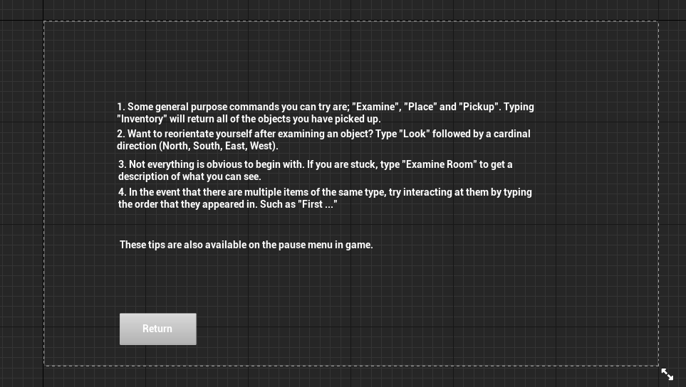

**Figure 34: The tips screen in the UMG editor**

#### 6.5.6 - Win Screen

The win screen replaces the UI when the player manages to solve the puzzle and interact with the door before time runs out. When this does happen, it displays the remaining time so that the player can feel accomplished.

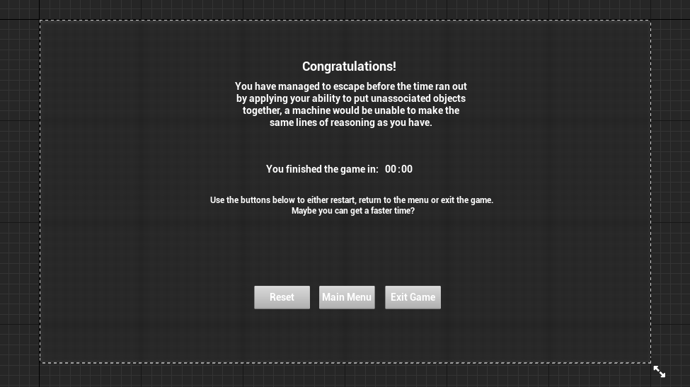

**Figure 35: The win screen in the UMG editor**

#### 6.6 - Finished Production

After implementing the UMG elements that worked with the game, it was considered finished and tests were done to ensure that it worked as expected. In appendix J are screenshots taken while in-game, these show a variety of screenshots which include the UI, the objects and shows the controller taking the inputs from the player and making a change to the environment based on the contents of it. The screenshots provided show the first few minutes of gameplay, as they show the initial starting point of what the player can see, and goes on to the different commands to look around the room, as well as the first shelf moving and interacting with it.

### Chapter 7 – Testing

#### 7.1 - Introduction

A full test plan has been provided in appendix C. This covers in detail the actions taken to test certain elements of the product, both for intended and unintended effects. The other sections of this chapter discuss in detail specifically the methods carried out while testing the game objects, and the player controller. Additionally, changes that were made to the design due to the results of testing are mentioned at the end of the chapter.

#### 7.2 - The Test Plan

Mentioned in the introduction, appendix C contains a test plan used to confirm that the game runs as expected, even when presented with situations that are not required to complete it. The plan covers the expected outcome, which is from a logical standpoint, and an actual outcome, which is the perceivable outcome within the game. The purpose of the test plan is to account for some of the potential inputs that could potentially break elements of the system, or cause errors to happen.

A specific test case which was important throughout the implementation process was test 8. This test was used to determine what states are being changed, and if it was being done correctly. The logic for these interactions and how they are affected is stated in table 6. There, it defines three potential states that an object can be in at any one time. Through the use of a print node and an int to string node, it is possible to print the number of any objects state variable to either the development command line or the in-game text box. For the purposes of this, the text was sent to the developer box. This test was useful throughout, and also played a part in making sure that the topic of test 9, which was interacting with objects that should not be interactable, was working correctly.

A set of tests that proved extremely useful throughout as well would be tests 2 through to 5. These tests covered the “text input” system, also referred to as the controller. These tests covered the handling of specific commands, and how they would affect the game. This is further discussed in section 7.4, which specifically looks at how the inputs for the controller were broken down and output so that they could be observed.

#### 7.3 - Game Object Testing

This section of the testing chapter will look at the process of introducing new objects to the game world and testing how they interact with each other. This section of testing took the longest to carry out and would get exponentially more complicated as more objects were made.

The testing requirements of an object were determined on an object-by-object basis. This meant that objects with fewer predicted uses, like the bolt, required less time testing as they would only be relevant a few times. Contrary to this, objects like the shelves and plinths would require more extensive testing, especially since they required direct input from other objects to progress.

Typically, the workflow for testing and creating a new object would go as followed:

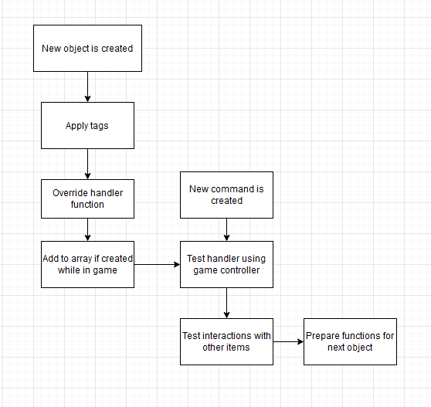

**Figure 36: Flowchart depicting the work order when testing an object.**

This is done repeatedly for new objects until all the functions done through the object handler are confirmed to work. In some cases, these functions act differently depending on the state variable (mentioned in 3.3.2) which means that the workflow is repeated multiple times. In total, this can lead to a very inefficient allocation of time. To fix this in the future, it could be possible to force the game into certain states, so that it does not require running through the entire game to the point that needs to be tested.

In the case of items like the lock or plinth, the workflow means that they can only be tested by completing the previous sections, which can sometimes take 2-3 minutes. This is compounded with making changes, which will require a new instance of the game, meaning this must be done again.

#### 7.4 - Controller Testing

To test the controller, it can be broken into two sections that require testing:

1. The input identifies the correct string to use
2. The controller finds the correct object

A simple way to test the outputs of the system is to use “print string” nodes in a way pictured below. The pictured nodes are from the text widget, which has three looping segments that are seen in figure 24, each of which has a separate string output. In the string output nodes, it appends them with prefixes stating which loop has identified the object. This was integral in determining the order of which an object will be identified for the sake of testing the individual objects and made it easier to understand the knock-on effects of adjusting the array list orders. The nodes for testing the controller are seen in figure 37, they have been changed so that they last on the screen for 15 seconds. The default for this is 2 seconds, which means they disappear before typing in a second command. The longer length means it is possible to type multiple commands, and by doing this it is possible to determine the order in the array an object has been put.

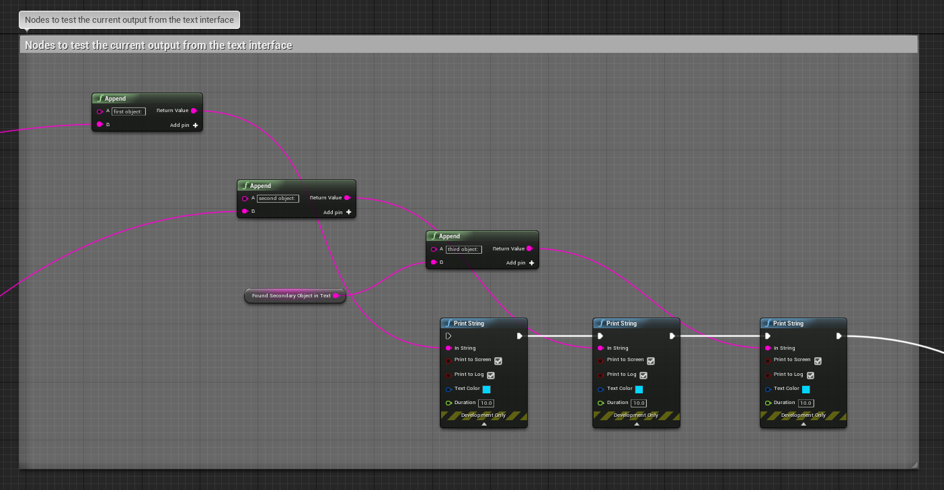

**Figure 37: The print nodes used to see how an output is categorized.**

### Chapter 8 - Evaluation

#### 8.1 - Evaluation Introduction

This chapter covers the acquirement and analysis of feedback on the product created in the implementation chapter. It discusses the feedback by generalizing them into six different findings, each of which tackles different aspects of the game and how they affect the consideration for how “successful” the game was at portraying the principles. To get an understanding of the product success in meeting expectations, it was evaluated under two pretences, a user evaluation, and a reflective evaluation.

#### 8.2 - User Evaluation

The user evaluation made use of a questionnaire made using Microsoft Forms (attached in Appendix F) and was sent with an application file for the game virtually to follow laws relating to social distancing due to Covid-19. The questionnaire involves qualitative and quantitative data recovery, with the quantitative questions being posed in the first person so their personal position on be gathered, whereas the qualitative questions were generalised. There are 11 questions in total on the questionnaire.

#### 8.2.1 - Questionnaire Design

The questionnaire was designed after the game was produced, and this was done so that the questions could be phrased in ways that would make the participant think about their actions in the game. To take a specific example, question 2 was worded the way it is as one of the key principles of the games design was that the player can tell what the next stage is, without knowing what the solution is. It was specifically done this way to also see if my personal understanding of flow in games had been properly used.

The questions were also done to get a wider spread of feedback, thus the qualitative and quantitative questions, both to have more points to discuss the success (or failure) of aspects of the game, but also to accommodate for the restriction on in-person interviews due to covid-19 guidelines.

#### 8.2.2 - Questionnaire Distribution

From the 15 participants contacted, 9 took part and provided consent for the data recovered to be used in this evaluation. The sample group that was used to identify participants consisted of peers from Northumbria University, and they were contacted through email to first acquire their consent to take part in the questionnaire, and secondly to provide the files required upon confirmation.

The files presented to participants include:  
1. A read me document containing a link to the questionnaire, and a statement saying that the participant information sheet should be read preceding any involvement with the project.

2. The Participant Information Sheet in the form of a word document detailing participant rights and contact details should further questions be required.

3. A folder containing the packaged version of the game for Windows computers. This application does not require an installer.

To uphold professional standard, and especially meet the standard set from the second finding in the literature review, no assistance was provided to any of the participants as to maintain the reliability of the questionnaire results.

#### 8.2.3 - Questionnaire Findings

Using the responses from the questionnaires, it is possible to determine multiple points in which the game could be improved and consider sections where it was successful in delivering the ideas that it was trying to convey. The full answers to the questions can be found in appendix F, answers that are relevant to the findings will be copied in this section. Because the questionnaires did not ask if the participant had finished the game, there is no definitive way to tell if any of them had managed to clear the puzzle. From the responses, it can be presumed that none of the participants had succeeded in winning the game.

#### 8.2.4 - Finding 1 - Confusing elements within the game

A frequent observation made by the participants is understanding the first element of the game; the shelfs. A reoccurring issue was that due to the naming system as mentioned earlier, with the shelves being labelled “first”, “second”, “third” and with no obvious way of telling this to begin with, many participants would get stuck trying to look at the shelf to see the book and carry on with the game. This can be seen in the responses to question 4 on the questionnaire:

Question 4: Did the timer run out while you were playing? If so, was there a specific section that caused you to lose a portion of that time?

Responses:

* “I could not figure out how to open the 2nd or 3rd drawer after getting the book and bolt.”
* “The timer did run out, I just didn’t make it very far at all – think the plinth confused me.”
* “My timer ran out around four times. The first two times, I was unable to figure out how to examine the first shelf.”
* “After the first shelf and finding the book”
* “The timer ran out while I was figuring out how to get to the third shelf the first time. The second time it ran out while I was trying to use the lock.”

The elements that caused the most time loss were the shelfs, and additionally the plinth served as a “fake-out” (defined as a trick or to misguide by Merriam-Webster 2021), an obvious element that one would presume is used here but is part of a different section. By including a misguiding element, it has further connected the narrative to that mentioned earlier with the intent to emulate how a machine would focus on a single element as it would numerically consider it a priority.

The fact that many of the participants focused on the plinth when they did not need to would imply that its presence in the puzzle might have overshadowed the other elements of the game. This could be due to the material issues discussed in 4.2.1, which makes it stand out immensely against the grey walls of the room.

#### 8.2.5 - Finding 2 - Understanding the next logical step

Another response that appears with the questionnaires was that the next goal in the game was difficult to deduce. This is partly supported through the responses to two of the questions:

Question 2: While playing, were you able to tell what the next step was?

Responses:

* Multiple participants answered with - “no”
* “I knew the goals of the game and found the objects, however was unable to put them into place and progress through the game”
* Not all of the time. It took a lot of trial and error”
* “Yes, after my first try I understood what to do pretty well until I reached a section later on”

Question 3: Did you encounter a situation where you lost the game? If so, were you able to determine what caused it?

Responses:

* “I lost the game because I ran out of time”
* “Yes but some of that was probably due to my inability to solve puzzles”
* “I wasn’t able to find out where to use the bolt and got stuck on that for about 20 minutes (two runs)”
* “Yes, the timer ran out”
* “I lost the game because I ran out of time.”

These responses aid the point that the game is difficult, which is an intended part of the design. Specifically, the next step is not an obvious one, and should be taken due to making abnormal decisions. The player is not penalised for guessing for this reason. This supports the conclusions from the literature review, wherein the Turing Test requires the participant to “prove they are not a machine through their actions” which is an abstract and difficult goal to achieve depending on the circumstances.

A consensus among the responses is that many of the players failed multiple times due to the timer running out. A quick fix to this would be to make the timer longer, which would likely reduce the number of times a player fails, but looking at question 11, this might not be necessary. Over 9 responses, the average score for the question “The use of a timer in game made the experience tense.” Was 7.44, with the highest score being a 10, and the lowest a 3. The evolution of failure within games has led to two distinct types of failing:

1. The game resets
2. The player is punished in some way, be it a life or a setback

The game makes use of the first option, as there would be no other way to setback the player regarding how the game works. A study done into the psychological impacts of responsibility (Perron, Wolf 2019) within a video game found that players do prefer having a sense of impact from failing, which is seen with the results of question 11.

#### 8.2.6 - Finding 3 - The presence of testing elements in the packaged game

Through a mistake in cleaning the unreal project before packaging it, some of the questionnaire responses shed light on elements of the game that needed more developing. These can be seen in a few responses to question 5:

Question 5: Did you encounter any errors while playing the game? If so, could you describe what caused them?

Response:

* “When I tried to ‘use bolt’ the chat would just say ‘object’. Also, the shelf could not be examined after taking the book from it.”
* “When I typed ‘lock’ into the command box, it said “object”, not sure if this was intended.”
* “When the level started, I saw blue text in the top right corner, this happened everytime I started.”

The initial part of the first response and the entirety of the second can be noted to a system that became obsolete but was not removed entirely after making the different iterations of the controller. One of the operations of it, “OnTextCommitNoCommand()” is activated whenever the text widget only detects an object. When this happens, it finds the object and prints the ‘description’ variable to the window. For many of the objects, this is the default value of “object”, leading to the occurrence of this issue in the command “use bolt”, as “use” is not a valid command.

Secondly, the issue of “the shelf could not be examined after taking the book from it” can be sourced from two points, when creating the text output for the text box when examining the shelf, it uses an if branch to determine if there is actually and object in it before appending a string with the appropriate information. This section of the branch does not end at the same point as the other branch, meaning the node to move the player character towards the shelf and rotating the camera does not play, meaning the player continues to stare in the same direction. While a minor issue, by testing it with other participants, the source of the issue can be easily determined.

The third response is due to the print nodes depicted in figure 37 being linked when packaging the project before distributing it. As part of the unreal exporting process, a “packaged” game is still considered a development mode, which is a condition that prevents the print nodes from working. By not unlinking, and if a packaged project would not trigger them, the nodes would print at the beginning of the level loading every time.

#### 8.2.7 - Finding 4 - The success of using a 3D environment

The attempt to use visual elements was not required to emulate an Interactive Fiction game, as mentioned in earlier chapters. To gauge the success of trying to “modernize” the game by using an environment, question 10 asked the participants to rate the statement “The use of a 3D environment to present the game aided my interpretation of the text” was presented. The average answer number was 6.89, with the highest answer being a 10, while the lowest was a 3. This would suggest that having the 3D space is not a requirement for creating an Interactive Fiction, and that instead time spent working on the environment could have been put into the UI or the game flow, which is supported by the answers to question 8; the average of which is 6.43. Looking at the ratings independently, of the 9 responses, 6 of them had answered with the number 6. This answer puts forward the idea that the UI was above average, but since an Interactive Fiction is based entirely through the use of a UI, this is not acceptable. These answers could potentially be due to the cut feature that allows the player to scroll through their past commands, which would have greatly improved the experience.

#### 8.2.8 - Finding 5 - The enjoyability of the game

The overall success of a game can be attributed to if the players enjoy the experience. While this might not be applicable to a horror, where the scarier and least enjoyable it is the better, for the case of the product, this has been included as part of the questionnaire. Question 12 asked the participant “I enjoyed my experience with the game.” To which the average score was 6.54, with the highest being a 9, and the lowest a 2.

The above average score is understandable. Especially considering the responses to the other questions, such as those to question 7:

Question 7: Are there any comments you would like to add that these questions did not cover?

Response:

* “The game could use more simpler puzzles.”
* “Could make it clearer on what to do next.”
* “A list of possible commands would be nice with examples.”
* “The descriptions of items could be more in depth to help figure out the next step.”

Looking at these, it would provide the reason for the low score as the game being too difficult, the attempts to improve the user experience had succeeded, but from the responses and the feedback provided it can be improved exponentially. It could have been possible to make a more enjoyable experience by introducing testers to the product at an earlier time, so that outside input could help improve the overall game.

#### 8.2.9 - Finding 6 - The application of a text narrative

The core aspect of an Interactive Fiction is the way in which is presents the world through text. Because the game produced uses both visual and text elements, it was not necessary to focus on these descriptions, as they typically include a lot of character associated with the world it is set in. To understand how the descriptions were perceived, question 9 asked the participant “The descriptions provided as part of the narrative helped form my next decision in game.” The average score for this question was a 6.54, but unlike the previous finding, most players (5) marked their answer with a 7, suggesting that the text element was more successful in improving the user experience than it was theorized.

#### 8.2.10 - Findings Conclusion

From the findings discussed above, the game succeeded in being difficult, as that was the intention, and that it was semi-well received by the participants. It was also clear as to which elements the game could be improved, with a focus on simplifying the puzzles, or potentially removing the 3D space and specifically keeping the narrative of the game world to the text boxes. The findings also provided clear ways in which this could all be improved, which is discussed later.

#### 8.3 - Project Goals, and the success at meeting them

As part of the project, a Terms of Reference document (appendix A) was created to establish the goals that will be met with this project. Within the TOR objectives chapter, the numbered list defines 11 specific objectives to be met over the course of the project. Of these, all but the 6th objective was met during the development (and excluding those that would naturally appear after this section).

The sixth objective was to produce a game design document. This was not done for the sake of time, as many game design documents require extensive writing that would only serve to repeat the contents of many chapters within this paper already. Also, reflectively looking at the work, many of the changes made throughout the implementation would not be accountable within a document, as they arose from the experience developed while working on the product, not from prior engagements with the engine and game design.

#### 8.4 - Reflective Evaluation

As mentioned in section 8.1, to determine the success of the product, a reflective evaluation is required. This section will look at sections of the project that were changed, any difficulties that were encountered and those that are still present in the version that was used for the questionnaires.

#### 8.4.1 - Text System

The most apparent difficulty with the system was managing the text inputs. It has already been discussed in depth in earlier sections, but what was not covered during them was that the existing documentation for widgets did not provide any help in using the inputs properly, which meant that developing this was a trial-and-error process entirely.

#### 8.4.2 - Models and Materials

Both the creation of models within Blender, and the usage of them within Unreal were not very difficult, but what was an issue would be the use of materials. An example of this issue can be seen on the plinth object shown in figure 38. On the left is the model inside of Unreal, and on the right is the model inside of Blender with the UV shading option. The two iterations use the same materials, but because of the specific process for exporting and importing, the material was not properly applied to the Unreal object.

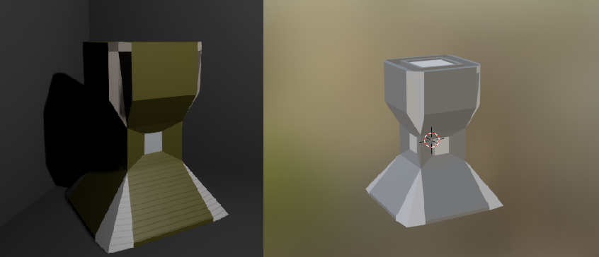

**Figure 38: The plinth model in both unreal and blender (respectively)**

This issue would be more prevalent with other objects, but a simple material that was provided by the engine was used for most of the objects.

Another issue with the materials was opacity. As part of the room, there is a light on the ceiling. To properly emulate this, the model in blender was made of three elements, the bulb, base, and glass. As part of this, the glass was given an opacity with its material in blender, but this was not exported, meaning that the material had to be created in Unreal. Figure 39 shows the results of exporting the pieces of the light model. The dome of glass on the unreal version of the model appears flatter, as the faces are not smoothed, but it does have the reflective quality around the outsides of the shape.

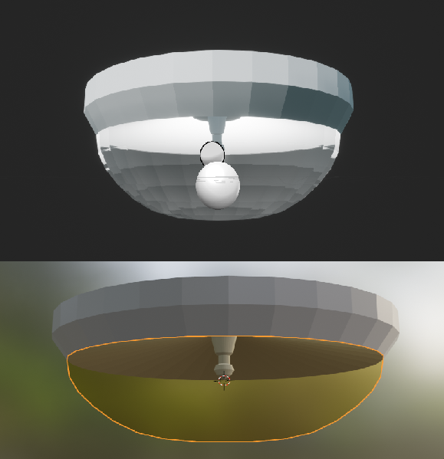

**Figure 39: The light model, with its components in unreal and blender (respectively)**

In total, this did not entirely disrupt the rest of the work, but it was required to enhance the user experience.

#### 8.4.3 - Changes to the Design Made Iteratively

Because of the growing understanding of the engine that was formed over the creation of the game, some of the previously planned elements were not created within the game.

* Examining objects that are held

Because of the issue caused by the view of the player being “chained” to the player character, the design idea of having a viewport on the left hand-side of the screen was not replicated. Additionally, if an object was held by the player, and examined, it would have provided them an opportunity to look at the item up close and rotate it using the mouse. This would have provided an avenue to hide a clue or the next step to solving the puzzle on objects that required the player to observe them, but due to the limitations of the camera, this was not implemented.

* Branching paths

Branching paths were not included in the game despite being mentioned in the requirements. This was due to two reasons:  
1) If there were to be branching paths, it would severely increase the complexity required for each object in the game, as there would be multiple different checks required each time a player interacted with it. This meant that both producing and testing the game would take much more time than is suggested and would interfere with finishing the project on time. If the base system for handling objects was supported by Unreal, like it is in software built for making this genre of game, this would entirely be possible.

2) For a branching path to work narratively, there must be different endings to branch towards. Because the intended idea for “escaping” only had one way out, this meant that branching would not confer any sense of success towards the player, such as finding a secret ending or escaping in a unique way.

* Dynamically sizing fields that track outputs

Adding this extra layer to the text box used for outputs isn’t necessary. For a situation where there are hundreds of objects, requiring meticulous interaction, then it would be required for the user experience to be bearable, but because the player will only interact with a few objects at a time, it would not be needed.

If this were to be done, it could be possible using a complex bind on the text box linked to a “slider” component on a widget, were the slider value directly translates to a position in an array, where each element of the array is an output that the player has seen.

#### 8.5 - What Could Have Been Done Differently

This section of the evaluation will discuss the elements of the project that personally could have been done differently. These differences are based on the experience gained as part of the project and are mostly to do with the planning of the implementation stage.

#### 8.5.1 - Abstract Inheritance

In section 3.3.4, the process of iteratively developing the controller has been detailed, but a key factor in why this process took as much time as it did was that by the final iteration, every new object needs a place function that can be used as both the primary and secondary object in a text command. If the project was to be done differently, making the abstract object that every world object was inherited from contain these functions in a highly abstract way would make it much easier to develop upon the flow of the game.

Especially considering that which is in section 3.3.6, as every new object required each function to be tested. Because these functions tended to be different, it meant that testing could be slower, or faster, depending on the point in the game at which they can be accessed.

#### 8.5.2 - Fully Designed Controller

Another change that could have been made early on was designing the controller to work around fluent text phrases, as opposed to iterating its development. The iteration process absorbed a lot of time both with updating the functions inside of objects retroactively, and understanding the logic required for the system as it was being developed.

#### 8.5.3 - More In-depth User Feedback

Due to Covid-19, the possibilities for acquiring feedback are extremely limited. If the circumstances were different, it would have been possible to perform in-person interviews which would provide information in much more detail which could potentially enable fixing problems mentioned in the game, and then acquiring feedback for a new build.

The user feedback could also be more in depth if it was acquired using a build that tracked what the user did, how the game reacted to it and then outputted it to a document that could be sent with the questionnaires so that user inputs could be analysed, and correlation between different sections and how the players tried to advance could be drawn.

#### 8.6 - Project Conduct Evaluation

This section of the evaluation will evaluate my personal conduct while both carrying out the research, and the implementation, and critically determine points in which scheduling could be improved. For most of the project, using Unreal and managing a large-scale project has been a learning process. Prior to doing this dissertation, the only projects of a similar scale would be other university assignments which were very direct in both teaching and marking schemes. Adjusting to the freedom of the project, and the long-time involvement was a difficult to begin with, but towards the Winter holiday, this became much easier to manage.

An initial point to discuss would be the allocation of time, and the priority placed on certain pieces of work. As part of the Terms of Reference (TOR), a document required to establish the intent for both the project, and the benefit to studies as a Computer Science student, a requirement of it was to produce a Gantt Chart (Appendix A, filled in to reflect the current moment in time) detailing how time would be spent so that it can meet the required deadlines. One issue that arose when producing this chart was that the expected time to create the game was impossible to predict, this is further evidenced by the fact that the main controller required a lot of iterative work, which wasn’t predictable due to a lack of experience working with the engine in this way. The chart made use of semester weeks to define specific dates, which did not accommodate for the Winter or Easter holidays provided but was used as a guidance for carrying out the work. The chart also did not detail which portions of the product would be ready at which points, this is most definitely a point in which organisation could be improved for future products; without a clear list of tasks and deadlines for when they should be done, some aspects of the project were carried out as they were required, which is not professional conduct.

#### 8.7 - Project Conclusion

This project has served as a basis for developing important skills within game development, an understanding and ability to carry out both the design and implementation is a base requirement of a game developer role, but it also requires an understanding of the other elements within game design. On top of the creation of the game, it has reinforced an understanding of the Unreal Engine, which was previously not a form of game development that I was greatly familiar with and also helped foster an understanding of 3D modelling and texturing which was also an unfamiliar topic. Additionally, the work carried out in this project coincided with educational studies carried out at the same time as it made use of C++, a programming language that is required for most game developers.

To critically look at the work carried out, it is clear there are elements in which it can improve. As mentioned throughout, the system for handling text is not native, and can be vastly improved given more time, the application of it also leaves much room for improvement, as the blueprints required for a new object require a lot of work to implement. In terms of what can actually be done in the game, it has been kept to a small scale. The use of agile development provided an appropriate outlook for developing the text system of the game, but it was only used specifically for that. A takeaway from the process would be that the developmental focus should not target a single element of the game, during the time that the system was iterated over, additions could have been made to the objects so that there was more to do in game.

The papers and principles discussed in the literature review provide points that can be used in the production of Interactive Fiction games, which can be used to modernize the genre further. Many of the concepts mentioned about the Turing Test were also not used and can serve as a basis for a variety of game designs.

#### 8.8 - Further Work

There have been numerous points throughout the project where there have been points that can be further developed, but due to time constraints and the scale of the project these have not been achieved. Potentially, in the future, these could be carried out. This section will expand a few of the ideas.

The initial change would be a complete rework of the system, and the abstract object that is inherited downwards. By making standardized versions of methods, like the “examine” function, it would be possible to cut down on further development time and make it easier to expand the list of objects, only overriding when required. Further to this, the system for handling text inputs could use a different method for acquiring the target of the command text, by changing the basis for the system it can make it easier to process the commands and wouldn’t require fixes like the “place” function in book handling both itself and the second object in a command, or the workaround required for distinguishing between shelves.

An element of the project that did not get expanded greatly was the creation of models and textures for implementation in the engine. Given more time, this could be explored, especially if the game was to be released as a public game. Increasing the fidelity of the game would improve both the user experience and general look of the game. The layout of the UI would also be considered a portion of the fidelity and figuring out how to make the camera and text boxes work like the layout depicted in figure 2 would also improve the experience.

Increasing the length of the game would also be work to carry out, taking it from a single room, it could be a variety of paths the player could take, providing a reason for players to play multiple times to see what happens.

The work done here also shows the potential success that other games featuring aspects of the Turing Test would find. Due to the research into the market, it is clear that it is an under-capitalized topic that provides interesting approaches and perspectives that can be implemented into a wide variety of game genres successfully. Both the topics discussed and Interactive Fiction genre emulation serve to show that despite their lack of market presence, it is still possible to create an engaging product in a very competitive industry where the uniqueness of a game can sometimes put it on the proverbial map.

## Chapter 9 - References

A.M. Turing (1950), I.-COMPUTING MACHINERY AND INTELLIGENCE, *Mind*, Volume LIX, Issue 236, Pages 433-460. [doi.org/10.1093/mind/LIX.236.533](https://doi.org/10.1093/mind/LIX.236.433)

Cambridge Dictionary (no date) *MACHINE | meaning in the Cambridge English Dictionary*. Available at: <https://dictionary.cambridge.org/dictionary/english/machine> (Accessed 18th November 2020).

Merriam-Webster (no date) *Machine | Definition of Machine by Merriam-Webster*. Available at: <https://www.merriam-webster.com/dictionary/machine> (Accessed 18th November 2020).

Merriam-Webster (2021) *Fake Out | Definition of Fake Out by Merriam-Webster*. Available at: <https://www.merriam-webster.com/dictionary/fake%20out> (Accessed 05/04/2021)

Searle, J, R., (1980). Minds, Brains, and programs. *Behavioral and Brain Sciences*, 3(3): 417-457 Accessed at: <http://cogprints.org/7150/1/10.1.1.83.5248.pdf>

Edelson, T. (1982). Stimulating understanding: Making the example fit the question. *Behavioral and rain Sciences,* *5*(2), 338-339. doi:10.1017/S0140525X00012425

Plotkin, A (2011). Characterizing, If Not Defining, Interactive Fiction. *IF Theory Reader*. pp 59 – 66

Accessed at: <https://www.ifarchive.org/if-archive/books/IFTheoryBook.pdf#page=65>

Buck, D (2019). Adventures In Interactivity. Accessed at: <https://tedium.co/2019/06/27/adventure-games-interactive-fiction-history/> (Accessed on 03/12/2020)

Mateas, M., Stern, A. (no date). Façade: An Experiment in Building a Fully-Realized Interactive Drama. Accessed at: <https://www.cc.gatech.edu/fac/Charles.Isbell/classes/reading/papers/MateasSternGDC03.pdf>

Christiansen, S. (2015). 80 Days. *The Interactive Fiction Database*. Accessed at: <https://ifdb.tads.org/viewgame?id=du51t0qrhjqlnbij> (Accessed 03/12/2020)

Montfort, N. (2011). Toward a Theory of Interactive Fiction. *IF Theory Reader*. pp 25-28

Façade. (2005). PC. *Playabl Studios*.

80 Days. (2014). PC: Steam, Mobile. *Inkle*.

Kelly, A. (no date). 80 Days Review. *PC Gamer*. Accessed at: <https://www.pcgamer.com/uk/80-days-review/> (Accessed on 08/12/2020)

Colossal Cave Adventure. (1976). PC. Crowther, W., Woods, D.

Marcus, P. M., Montfort, N., Prince, G. (2007) Generating Narrative Variation in Interactive Fiction. Available at: <http://citeseerx.ist.psu.edu/viewdoc/download?doi=10.1.1.689.4328&rep=rep1&type=pdf>

Zork I, II, III (1980). PC. *Infocom*.

Pucillo, N. (2020). What the Zork Games are (& why they’re so important). Available at: <https://screenrant.com/zork-text-adventure-game-call-duty-easter-egg/> (Accessed 08/12/2020)

Byrd, C. (2016). ‘The Turing Test’ Review: An AI game that achieves a rare harmony of gameplay and narrative. Available at: <https://www.washingtonpost.com/news/comic-riffs/wp/2016/09/09/the-turing-test-review-an-ai-game-that-achieves-a-rare-harmony-of-gameplay-and-narrative/> (Accessed on 08/12/2020)

Douglass, J. (2007). Command Lines: Aesthetics and Technique in Interactive Fiction and New Media. Available at: [https://library.um.edu.mo/ebooks/b17790128.pdf pp 22-23](https://library.um.edu.mo/ebooks/b17790128.pdf%20pp%2022-23)

Luminous Airplanes. (2012). PC. Farge, L., P.

Eliteediting. (2011). The Four Types of Nonfiction Explained. Available at: <https://eliteediting.com/resources/the-four-types-of-nonfiction-explained/> (Accessed 09/12/2020)

Anderson, R., M. Twenty Years on from Deep Blue vs Kasparov: how a chess match started the big data revolution. Available at: <https://eliteediting.com/resources/the-four-types-of-nonfiction-explained/> (Accessed on 09/12/2020)

Detroit: Become Human. (2018). Console: Playstation 4. *Quantic Dreams*.

The Hobbit (1982). PC. *Beam Software*.

Unreal Engine. (no date). *Unreal Engine 4 Documentation*. Available at: <https://docs.unrealengine.com/en-US/index.html> (Accessed on 10/01/2021)

Unreal Engine. (no date). *UMG UI Designer*. Available at: <https://docs.unrealengine.com/en-US/InteractiveExperiences/UMG/index.html> (Accessed on 20/03/2021)

Inform. (2019). *About | Inform 7.* Available at: <http://inform7.com/about/> (Accessed on 21/01/2021)

Phan, M. H., Keebler, J. R. and Chaparro, B. S. (2016) ‘The Development and Validation of the Game User Experience Satisfaction Scale (GUESS)’, Human Factors, 58(8), pp. 1217–1247. doi: 10.1177/0018720816669646.

Padilla-Zea, N., Sánchez, J. J. G., Simarroa, F. M., Vela, F. L, G. (2011) ‘Playability: analysing user experience in video games’, Behaviour & Information Technology, 31:10, 1033-1054, doi: [10.1080/0144929X.2012.710648](https://doi.org/10.1080/0144929X.2012.710648)

Perron, B., Wolf, M. J. P. (2009) “Fear of Failing? The Many Meanings of Difficulty in Video Games”, The Video Game Theory Reader, pp. 237-252. Available at: <https://www.jesperjuul.net/text/fearoffailing/> (Accessed 08/04/2021)

Itch.io, (no date) “Game Design Document (GDD) Template” Available at: <https://vitalzigns.itch.io/gdd?download>

Ackerman, D. (2017) "Explore the groundbreaking Colossal Cave Adventure, 41 years on" Available at: <https://www.cnet.com/news/a-groundbreaking-computer-game-returns-41-years-later/>

Morena, J., H. (2016) "The Interacitve Fiction Renaissance" Available at: <https://www.gameskinny.com/wjwcw/the-interactive-fiction-renaissance>

Stuckey, H. (no date) "Exhibiting The Hobbit: A tale of memories and microcomputers" Available at: <https://www.kinephanos.ca/2014/the-hobbit/>

Thompson, T. (2020) "The Story of Facade: The AI-Powered Interactive Drama" Available at: <https://www.gamasutra.com/blogs/TommyThompson/20200423/361473/The_Story_of_Facade_The_AIPowered_Interactive_Drama.php>

Hartup, P. (2015) "Inkle's 80 Days is a brilliant game that isn't really a game at all"

Available at: <https://www.newstatesman.com/killing-time/2015/01/80-days-brilliant-game-isnt-really-game-all>

O'Connor, A. (2018) "Fallen london redisgn spruces up the horror, the horror"

Available at: <https://www.rockpapershotgun.com/fallen-london-website-redesign>

Heaney, D. (2020) "The Turing Test out now on Nintendo Switch"

Available at: <https://square-enix-games.com/en_GB/news/turing-test-nintendo-switch>

Fulton, W. (2018) "'Detroit: Become Human' Review" Available at: <https://www.digitaltrends.com/game-reviews/detroit-become-human-review/>

Aleem, S., Capretz, L.F. & Ahmed, F. (2016) Game development software engineering process life cycle: a systematic review. J Softw Eng Res Dev 4, 6. <https://doi.org/10.1186/s40411-016-0032-7>

Kanode, C., M. & Haddad, H., M. (2009) "Software Engineering Challenges in Game Development," 2009 Sixth International Conference on Information Technology: New Generations, Las Vegas, NV, USA, pp. 260-265, doi: 10.1109/ITNG.2009.74

## Chapter 10 - Appendix

### 10.1 Appendix A – Terms of Reference

**KV6003: Individual Computing Project**

Project Terms of Reference

James Robert Leslie Davis

W17000890, Computer Science with Games Development

**An Interactive Fiction exploring the principles of the Turing Test**

John Rooksby & Nick Dalton

General Computing Project

#### An Interactive Fiction exploring the principles of the Turing Test

##### Background

The aim of the project is to develop a playable demo for an interactive fiction about the Turing Test. It will explore and inform the player about the principles involved in the test.

To explore the principles of the Turing Test and develop an appropriate design for a game, I will research relevant papers that will aid my understanding of these principles. The main article that will be reviewed is the one produced by Turing himself in the 1950s, titled “Computing Machinery and Intelligence”, (Turing 1950). In this paper, Turing presents the Imitation Game, and also details possible conflicting theories and ideas. By looking at this as a foundation for the rest of the research, it will help develop a greater understanding of what a “thinking machine” is. Other articles, like the one by Moor (2003), provide additional insight into the topic past what Turing himself has written.

The field of “thinking machines” is an interesting one due to its impact on Computer Science as a whole, artificial intelligence forms a large part of society, but we have been unable to create a free-thinking machine. I do not intend to create one such machine, but research into the field is invaluable even in the game sector, as many games have a heavy reliance on AI for NPCs, storytelling, or even generation.

To fully understand the Imitation Game and the principles behind it, looking deeply into the conflicting theories (such as The Chinese Room by Searle, 1982) will reinforce the conclusions provided by Turing’s paper on the matter, and will diversify what a “thinking machine” can be defined as, and how, if possible, one would be invented. The purpose is not to create one, but by reporting my findings in the project, it may aid in research in the future. While the Chinese Room argument does not directly add to that of the Imitation Game, it is considered an important piece of rhetoric surrounding the deceitful nature that many consider the game to be in its entirety. This opinion is reflected in Searle’s work, as he describes a situation in which one would draw a different interpretation of a machines action solely because you lack a certain piece of knowledge (Searle 1982). This sentiment is also shared in the Ada Lovelace test, one that instead focuses on how a machine comes to produce an output, rather than the observation of said machine (Bringsjord et al 2003).

General understanding of the Imitation Game would dictate that a machine is capable of passing if it can answer the questions ask to it as if it were a human, and the answers given could not be differentiated from those given by actual humans. To achieve and present this in a video game will prove to be one of the most difficult tasks involved with the entire project. Additionally, being the only person working on this video game will prove to be a challenge, as most of the projects that I have taken in the past have been done as part of a group. Should the scope of the work get to large, it will not be possible to have like-minded individuals aid in the development of it, as all work included should belong solely to me.

Before carrying out research into other elements of a thinking machine, and how Turing’s paper could be analysed, I first sought out what a thinking machine would be defined as, as this would help serve the basis for any future research. The research into this answer is what inspired me to choose this as a topic for the project. Turing himself answered the question by saying that a thinking machine would be created, “using every kind of engineering technique”, and that its operation cannot “be satisfactorily described” due to the experimental nature of its production (Turing 1950). The era in which this paper was written was before the onset of home PCs (Personal Computers), nowadays, the definition of a machine would be considered, “a mechanically, electrically or electronically operated device for performing a task” as defined by Merriam-Webster

The research involved with the project does not stop with the Imitation Game and Turing’s thinking machines but will also encompass learning about the video game genre of “Interactive Fiction”. This presentation form for video games is not as popular as it once was due to the improvements of hardware and software, but they are still a viable method for intriguing the players. One notable interactive fiction game would be “80 Days”, a mobile interactive fiction game that was nominated for multiple BAFTA awards (BAFTA 2015) and received Time’s Game of the Year award for 2014 (Peckham 2014).

Additionally, research into types of video games will also delve into games that have similar topics, such as a game by the name of “The Turing Test”. A well-received first-person puzzle game, “The Turing Test” explores the ideas behind a machine being able to think for itself, but also the general cognition that a machine will always lack. This product choice was made to fit with the modules and course that I am taking, Computer Science with Games Development, and will be able to utilize my experience from second year in the creative process. The product design will be achieved using Ideation, which will use the literature review to produce multiple design ideas, with the goal of developing them to a point which is usable.

I believe that carrying out the research and synthesis portions of this project will greatly improve my understanding of the elements involved. In the future, I plan on entering the game development sector, so having the experience of developing the product by myself will be extremely useful for the sake of employability.

##### Proposed work

* A report used for the basis of video game creation, this report will perform a literature review on relevant journals and articles about the Turing Test, and review any relevant video game media that share a topic or genre.

The report will contain the literature review performed during the project, which will be used in the Ideation process for designing the product. It will have a variety of articles and journals that are used for the literature review which will focus on the Turing Test, and will contain less educational articles for the sake of evaluating and comparing similar genres used within video games.

To ensure that the report does not tackle questions of philosophy, I will stick to researching the Turing Test as a main topic and will only refer to “thinking machines” as a side point. Part of the argument around the Turing Test is the debate on whether machines ‘should be allowed’ to think rather than ‘can they think’, which moves away from the underlying principle that I’m researching. Additionally, by the end of the report, a clear conclusion should be made, which combines that of the literature review and my own analysis.

* A video game that will fit the “interactive fiction” genre, based on the Turing Test. It will be created using a game engine

This section of the project would fulfil the product requirement, and has many steps involved in the work. While undecided, there are many different methods for creating a video game that will fulfil the specifics that are required. One such is Unreal, a game engine provided by Epic Games, which allows the user to create games using “blueprints”, or via coding in C++. A counterpart to Unreal would be Unity, another game engine that instead uses C# for a coding basis.

Depending on the presentation form decide on, either of the two engines would be suitable, but there are also other options available, meaning that the choice isn’t limited between the two. But, to avoid learning a new programming language that might be suitable, or might not, the one that will be decided upon will be a language that I already know.

To properly convey the messages that the video game will contain, there must not be an “illusion of choice” with how the game plays out. This is a common trope seen within narrative driven stories, where the player is given multiple options or paths, but they lead to the same end. Being able to do this within the confines of the chosen presentation method will be difficult and serve as another part of the project that will challenge my abilities (Mark 2002).

##### Aims of project – General

1. To analyse the theory introduced with the Turing Test, and the surrounding critiques of it. This will explore arguments about the test, such as the Chinese Room, and how they conflict with Turing’s paper. Research into Interactive Fiction games will also be carried out. Both the literature review and game review will be used with ideation to produce designs for a video game.
2. Using ideation, I will create multiple concepts that can be used to produce a thought-provoking Interactive Fiction demo. When the implementation of these concepts is finished, user evaluations will be carried out to determine how well it has been implemented, and if it has achieved my expectations.

##### Objectives

The following list of objectives is based on the aim of the project.

1. Identify relevant articles and perform a literature review.
2. Identify video games that are of a similar genre, or topic, and review the findings.
3. Using ideation, document the creative process with methods such as paper-prototyping or mind maps, create multiple ideas that can be used to design the product. Requirements should be established based on these ideas.
4. Throughout the project, develop upon the core skills involved in game design, such as storytelling and critical thinking.
5. Design the user interface and presentation style of the product using storyboarding and show the development of these styles through iterative designs.
6. Create a Game Design Document that will detail all of the design processes and choices involved with the creation of the product.
7. Creating the product.
8. Producing a test plan, which can then be used in the testing process to determine if the product works as intended.
9. Evaluating the finished product.
10. Acquiring feedback from users and detailing feedback.
11. Perform reflective feedback based on personal & user evaluation and compare it against the desired objectives of the project.

Skills

During the project, these skills are ones that I already have, but should improve throughout:

* Individual Project Management
* Time Management
* Relevant Literature Reading
* Graphics Design
* Sound Design
* World Design
* Note Taking
* Critical Analysis

These skills are new to me, and will be developed upon:

* Building AI
* Player Interaction

##### Sources of information

A. M. TURING, (1950) I.—COMPUTING MACHINERY AND INTELLIGENCE, Mind, Volume LIX, Issue 236, Pages 433–460, [https://doi.org/10.1093/mind/LIX.236.533](https://doi.org/10.1093/mind/LIX.236.433)

G. Mark (2002) *The Educational Benefits of Videogames,* Available at: <http://irep.ntu.ac.uk/id/eprint/15272/1/187769_5405%20Griffiths%20Publisher.pdf>

M. Peckham (2014) *Top 10 Video Games,* Available at: <https://time.com/3582118/top-10-video-games-2014/>

BAFTA (2015) *British Academy Games Awards 2015*, Available at: <http://awards.bafta.org/award/2015/games>

Merriam-Webster (no date) *Machine | Definition of Machine*, Available at: <https://www.merriam-webster.com/dictionary/machine> (Accessed 10th October 2020)

Searle, J. (1982). The Chinese room revisited. *Behavioral and Brain Sciences,* *5*(2), 345-348. <https://doi.org/10.1017/S0140525X00012425>

Bringsjord S., Bello P., Ferrucci D. (2003) Creativity, the Turing Test, and the (Better) Lovelace Test. In: Moor J.H. (eds) The Turing Test. Studies in Cognitive Systems, vol 30. Springer, Dordrecht. <https://doi.org/10.1007/978-94-010-0105-2_12>

##### Resources

The project will not require access to lab equipment, and will be possible to do so with the following:

* Computer
* Game engine
* Online article access

##### Structure and contents of project report

**Title**

**Abstract**

**Contents**

1. **Introduction**

**Analysis**

* (2) Literature Review
  + (2.1) The Imitation Game – A chapter analysing the original paper by Turing
  + (2.2) The Chinese Room – A chapter covering the response to the Turing Test by Searle
  + (2.3) The Ada Lovelace Test – A chapter covering the response titled after Ada Lovelace
* (3) Game Review
  + (3.1) Interactive Fiction – Interactive Fiction as a genre, and the key points involved in replicating it
  + (3.2) Similar Video Games – Video games produced in the industry that present similar ideas or share a name with the test
* (4) Design Ideation – Development of the concepts that will be used in the product based on the different methods of ideation used. Presenting the choices that can be made with the games design.
* (5) Requirements – Using the MoSCoW (Should have, Could have, Would have) method to determine requirements of the design, which are both functional (requirements of the base code for the game to work) and non-functional (requirements that the player would propose for the game to be appealing to them).
* (6) Tools and Techniques – Discussing the relevant and available tools for use in producing the game, such as the engine being used and the values of the possible choices, the methodologies to be used in the development stage and the reasonings behind them. **Synthesis**
* (7) Product Design – Involves storyboarding and writing a design document that will provide visuals to the concept that the game will follow, providing a basis to refer to during development to ensure it is relevant. This chapter will act as a discussion for explaining the decisions that have been made.
* (8) Implementation – Chapter denoting what happened during the implementation, with evidence and examples of code. Using this, an explanation of what was meant to happen with the product, and what was unexpected during the development.
* (9) Testing – Documents dictating what will be tested in the final product, how testing will be carried out and a planned list of items that should be done before considering the product “finished”.

**Evaluation**

* (10) User evaluation – Will cover two questionnaire sheets being used to ask the participants, and examining what the responses are.
* (11) Product evaluation – Evaluating the product based on the synthesis sections and objectives listed within the TOR, critically analysing the product.
* (12) Project conclusion – Drawing conclusions on the project as a whole, and performing reflective work.
* (13) Further work – Comparing the reflections in the conclusion, suggesting what could possibly be done to further the work within the project if given the opportunity.

**References**

**Appendix**

##### Marking Scheme

Marking Weight:

Report: 60%

* Abstract & Introduction (5%)
* Analysis (30%)
* Synthesis (30%)
* Evaluation & Conclusions (30%)
* Presentation (5%)

Product: 30%

* Fitness for Purpose (50%)
* Build Quality (50%)

Viva: 10%

Abstract and Introduction

|  |  |
| --- | --- |
| **DESCRIPTION OF QUALITY** | **MARK RANGE** |
| The abstract and introduction are wholly inadequate or several of the elements are missing. | **0 - 1** |
| A barely acceptable Abstract and/or Introduction - adequate in some respects but with major deficiencies. Most of the elements listed above are present but some are missing or flawed. | **2** |
| An adequate Abstract and Introduction but not in any way outstanding. May show some inadequacies of style and/or structure, or minor omissions. The introduction lacks no major elements – background, aims and objectives, subject of the work, and plan of the study; alternatively, one missing element may be balanced by excellence in other respects. | **3** |
| A clear, accurate and concise Abstract and Introduction that cover all required aspects as listed above. May have some outstanding aspects but is not wholly outstanding. | **4** |
| An outstanding Abstract and Introduction which read well, cover all required areas, exhibit no factual errors, give sound justification for choosing this topic as a computing project, and convey an excellent understanding of the work to be done. | **5** |

Analysis

|  |  |
| --- | --- |
| **DESCRIPTION OF QUALITY** | **MARK RANGE** |
| Very poor. Little or no discussion of alternative approaches to the problem, techniques, tools or the principles relating to the problem area. | **0 – 5**  (< 20%) |
| A discussion which is inadequate in many respects but at least presents most of the areas listed above. | **6 – 11**  (<40%) |
| An adequate discussion of the problem area. It is clear what problem is being solved, and the work covers the other required areas: literature review, justified requirements, available tools/techniques and alternative methods of solution. Adequate but in no respect outstanding. | **12 – 17**  (<60%) |
| A good analysis which successfully identifies the underlying principles behind the problem area and provides a sound justification of requirements. The literature review demonstrates a critical approach to the material. The different approaches to the solution of the problem and available tools / techniques are explored. Minor weaknesses may be balanced by excellent features; on balance good but not wholly excellent. | **18 – 20**  (<70%) |
| An excellent analysis which shows good understanding of the underlying principles behind the problem area and gives a thorough discussion and justification of requirements. The literature review consistently demonstrates a critical approach to the material. The different approaches to the solution of the problem and available tools / techniques are explored, and well-justified decisions presented. May have some outstanding features; on balance excellent but not wholly outstanding. | **21 – 23**  (<80%) |
| An outstanding analysis which shows excellent understanding of the underlying principles behind the problem area and gives a thorough discussion and justification of requirements. A full appraisal of possible approaches to solving the problem and available tools/techniques. The work shows particular insight or originality in its approach. | **24- 30**  (80%+) |

Synthesis

|  |  |
| --- | --- |
| **DESCRIPTION OF QUALITY** | **MARK RANGE** |
| An inadequate discussion of the solution of the problem. | **0 – 5**  (< 20%) |
| A discussion of the problem solution which is in some respects adequate but fails to address key issues or important aspects of the process. | **6 – 11**  (<40%) |
| An adequate discussion of the problem solution which exhibits no major flaws and provides discussion and justification that relate to at least design, implementation, and testing (or equivalent activities) but is not outstanding in any respect. | **12 – 17**  (<60%) |
| A discussion of the problem solution which is on balance good, and may be excellent or outstanding in some respect. At least adequate in all respects; minor weaknesses may be balanced by excellent features. Displays a good understanding of the issues and techniques involved. | **18 – 20**  (<70%) |
| A discussion of the problem solution which is on balance excellent, and may have some outstanding features, but is not wholly outstanding; any weaknesses must be few and minor. Thorough exploration of a range of decisions, showing an excellent understanding of the issues and techniques involved throughout product development. | **21 – 23**  (<80%) |
| An outstanding discussion of the problem solution which explores all aspects of the application of methods/tools used. The discussion of decisions made demonstrates an excellent understanding of the issues and techniques involved and critically considers a range of novel or creative solutions. | **24- 30**  (80%+) |

Evaluation and Conclusions

|  |  |
| --- | --- |
| **DESCRIPTION OF QUALITY** | **MARK RANGE** |
| Little or no evaluation is offered of the product or the student’s performance. Conclusions and recommendations are missing or inadequate. | **0 – 5**  (< 20%) |
| Some attempt at an evaluation and conclusion, but the work is weak in at least two sections. Evaluation of the product, choice of methods and tools and personal progress and performance is present but the extent or quality is inadequate; and/or the conclusion has significant omissions in the comparison between the main aims or purposes of the project and the results obtained or work done, or the recommendations for further work are missing or ill-considered. On balance, the standard of work is not acceptable. | **6 – 11**  (<40%) |
| The evaluation and conclusions are on balance acceptable, but the work is weak in at least one section: some significant issues may be omitted from the product or process evaluation, or the discussion may lack depth; conclusions may be incomplete, or the recommendations for further work are limited and do not show the necessary broader perspective. Not outstanding in any respect. | **12 – 17**  (<60%) |
| A sound evaluation of the product and the project process that covers a good range of issues. The conclusion compares the aims and purpose of the project and the results obtained or work done. Recommendations for further work are well-considered and may show a broader perspective than that of the project. No section has serious weaknesses, and there may be excellent or outstanding features. On balance the work is good but not wholly excellent. | **18 – 20**  (<70%) |
| An excellent evaluation of the product and the project process that covers a good range of issues with no more than minor omissions in any section. The conclusion gives a complete comparison between the aims and purpose of the project and the results obtained or work done. Recommendations for further work are well-considered and show a broader perspective than that of the project. May have outstanding features; on balance excellent but not wholly outstanding. | **21 – 23**  (<80%) |
| An outstanding evaluation of the work undertaken, incisive, self-critical and complete in all respects. The conclusion gives a complete comparison between the main aims or purposes of the project and the results obtained or work done. Recommendations for further work take a broader perspective than the project and show particular insight or originality. | **24- 30**  (80%+) |

Presentation

|  |  |
| --- | --- |
| **DESCRIPTION OF QUALITY** | **MARK RANGE** |
| The whole report, a significant part or several parts is/are very difficult to understand, or the report as a whole requires considerable effort from the reader to follow. | **0-1** |
| The report communicates to a satisfactory degree throughout, without too much effort required by the reader, despite a number of weaknesses on the above criteria. | **2** |
| The report in general communicates well and has few and only minor weaknesses on the above criteria. | **3** |
| A very good level of communication to the reader is achieved throughout the report. The report is within the maximum allowed length and a word count is provided. | **4** |
| The report is excellent on all the above criteria and communicates exceptionally well to the reader. The report is within the maximum allowed length and a word count is provided.. | **5** |

Product

|  |  |
| --- | --- |
| **FITNESS FOR PURPOSE (50%)** | **Mark Range**  **(to total 50%)** |
| Meeting of Requirements as identified during project.  Other criteria & deliverables (specify) :-  **Default criteria:**  Meeting of requirements as identified during project:  Quality and suitability of implemented functionality. | To be agreed  0 – 25  0 – 25 |
| **BUILD QUALITY (50%)** | **Mark Range**  **(to total 50%)** |
| Criteria & deliverables (specify) :-  **Default criteria:**  Quality of requirements specification  Quality of design  Quality of implementation  Quality of testing | To be agreed  0 – 10  0 – 15  0 – 15  0 – 10 |

Demonstration / Viva

|  |  |
| --- | --- |
| **Mark Range** | **Presentation** |
| 0-1 | Presentation / demonstration is deficient in most of the listed criteria and / or does not adequately communicate understanding of the key elements of the work. |
| 2 | On balance, the presentation is barely adequate but at least communicates a useful level of understanding of the work done. |
| 3 | A good presentation, conveying a clear understanding of the work done; may show substantial weakness in no more than two of the listed criteria. |
| 4 | An excellent presentation which meets all the listed criteria with only very few and minor weaknesses. |
| 5 | An exceptionally clear, well-structured and engaging presentation of the work done, meeting all listed criteria to a very high level. |

|  |  |
| --- | --- |
| **Mark Range** | **Handling** |
| 0-1 | Most questions received weak answers or no answer, and / or student showed little familiarity with code or other major deliverables. |
| 2 | Answers to questions and explanations of deliverables were on balance acceptable. Some poor answers or difficulty explaining code or other deliverables. |
| 3 | Answers to questions were on balance good. Student showed familiarity with code and other and gave clear explanations |
| 4 | All answers to questions and explanations of code and other deliverables were well-focused and good or excellent in content and clarity, showing an excellent understanding of the work and its context. |
| 5 | Answers to questions and explanations of code and other deliverables were exceptionally clear, thorough, succinct and relevant, and demonstrated an outstanding understanding of the work done and the subject context. |

##### Project plan

The main objectives will be broken down into separate tasks so that they can be scheduled effectively. Pieces that require direct checking (such as the ethics form and the report) will be broken down into first drafts, and final drafts. This will provide a date that the work should be finished by, which will make sure that nothing falls behind schedule. The time being dedicated to each task is estimated based on how important it is to the overall project, for example, the report has 100 hours estimated time dedicated on writing it alone, and including the pre-required work of research it should take over 220 hours.

By using and modifying a free Gantt chart template provided by Microsoft, I have planned out the following weeks that the project will require,

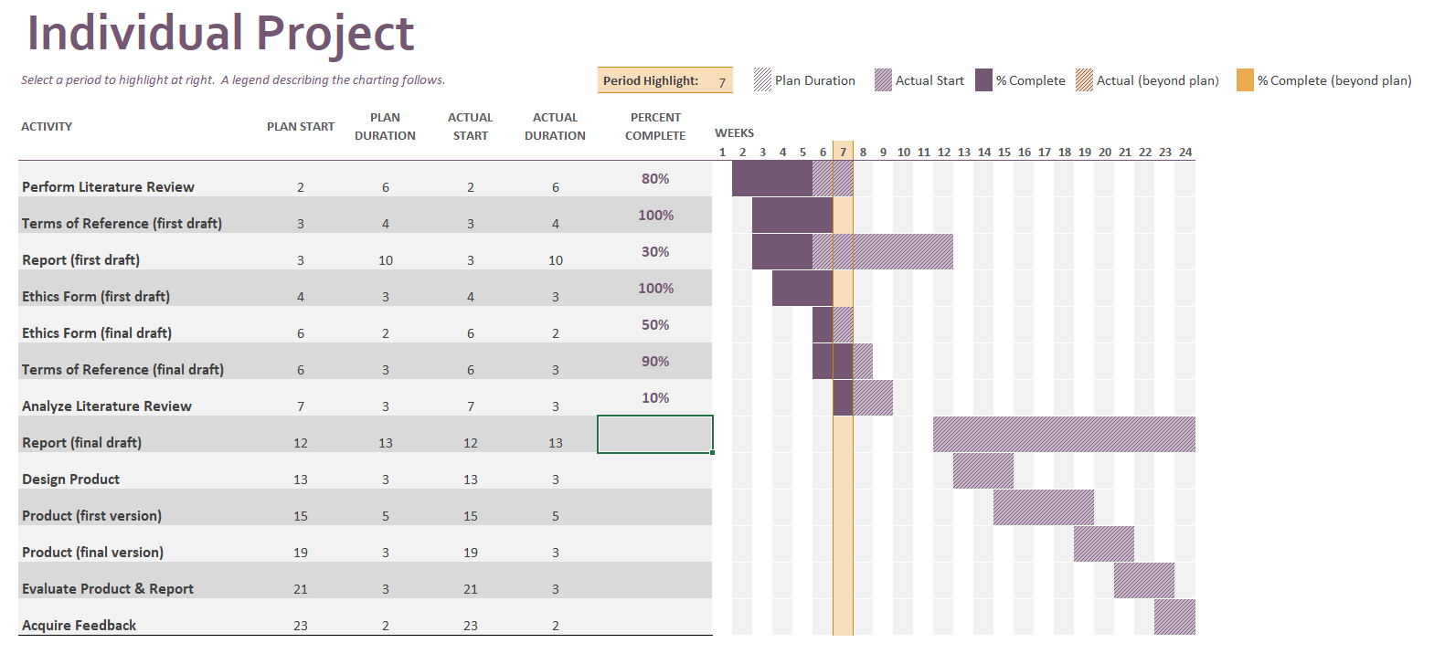

And with a table of my own, I have planned the hours I expect each task will take, including the specific weekdays that each week will begin and start on.

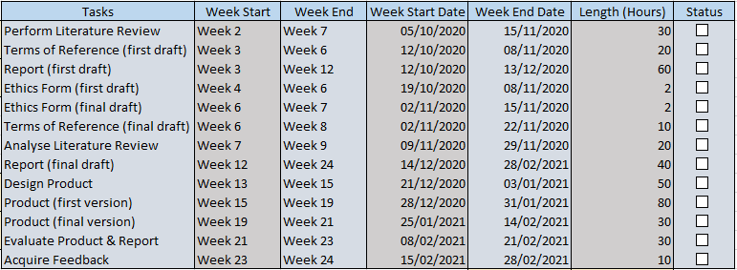

Both of these tables do not accommodate holiday time, but the only expected work that overlaps with out of semester time would be finalizing the report and using ideation to design the product, which are not strenuous and should not interfere with the break from university.

##### Appendix: Ethics Form

##### Appendix: Risk Assessment Form

|  |  |
| --- | --- |
| Student Name | James Robert Leslie Davis |
| Student ID | W17000890 |
| Student Email | [W17000890@northumbria.ac.uk](mailto:W17000890@northumbria.ac.uk) |
| Course Title | Computer Science with Games Development |
| Project Title | An Interactive Fiction exploring the principles of the Turing Test |
| Project Location | N/A |
| List the Significant Hazards associated with your project | N/A |
| List the other people at risk | N/A |
| Describe the working procedures to be used to minimise risk | N/A |
| Are any other Risk Control Measures needed? | N/A |
| When will you and your supervisor review the risk assessment? How will the risk be monitored on an ongoing basis? | N/A |
| Are you aware that no-one is allowed to work alone in the specialist laboratories | Yes |
| Student Signature |  |
| Supervisor | John Rooksby |
| Supervisor Signature |  |
| Second Marker | Nick Dalton |
| Second Marker Signature |  |
| Date of Agreement |  |

##### Appendix: Consent and Participant Information Sheets

The following sheets were taken from the handbook, and may be subject to change by time they are used.



**Faculty of Engineering and Environment**

##### RESEARCH PARTICIPANT CONSENT FORM TEMPLATE

|  |  |
| --- | --- |
| **Name of participant** |  |
| **Organisation** |  |
| **Researcher’s name** | **James Robert Leslie Davis** |
| **Title of research project/dissertation** | **An Interactive Fiction exploring the principles of the Turing Test** |
| **Programme of study** | **Computer Science with Game Development** |
| **Supervisor’s name**  **and email address** | **John Rooksby**  **John.Rooksby@northumbria.ac.uk** |

**Brief description of nature of research and involvement of participant: As a participant, they will be performing a Q&A play test (Quality & Assurance), were they will play a demo of a video game, rate it on a System Usability Scale (SUS) and fill out a short questionnaire**

###### Standard statement of participant* consent (please tick as appropriate)

I confirm that:

I have been briefed about this research project and its purpose and agree to participate*

I have discussed any requirement for anonymity or confidentiality with the researcher**

I agree to being audio recorded/filmed/photographed ***

***\**** *Participants under the age of 18 normally require parental consent to be involved in research.*

*\*\*\* Delete as appropriate*

**\*\*Specific requirements for anonymity, confidentiality, data storage, retention and destruction**

**Signed Date**

**Standard statement by researcher**

I have provided information about the research to the research participant and believe that he/she understands what is involved.

**Researcher’s signature ……………………………………….**

**Date ……………………………………….**



**Faculty of Engineering and Environment**

##### RESEARCH PARTICIPANT INFORMATION SHEET TEMPLATE

|  |  |
| --- | --- |
| **Name of participant** |  |
| **Organisation** | **Northumbria University** |
| **Researcher’s name** | **James Robert Leslie Davis** |
| **Title of research project/dissertation** | **An Interactive Fiction exploring the principles of the Turing Test** |
| **Programme of study** | **Computer Science with Games Development** |
| **Supervisor’s name** | **John Rooksby** |

|  |
| --- |
| **Project overview:** |
| **The project contains a report and product, which make use of articles and journals relevant to The Turing Test, an article released by Alan Turing in the 1950s which explored the idea of machines capable of imitating humans.** |
| **Project aims:** |
| **The aims of the project is to produce a report analysing the Turing Test, and to produce a demo for an interactive fiction game. To evaluate the demo, participation is required in the form of user testing. This testing will be done through two questionnaires that are based on the contents of the demo.** |
| **Information required and outline of any potential risks involved:** |
| **There are no inherent risks involved with demoing the product.** |
| **How the information will be stored and published (if applicable):** |
| **Personal information detailed in the consent forms will be stored on a computer, which will only be published if requested by the University, this information will not be used for any data analysis, and is solely to prove that partaking in the questionnaire has been done with consent. Data obtained through the SUS and written questionnaires will be used in a report to evaluated the product. Questionnaire forms will be kept anonymous.** |
| **Any other information deemed relevant to the project:** |
| **N/A** |

### 10.2 Appendix B – Gantt Chart

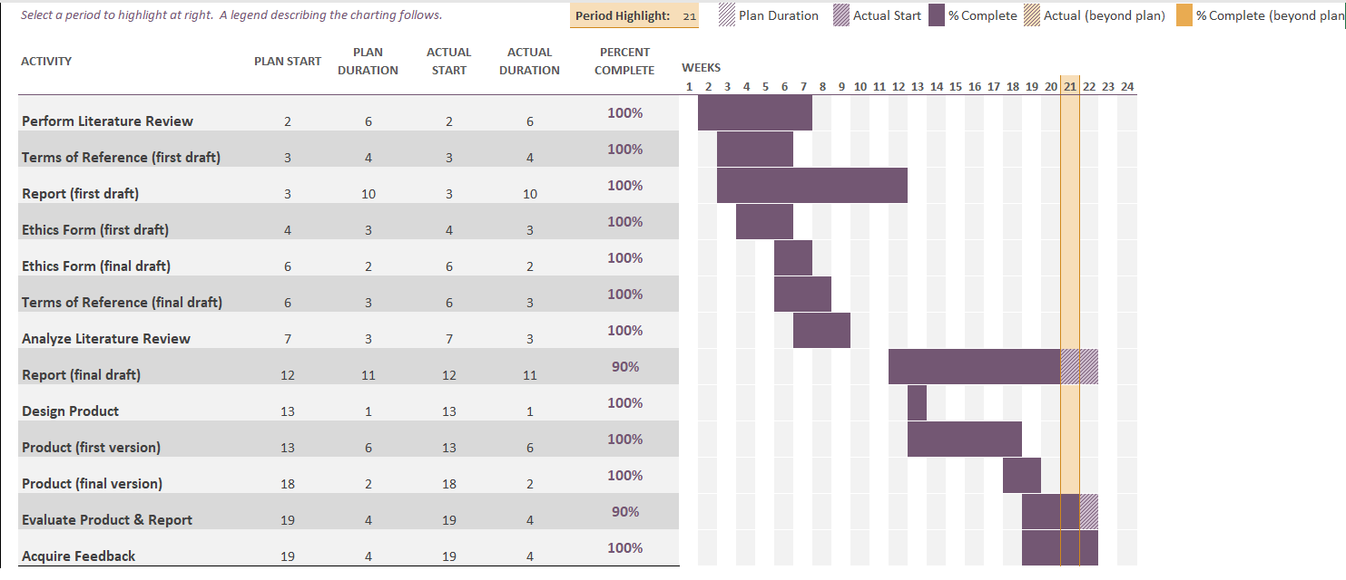

### 10.3 Appendix C – Test Plan

The following table contains the extensive list of tests carried out on the system both during and after the implementation process.

|  |  |  |  |
| --- | --- | --- | --- |
| Task Name | Task Description | Task Specifics | Test successful |
| Test 1  Player Movement | Player movement should be restricted to command text only – the ability to move via normal means within a game – WASD – should be disabled and have no effect on gameplay. | To remove the players ability to move this way, the input window in the editor was modified so that the mentioned inputs on the keyboard did not cause any events to occur when playing.  Events that rely on these keys were also not implemented to ensure this. | Test is considered successful – The intended way for player movement is via the text widget. |
| Test 2  Text Inputs – Collecting an Input | Backend test to confirm that an output is provided by the widget that can be used. | Linking the widget output directly to a print string node provides a text box in the corner of the screen with the correct information. Same behaviour is carried out while clearing the text box after use. | Test successful – Clearing the text box works after the player presses enter, and the text output is untouched and usable elsewhere. |
| Test 3  Text Inputs – Using an Input | Backend test to understand the way that an input is broken up. | Substring nodes are used to break up the text input (seen in figure 23 & 24). These are linked to print string nodes that confirm which position each input is in the text box (figure 37). | Test successful – see section 7.2 |
| Test 4  Text Inputs – Using one object with another. | In-game test, test is to determine if the object handlers are used in the correct order for certain interactions. | To test the outcome of trying to use objects with one another, a table was used to track the outputs of the command box and compared to the expected output. | All of the tested interactions worked as intended except for case three, which saw the book being placeable on the third shelf despite the in-world rotation of the shelf suggesting it is upside down. As noted in the table, this can be solved by checking which shelf is being interacted with specifically, and on a case-by-case basis either blocking or allowing the interaction. |
| Test 5  Text Inputs- Using commands to look around the room. | In-game test, examining certain objects will move the player and the camera to focus on those objects. This is also matched with “look” followed by a direction, which will return the player to a neutral position. Also to text that the “look” command is recognized and processed correctly. | Moving around the room and examining the light on the ceiling will angle the players camera towards the light. This needs to be tested from each potential position to ensure that it does not break anything. | After testing the examine function, looking at the third shelf (an upside down one higher up) puts the player at a point were looking at the light will point the player towards the shelf still. Feasible way to fix this is to detect which object the player is looking at, but would take a long portion of time to fix for a minor issue. |
| Test 6  Menu Interface – Buttons activate or link to the correct widgets or levels. | In-game test, pressing the buttons uses the correct functions that are repeated for each instance of a button. | Main menu buttons return to the main menu.  Start game & retry buttons start a new instance of the level.  Exit game buttons either end the simulated game or application.  Tip button on the main menu opens the tip widget, and the back button returns to the main menu. | All buttons work as intended. |
| Test 7  Object Casting – For the object handler to work, it needs to use “polymorphism” within the blueprints. This is achieved by “casting” an object as the superclass. | Backend test, checking that attempts to access an object handler work correctly.  The object handler in the abstractObject superclass is overridden by each object, but the point that needs to be tested is that the correct object is being cast as the superclass. | Using the text widget to interact with all of the objects independently will determine if the casting works. If nothing happens with a valid command, then it is casting the wrong object as an abstract object.  This will be tested alongside test 3 | All of the attempts to interact with the objects worked as intended. |
| Test 8  State changing – The state variable is changed through interactions, the test will see if this is done correctly. | In-game test, using a print string node, it is possible to print an int variable that has been converted to a string. Attaching this to the end of a function that changes a variable allows the console to print the number so that it can be observed properly. | Using the described technique, functions which change multiple states (such as placing the bolt in the lever) will have this node attached to test that both objects in the interaction are updated accordingly. | The notable instances were state is changed are observed to work correctly. |
| Test 9  Interacting with unusable objects | In-game test, the state variable is used to check if an object is interactable when the player enters a command related to it. This test will check if the state variable prevents using objects that are not currently usable. | Table 6 shows the logic applied to the variable. When an object is in state 1, it should not be interactable. This test will attempt to interact with these objects. | The objects that were interacted with were not usable in state 1, matching the expected outcome. |

#### 10.2.1 - Test 5 Comparison Table

|  |  |  |  |  |
| --- | --- | --- | --- | --- |
| Object 1 | Object 2 | Interaction | Expected Outcome | Actual Outcome |
| Book | First Shelf | Place | “You place the book down on the shelf” | “You place the book down on the shelf” |
| ‘’ | Second Shelf | Place | ‘’ | ‘’ |
| ‘’ | Third Shelf | Place | Should not be possible, in the game world the shelf is upside down and would not realistically be able to store the book. | “You see an upside down shelf protruding from the wall. There is a book attached to a loop.” – This can be solved by using a check to see which shelf is being interacted with and prevent the interaction. |
| Lever | Bolt | Put / Place | “You find a spot in the levers hinge to place the bolt. It fits into the position.” | “You find a spot in the levers hinge to place the bolt. It fits into the position.” |
| ‘’ | Bolt | Push | “You try to push the lever, but it does not move. The bolt blocks the handle from moving.” | “You try to push the lever, but it does not move. The bolt blocks the handle from moving.” |
| Box | First Shelf | Place | “You place the box down on the shelf” | “You place the box down on the shelf” |
| ‘’ | Second Shelf | Place | ‘’ | ‘’ |
| ‘’ | Third Shelf | Place | N/A (not possible within the gameplay loop) | N/A |
| ‘’ | Book | Place | N/A | N/A |
| Book | Plinth | Place | “You place the book on the plinth” | “You place the book on the plinth” |

### 10.4 Appendix D – Participant Information Form

As part of University Regulations, a Participant Information Form is required so that participants are aware of their rights, and their ability to rescind their participation. This was included in a zip file along with the questionnaire and the game application.

**An Interactive Fiction Exploring the Principles of the Turing Test**

**Participant Information Sheet**

This project requires participants to take part in a questionnaire based on their experience playing the Interactive Fiction game they have been supplied with.

Purpose of Study

The aim of this questionnaire is to acquire feedback from participants on the Interactive Fiction game based on how easy or difficult they found it. An Interactive Fiction game is defined as “software that uses text commands to control the character and influence the environment. As a video game, Interactive Fiction comes in the form of either an adventure game or role-playing game.”

This study is being carried out as part of a dissertation within the Computer Science with Games Development undergraduate course at Northumbria University.

Why have I been invited?

You have been chosen to participate as you are older than 18 and a student at Northumbria University with a presumed experience with video games.

Do I have to take part?

Your participation is not required if you choose not to. The purpose of this document is to provide an idea of what participation is required so that a decision can be made with all of the information required.

Refusing to take part will not be reflected in any documentation within the dissertation.

What will happen if I take part?

If you do decide to take part, you will be provided with a zip file containing an executable form of the game that I have produced, and will also be provided with a Microsoft Form which you can fill out after playing the game. The questionnaire will not require any personal details and will be kept anonymous.

The game is designed to be played around 10 minutes; however, this is not a timer and play time can be longer or shorter depending on the player. After playing, the participant can fill in their questionnaire based on their experience. If another play-through is required to form an opinion, that is fine. Participants are free to play the game as many times as they want, but it is recommended to only play it once before filling in the questionnaire.

How will my data be stored, and how long will it be stored for?

No personal data will be stored on any documentation. After the questionnaires have been filled out, they will be uploaded to a secure Onedrive and kept online so they can be provided to examination bodies if they are required.

Who has reviewed this study?

This project has been approved by the Northumbria University’s Ethics Online System. It has been reviewed in order to safeguard your interests and have granted approval to conduct the project.

**Contacts for further information:**

If you have any concerns about the aspects of this project, you should use the following contact details to speak with myself, and I will try my best to answer your questions. If you are further dissatisfied, you can contact the project supervisor who’s contact details have also been included.

Project Members

James Davis: [james.r.l.davis@northumbria.ac.uk](mailto:james.r.l.davis@northumbria.ac.uk)

Project Supervisor

John Rooksby: [john.rooksby@northumbria.ac.uk](mailto:john.rooksby@northumbria.ac.uk)

Name and contact details of the Records and Information Officer at Northumbria University:

Duncan James (dp.officer@northumbria.ac.uk)

***You can find out more about how we use your information at:*** ***www.northumbria.ac.uk/about-us/leadership-governance/vice-chancellors-office/legal-services-team/gdpr/gdpr---privacy-notices/***

***or by contacting a member of the research team***

### 10.5 Appendix E – Questionnaire Form

As Microsoft Forms cannot be downloaded, the form has been printed and scanned so that it can be entered into this document. Also included at the end of this section are screenshots of the responses to the Microsoft Form. They are grouped by question.  
The actual form can be found here: <https://forms.office.com/r/iANTetiLXh>

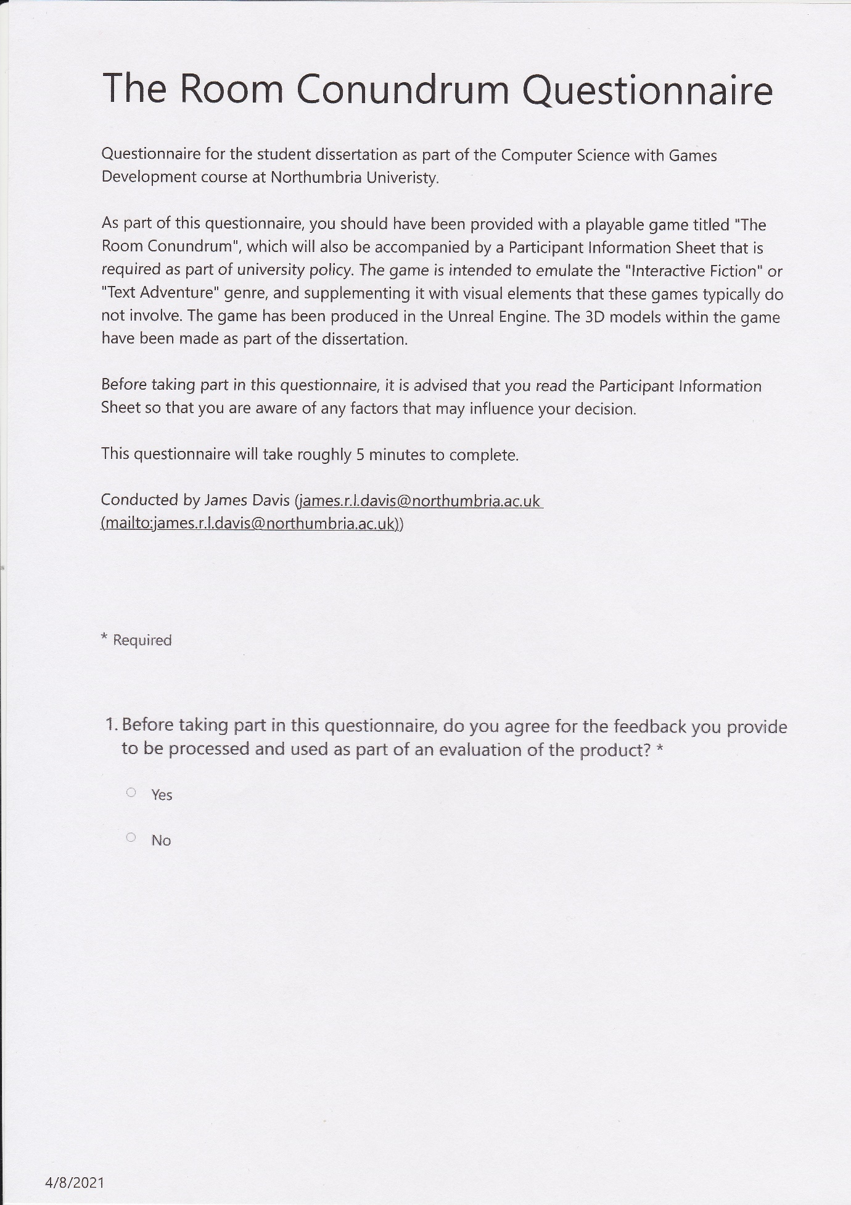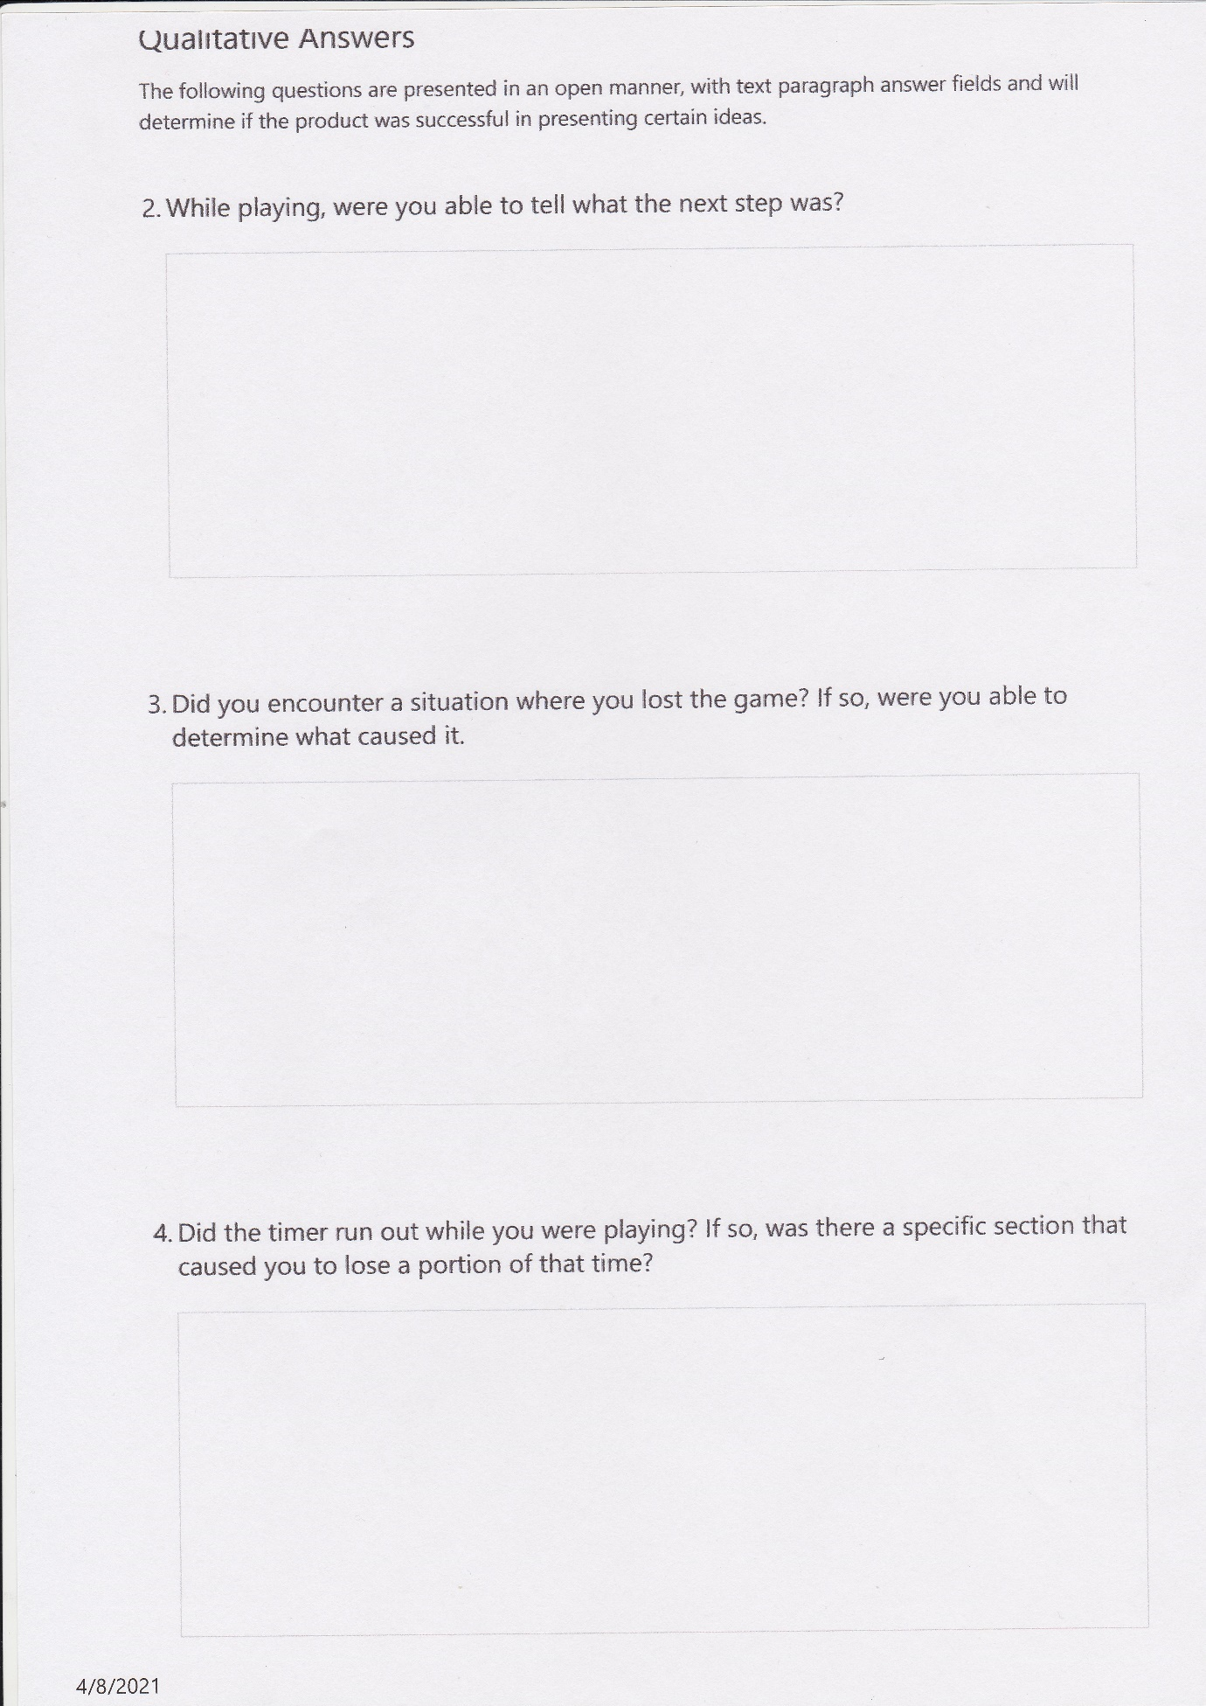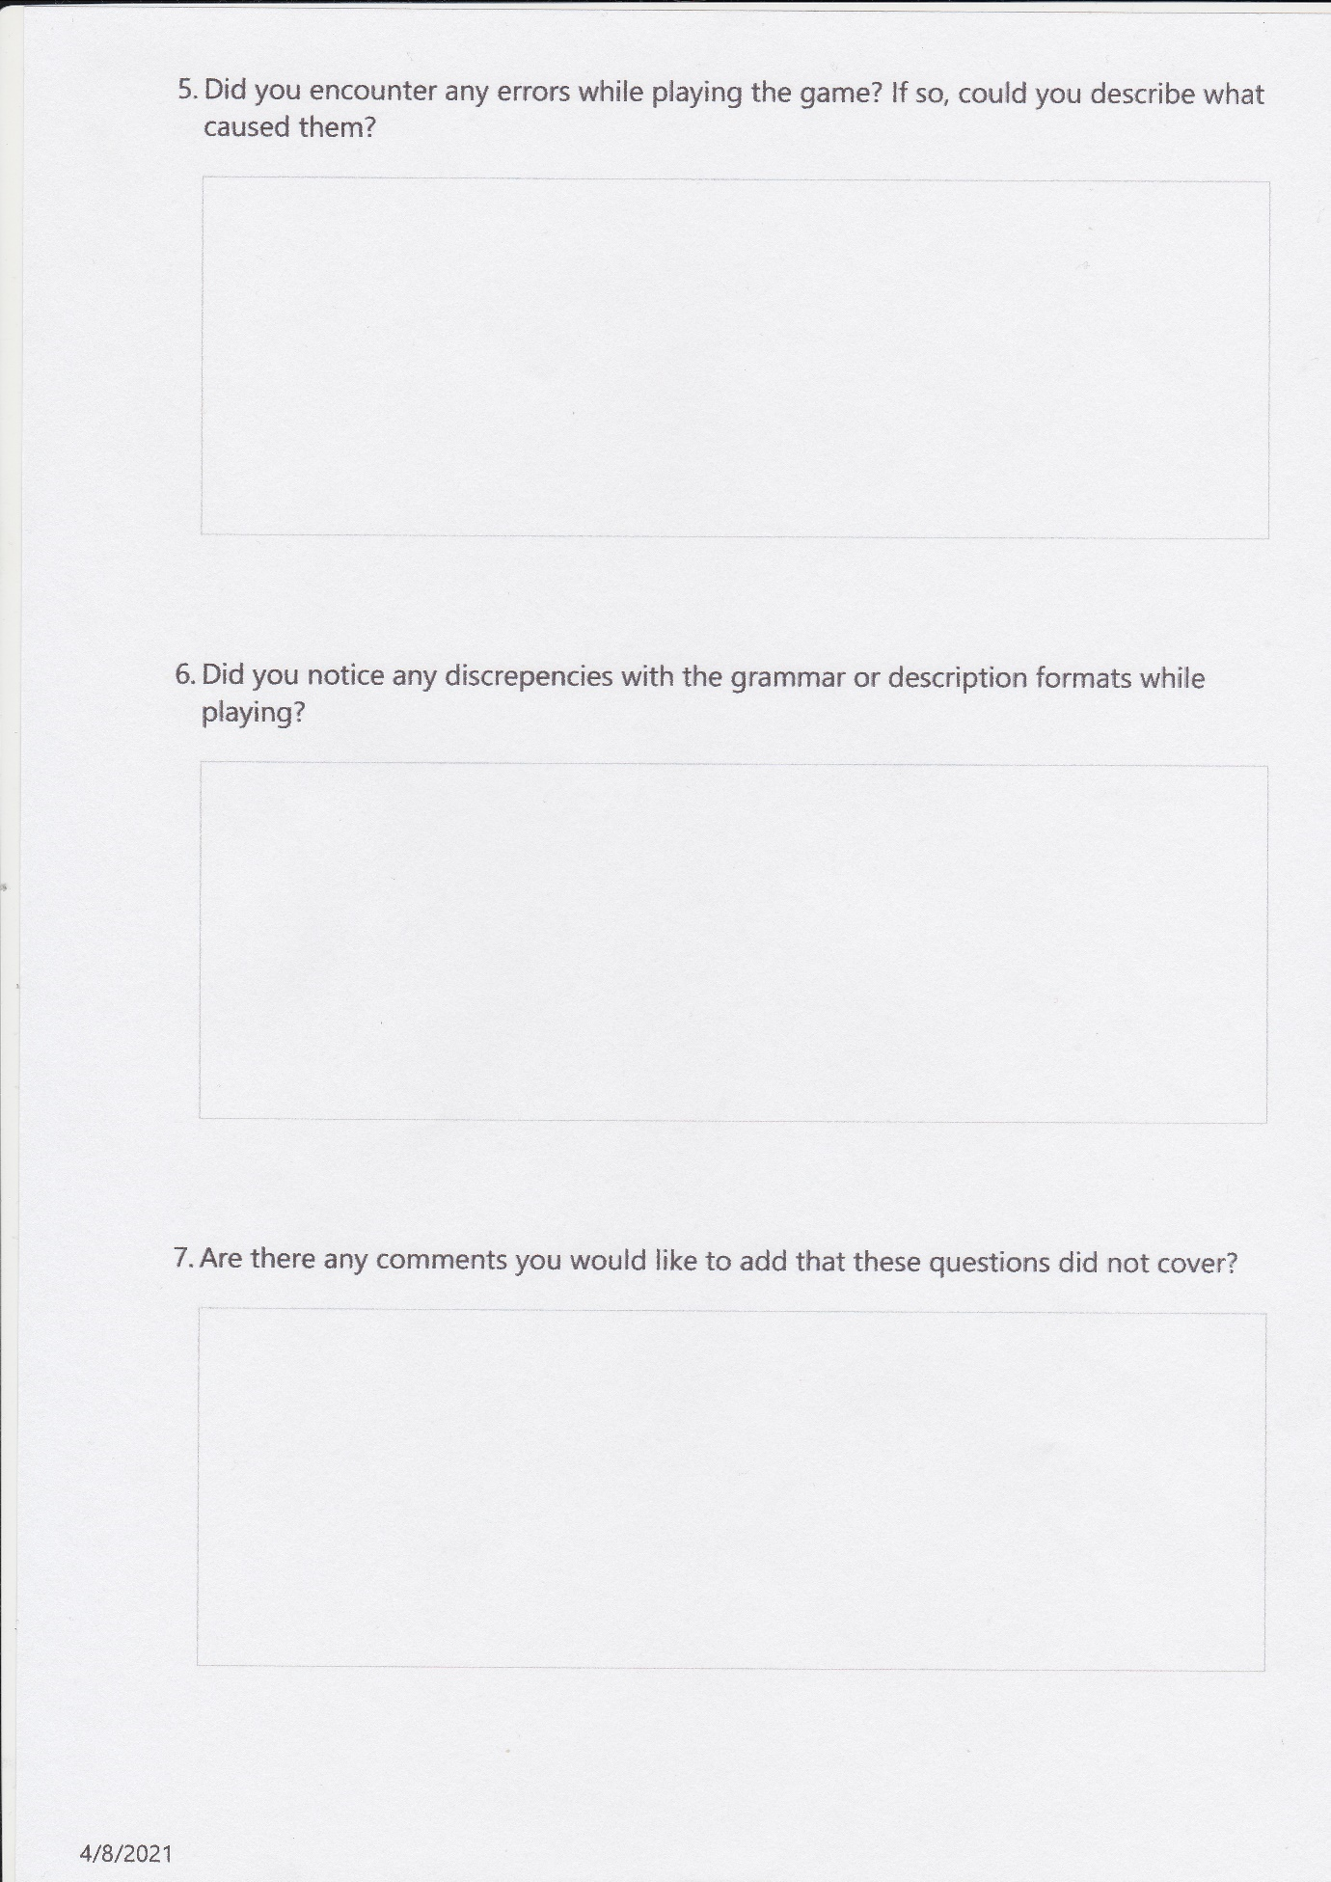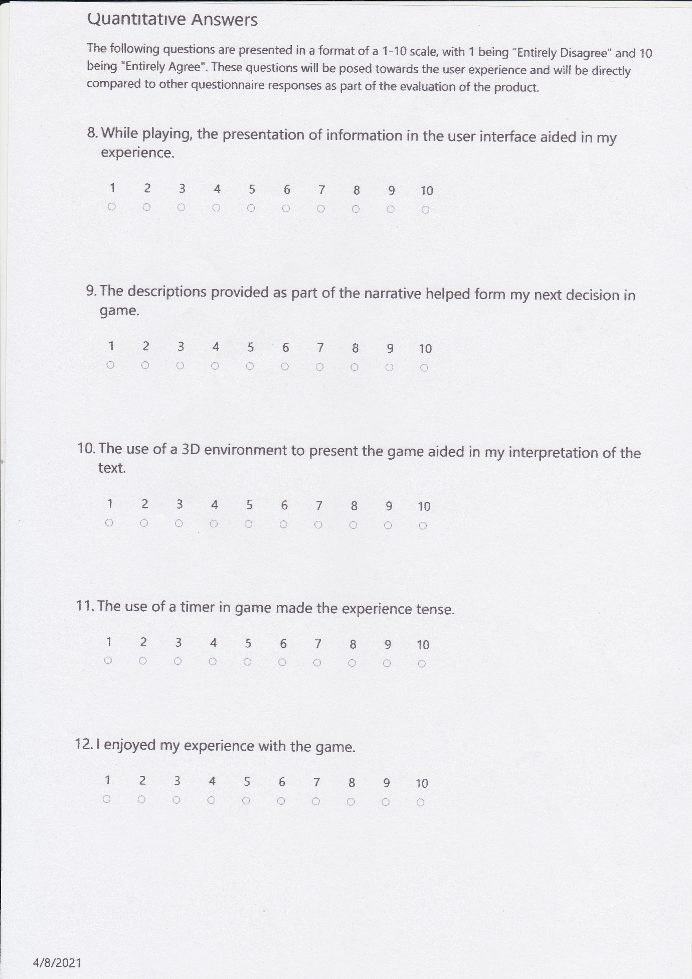

### 10.6 Appendix F - Questionnaire Responses

The ID of a response correlates to a single participant, with the IDs being related throughout. So each response under ID 1 is by participant 1, likewise through to 9 except in the responses to question 7, as there were not a total of 9 answers, it does not accurately correlate the ID with the other answers.

Any of the responses logged here have been done with the participant checking “yes” for providing consent to use this information.

1. While playing, were you able to tell what the next step was?

|  |  |  |
| --- | --- | --- |
| ID | Name | Response |
| 1 | anonymous | Not all of the time. It took a lot of trial and error, but it was purely down to my own low experience in puzzle/escape room games. |
| 2 | anonymous | I knew the goals of the game and found the objects, however was unable to put then into place and progress through the game. |
| 3 | anonymous | No |
| 4 | anonymous | I struggled to determine what to do next when after examining a few items. |
| 5 | anonymous | I had a good idea of what to do to begin with, but the later stage with the box confused me. |
| 6 | anonymous | No. |
| 7 | anonymous | Yes, after my first try I understood what to do pretty well until I reached a section later on. |
| 8 | anonymous | It wasn't obvious, but I was able to get the lock. |
| 9 | anonymous | No |

1. Did you encounter a situation where you lost the game? If so, were you able to determine what caused it?

|  |  |  |
| --- | --- | --- |
| ID | Name | Response |
| 1 | anonymous | I wasn't able to find out where to use the bolt and got stuck on that for about 20 minutes (two runs of the escape room). |
| 2 | anonymous | Yes but some of that was probably due to my inability to solve puzzles also didn't know all of the commands to try. |
| 3 | anonymous | I lost the game because I ran out of time. |
| 4 | anonymous | I lost three times due to the timer running out. |
| 5 | anonymous | I lost the game twice, the first one was due to running out of time, and the second was because I made a mistake according to the game. |
| 6 | anonymous | I struggled at the beginning of the game and lost a few times when the timer ran out. I got the book but wasn't able to progress past it. |
| 7 | anonymous | I lost once due to the timer running out. The second attempt I got stuck, and decided to quit. |
| 8 | anonymous | I lost twice, both times were because the timer ran out. |
| 9 | anonymous | Yes, the timer ran out |

1. Did the timer run out while you were playing? If so, was there a specific section that caused you to lose a portion of that time?

|  |  |  |
| --- | --- | --- |
| ID | Name | Response |
| 1 | anonymous | My timer ran out around four times. The first two times, I was unable to figure out how to examine the first shelf, due to over-looking the final part of the last hint. The last two times were due to being unable to figure out where to place the aforementioned bolt. |
| 2 | anonymous | The timer did run out, I just didn't make it very far at all - think the Plinth confused me but that's probably my inability to complete escape rooms. |
| 3 | anonymous | I could not figure out how to open the 2nd or 3rd drawer after getting the book and bolt. Or use them on the plinth? Not sure |
| 4 | anonymous | Each time I played the timer ran out after I unlocked a new item. A lot of my time was taken up trying to interact with the objects as I found them. |
| 5 | anonymous | The timer ran out once, this was during my first time playing, and was when i was using the box. |
| 6 | anonymous | The timer ran out 3 times. Every time was while I was trying to use the book. |
| 7 | anonymous | On my first attempt I got to the box and the timer ran out. I lost a lot of time figuring out what to do with the bolt. |
| 8 | anonymous | The timer ran out while I was figuring out how to get the third shelf the first time. The second time it ran out while i was trying to use the lock. |
| 9 | anonymous | After the first shelf and finding the book |

1. Did you encounter any errors while playing the game? If so, could you describe what caused them?

|  |  |  |
| --- | --- | --- |
| ID | Name | Response |
| 1 | anonymous | When restarting, there was a section on the top left of the screen where some leftover text remained, but this has been noted to the game developer during play. Additionally, some look commands would leave a sample word in the top left of the textbox if the command was incorrect, but the word didn't really correlate to the error message. |
| 2 | anonymous | None |
| 3 | anonymous | When I tried to "use bolt" the chat would just say "object". Also, the shelf could not be reexamined after taking the book from it. |
| 4 | anonymous | When the level started, I saw blue text in the top right corner, this happened everytime i started. |
| 5 | anonymous | I did not. |
| 6 | anonymous | I didn't encounter any errors, but I think the game didn't understand what i was trying to do. |
| 7 | anonymous | I did not. |
| 8 | anonymous | When I typed "lock" into the command box, it said "object", not sure if this was intended. |
| 9 | anonymous | It was difficult to understand to type first shelf when only one was visible |

1. Did you notice any discrepancies with the grammar or description formats while playing?

|  |  |  |
| --- | --- | --- |
| ID | Name | Response |
| 1 | anonymous | Grammar and spelling seemed all correct, and well structured. |
| 2 | anonymous | None |
| 3 | anonymous | Not that I could tell |
| 4 | anonymous | All of the text I saw made sense. |
| 5 | anonymous | The text was fine. |
| 6 | anonymous | The text that I did see looked correct. |
| 7 | anonymous | The description formats could benefit from a different font, all of the text for the menus use the same fonts and colours. The grammar was fine. |
| 8 | anonymous | I think the descriptions were grammatically correct. |
| 9 | anonymous | Some text didn't have a response |

1. Are there any comments you would like to add that these questions did not cover?

|  |  |  |
| --- | --- | --- |
| ID | Name | Response |
| 1 | anonymous | The type commands to actually do things within the game can be rather open which can be rather difficult with what options you can have, which is why the tips helped a lot. I kept trying turn until the tips helped with 'look south', 'look west', ect. |
| 2 | anonymous | Lots of the time there was no feedback for if what I was inputting was wrong, it would be nice to have that. |
| 3 | anonymous | The descriptions of items could be more indepth to help figure out the next step. |
| 4 | anonymous | The game could use more simpler puzzles. |
| 5 | anonymous | Could make it clearer on what to do next. |
| 6 | anonymous | The step with the lock could use some better descriptions so its easier to figure out. |
| 7 | anonymous | A list of possible commands would be nice with examples |

1. While playing, the presentation of information in the user interface aided in my experience.

|  |  |  |
| --- | --- | --- |
| ID | Name | Response |
| 1 | anonymous | 6 |
| 2 | anonymous | 10 |
| 3 | anonymous | 4 |
| 4 | anonymous | 6 |
| 5 | anonymous | 7 |
| 6 | anonymous | 6 |
| 7 | anonymous | 6 |
| 8 | anonymous | 6 |
| 9 | anonymous | 6 |

1. The descriptions provided as part of the narrative helped from my next decision in game.

|  |  |  |
| --- | --- | --- |
| ID | Name | Response |
| 1 | anonymous | 7 |
| 2 | anonymous | 7 |
| 3 | anonymous | 9 |
| 4 | anonymous | 4 |
| 5 | anonymous | 6 |
| 6 | anonymous | 4 |
| 7 | anonymous | 7 |
| 8 | anonymous | 7 |
| 9 | anonymous | 7 |

1. The use of a 3D environment to prevent the game aided in my interpretation of the text.

|  |  |  |
| --- | --- | --- |
| ID | Name | Response |
| 1 | anonymous | 8 |
| 2 | anonymous | 9 |
| 3 | anonymous | 10 |
| 4 | anonymous | 7 |
| 5 | anonymous | 6 |
| 6 | anonymous | 3 |
| 7 | anonymous | 5 |
| 8 | anonymous | 6 |
| 9 | anonymous | 8 |

1. The use of a timer in game made the experience tense.

|  |  |  |
| --- | --- | --- |
| ID | Name | Response |
| 1 | anonymous | 9 |
| 2 | anonymous | 10 |
| 3 | anonymous | 8 |
| 4 | anonymous | 8 |
| 5 | anonymous | 4 |
| 6 | anonymous | 3 |
| 7 | anonymous | 9 |
| 8 | anonymous | 8 |
| 9 | anonymous | 8 |

1. I enjoyed my experience with the game.

|  |  |  |
| --- | --- | --- |
| ID | Name | Response |
| 1 | anonymous | 7 |
| 2 | anonymous | 8 |
| 3 | anonymous | 9 |
| 4 | anonymous | 7 |
| 5 | anonymous | 5 |
| 6 | anonymous | 4 |
| 7 | anonymous | 8 |
| 8 | anonymous | 8 |
| 9 | anonymous | 2 |

### 10.7 Appendix G – Search Strategy

The below table shows terms used to search for material to use within the Literature Review, it includes the terms used to search for games that are related to certain topics, and the results of what is found using them. The articles linked below (and matched with numbers inside of the table) were not used as part of this dissertation, but are interesting enough that further research into the topic would benefit from looking at them.

|  |  |  |
| --- | --- | --- |
| Term Used | Google | Steam |
| Turing game | Turing Tumble (N/A), Turing Test (video game), | Turing Test, Turing Tumble (N/A) |
| Imitation | N/A (movie) | N/A |
| Turing Standard Interpretation | (1), (2), | N/A |
| Interactive Fiction | (3), (4), (5), (6) | (7) |
|  |  |  |
|  |  |  |
|  |  |  |
|  |  |  |

1. <https://www.researchgate.net/publication/220686281_Turing%27s_test_and_believable_AI_in_games>
2. <https://www.academia.edu/10163920/An_Analysis_of_the_Literal_Interpretation_of_Turings_Imitation_Game>
3. <https://link.springer.com/chapter/10.1007/978-3-540-27797-2_14>
4. <https://library.um.edu.mo/ebooks/b17790128.pdf>
5. <https://link.springer.com/article/10.1007%252FBF01894033>
6. <https://www.researchgate.net/profile/Brett_Shelton/publication/228959393_Designing_and_creating_interactive_fiction_for_learning/links/00b495346f2b9498b8000000/Designing-and-creating-interactive-fiction-for-learning.pdf>
7. Many of the games that can be found using the tag “interactive fiction” on the steam store page do not match the definition provided in the literature review. Games found here do not use a command line to interact with the world, and will not be considered as relevant for that point. While this is hypocritical, as some of the games reviewed in chapter 2 also do not use a command line, those games have a focus on text. Games found using this tag span scales of usability for this regard.

### 10.8 Appendix H – Model Screenshots

To prevent space within the main document from being taken up, a few screenshots of the models within blender have been placed here.

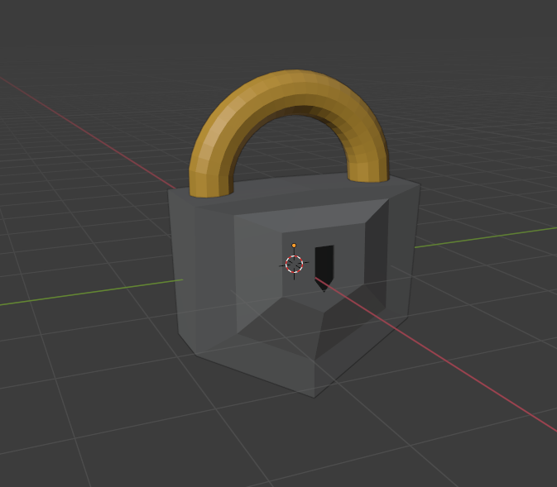

**A model for a lock using basic UV editing to add colour to it.**

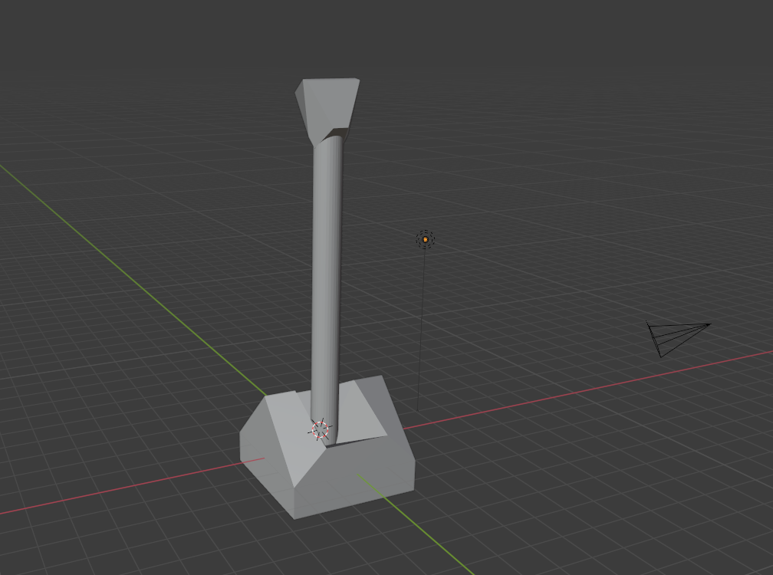

**The model for the lever in the centre of the room. It uses three separate meshes that are joined together.**

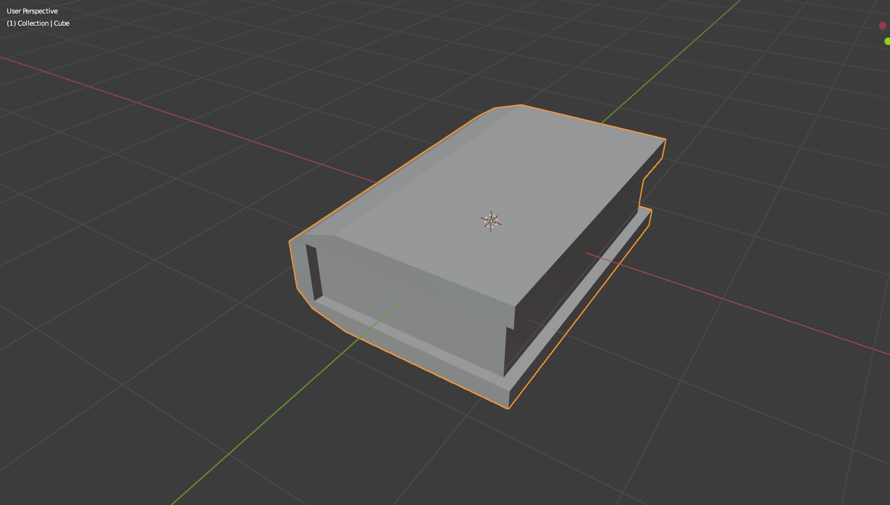

**The untextured book model used in the game. A separate model was created for the book when it is “examined”, but due to the functionality of physically observing the book not being made, it isn’t relevant.**

### 10.9 Appendix J – Game Screenshots

Within this section are a number of screenshots taken from the final product. These are discussed in section 6.7.

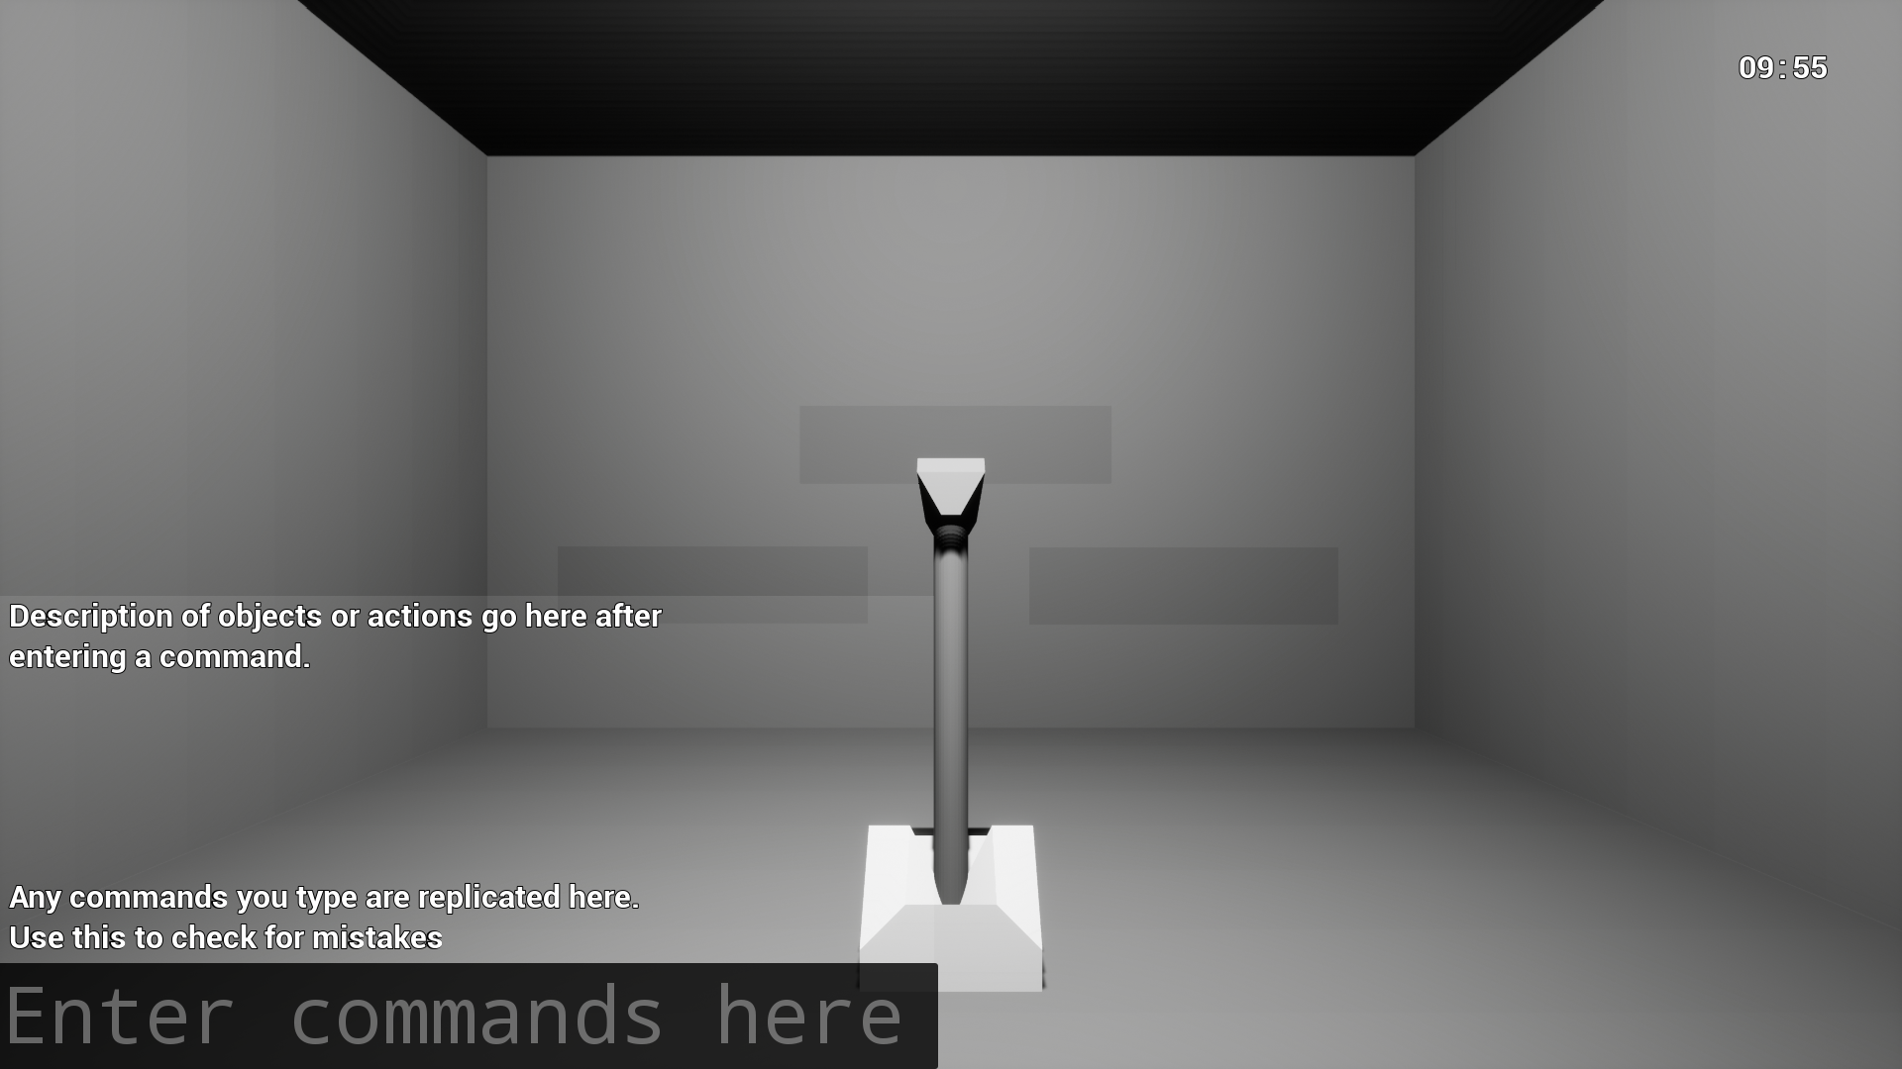

**The initial starting position when clicking “start game” on the main menu. The timer can be seen in the top right.**

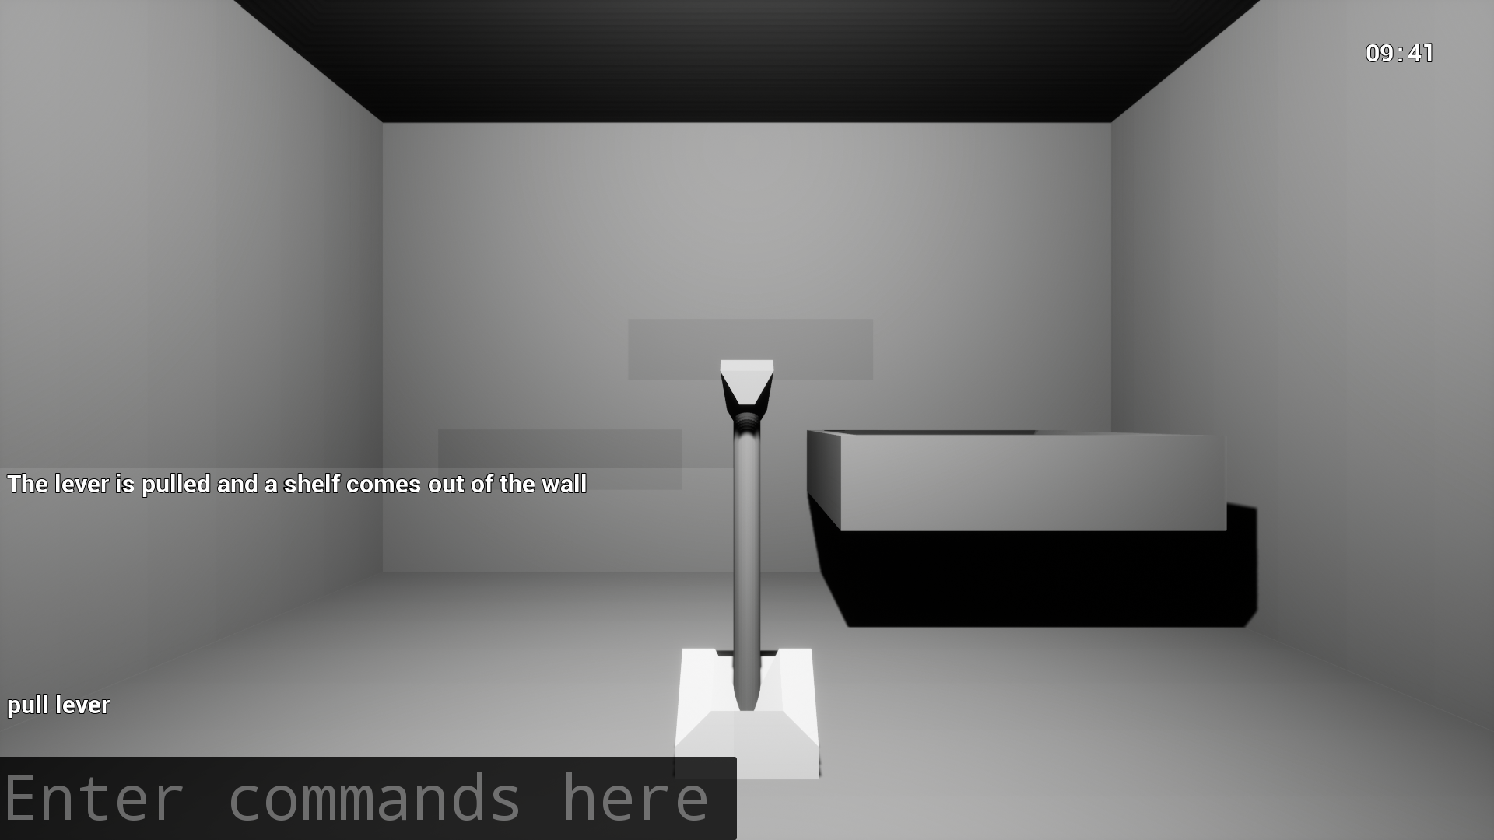

**Taken following the first screenshot, shows the shelf moving in response to the lever being pulled.**

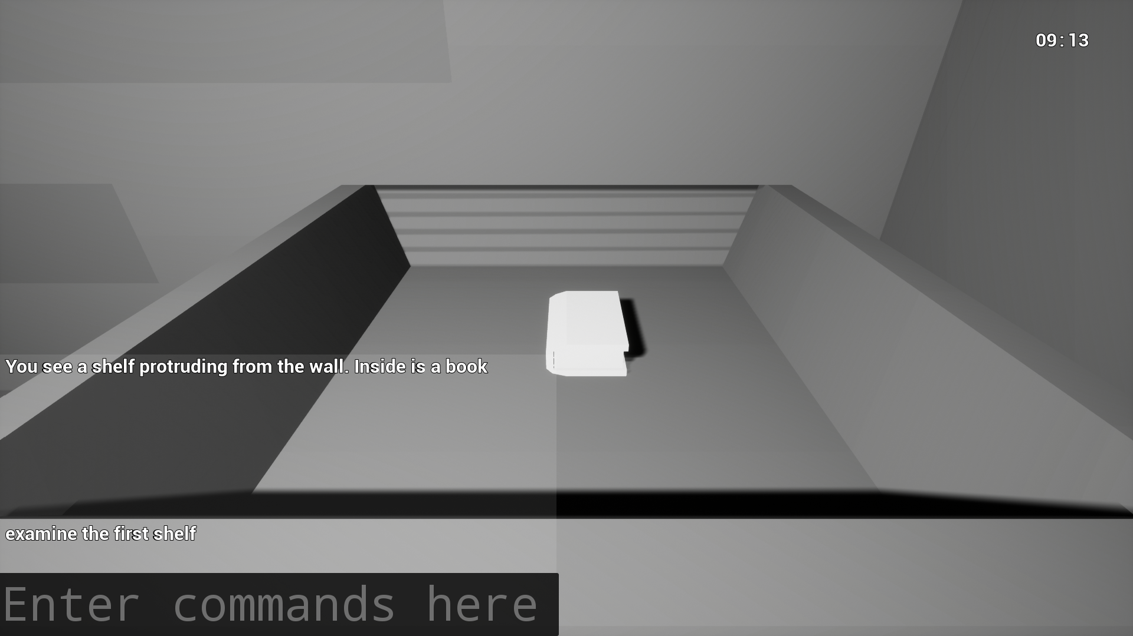

**Shows the examine function taking the player to the object so they can see it.**

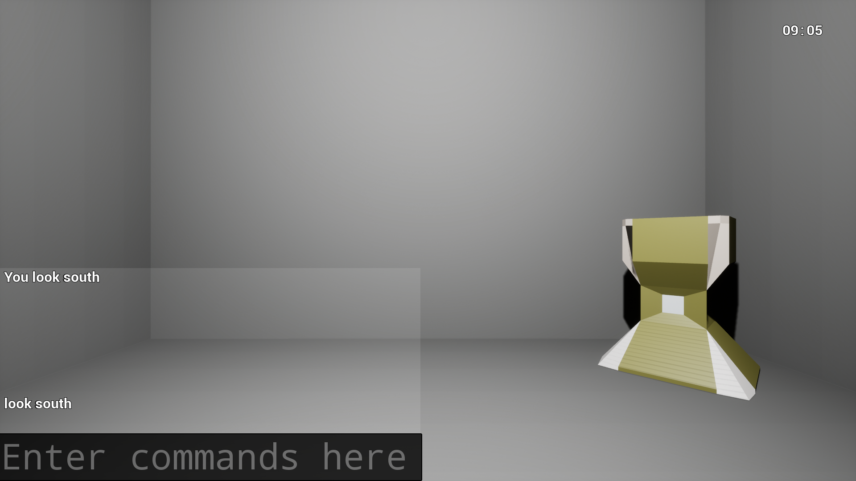

**The command to look in a certain direction, this screenshot shows “south”.**

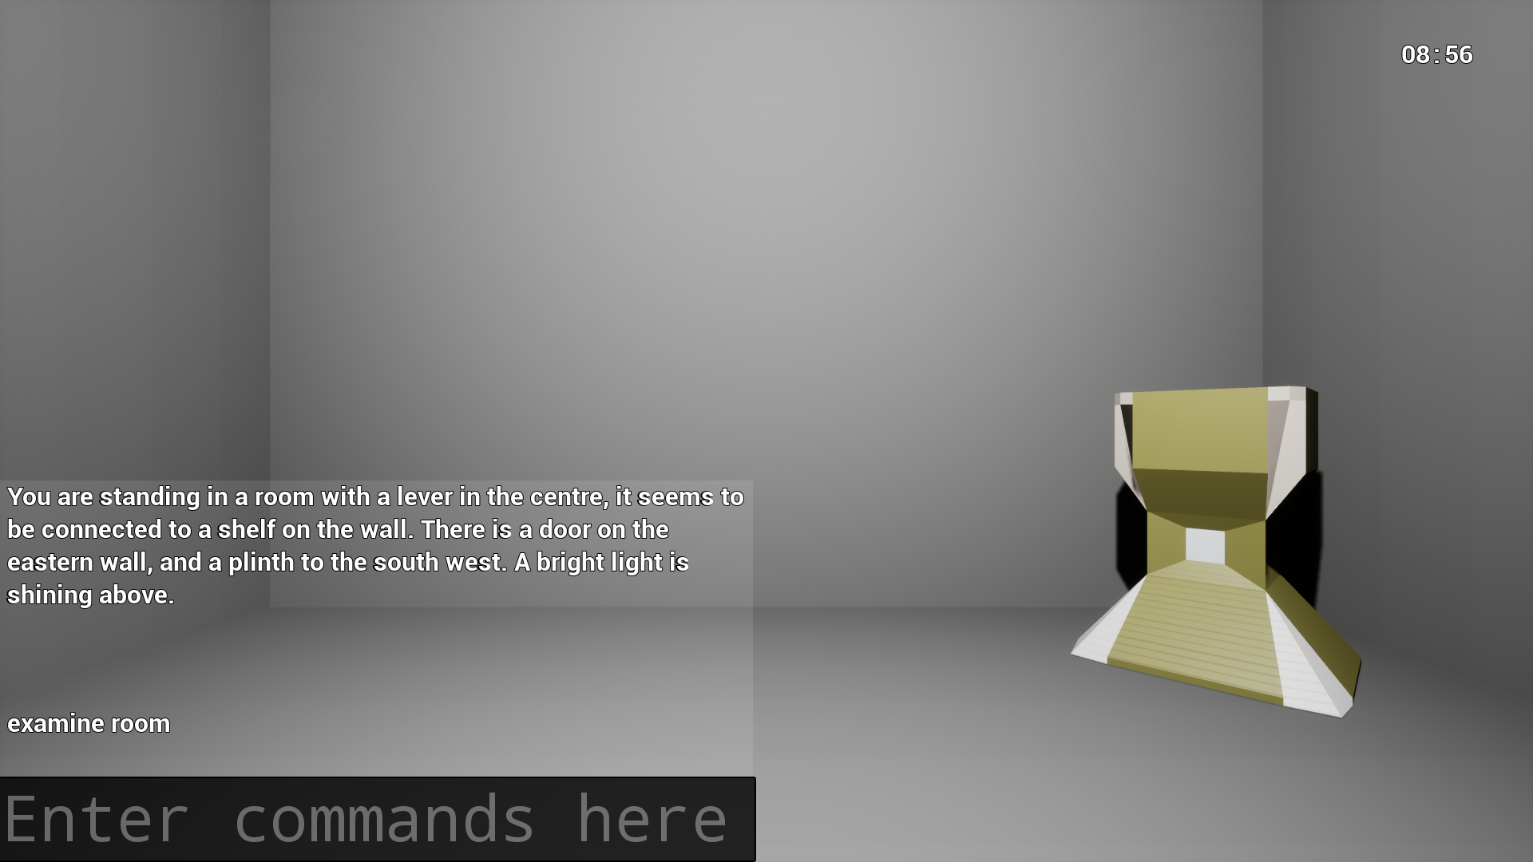

**Screenshot showing the “examine room” command, which details what the player can see and a general explanation of what has happened so far.**